User Manual

Installation

Windows
This software requires Windows XP, Vista, 7, 8, 8.1 or 10
Download the Python 3.4 installer from
https://www.python.org/downloads/windows/
Download the PyQt framework from https://www.riverbankcomputing.com/software/pyqt/download
Open both of the downloaded files and install the software packages.
Now, access the installation media given to you by your software developer and run “setup.py” by double clicking on it. Follow all the on-screen instructions.

Debian Linux
Downloac and install the python3 and the python3-pyqt4 package from the internet using the following command
sudo apt-get install python3 python3-pyqt4
Then access the installation media and extract the file “cms-suite.zip” to the desired location, open that folder and run the setup.py file and follow the on-screen instructions

Mac OSX
I need to do this later.

Basic operation
When you run the software, you will be presented with the login screen:
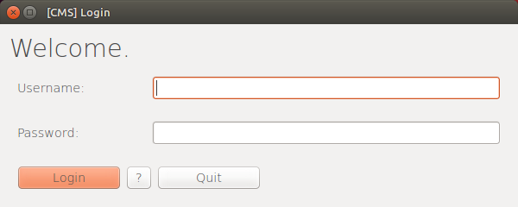
This is where you input the username and password given to you by the administrator. You will then be presented with this screen:
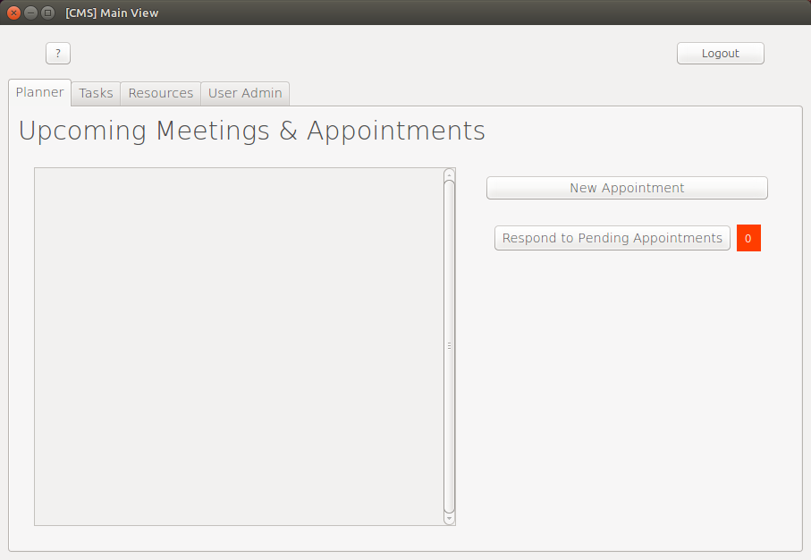

Creating Appointments
From this screen you can add new appointments and respond to pending appointments. To add a new appointment click the button marked “New Appointment”, you will be presented
with the following window:
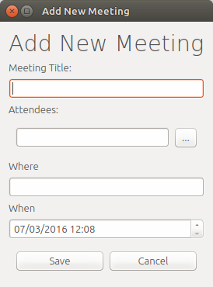

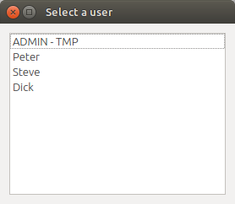
Input the title of the meeting in the field labelled “Meeting Title”, next input a list of usernames separated by either commas or semicolons, for example:
bob, john; william
Or you can click on the […] button to select the username from a list of available usernames. Next input the location of the meeting in the input box marked “Where”. Finally select a date & time for the meeting with the field marked “When” and click “[Save]” to store the meeting information.

Responding to a Meeting Request
In order to respond to a meeting request (which occurs when someone else adds your username to the Attendees field in the Add New Meeting form), first click on the “Respond to Pending Appointments”
You will then be presented with the following window:
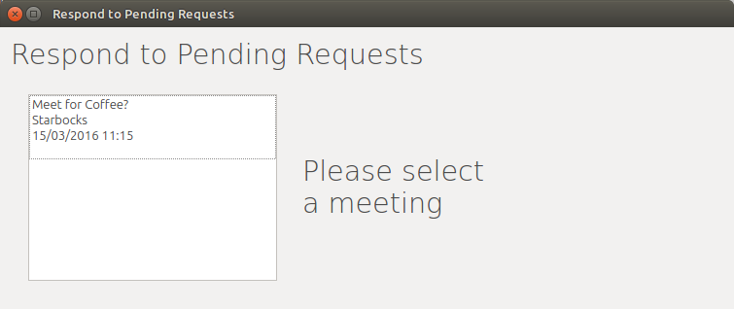
When you select a meeting from the list on the left, further information such as the title, the meeting's 'owner', the location and the date & time for that meeting will appear on the right, like so:
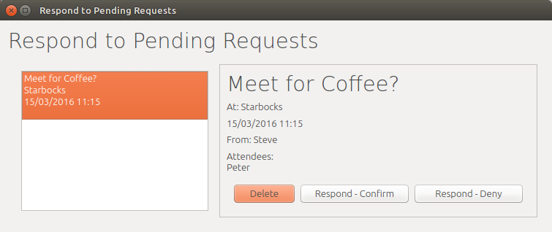
If you want to agree to attending the selected meeting, click the “[Respond – Confirm]” button, if not click the “[Respond – Deny]” or the “[Delete]” buttons.

Task View
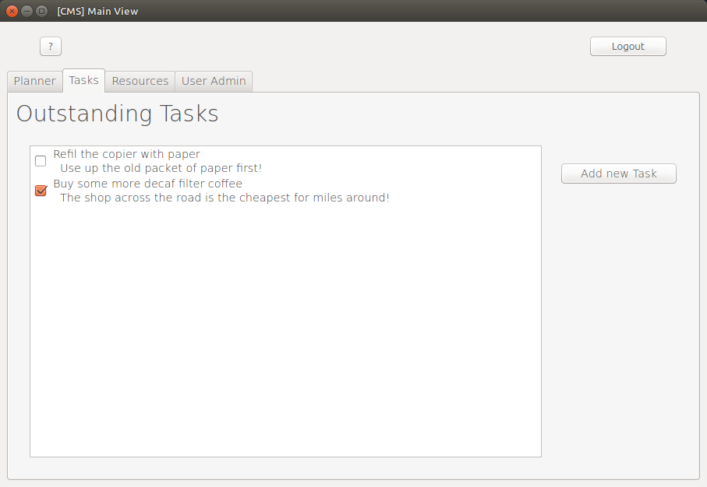
The task view contains a list of tasks that you can tick as “done” which is useful for keeping track of small things you need to do. This feature is designed to do effectively the same thing as the Meetings functionality but for when there are no other attendees and the time and location are not important.

Creating a New Task
To create a new task, click the “Add New Task” button in the Tasks tab, you will then be presented with the following window:
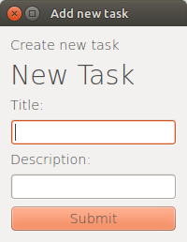

Enter a title and a description for your task then click “[Submit]” to store that task.

Resources View
This view is shared across all the users with access to it

