Block Estimate for ERCC JOS

Block Estimate for **Client** prepared by *Peebot BOQ Analzer.*

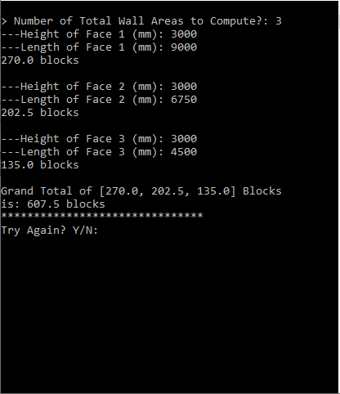

|  |  |
| --- | --- |
| Wallname | Block(s) |
| Wall 1 | 174 |
| SUB-TOTAL | 444 |