Doc 1

Block Estimate for **Client** prepared by *Peebot BOQ Analzer.*

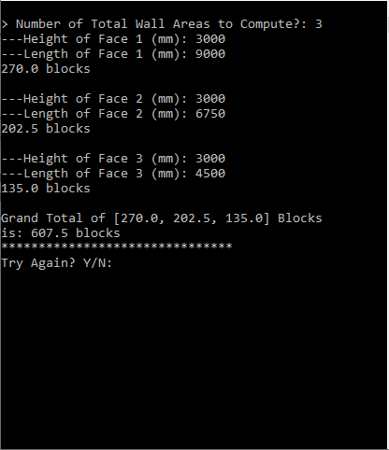

|  |  |
| --- | --- |
| Wallname | Block |
| 1 | 90 |
| 2 | 150 |