Lab 8.1.2.4 - Configuring Basic DHCPv4 on Router

Part 1: Build the Network and Configure Basic Device Settings

***Step 4: Verify network connectivity between the routers***

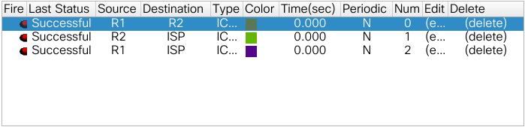

Part 2: Configure a DHCPv4 Server and a DHCP Relay Agent

***Step 2: Configure R1 as a DHCP relay agent***

**On the lines below, write the commands necessary to configure R1 as a DHCP relay agent for the R1 LANs.**

interface g0/0

ip helper-address 192.168.2.254

interface g0/1

ip helper-address 192.168.2.254

***Step 3: Record IP settings for PC-A and PC-B.***

**On PC-A and PC-B, issue the ipconfig /all command to verify that the PCs have received IP address information from the DHCP server on R2. Record the IP and MAC address for each PC.**

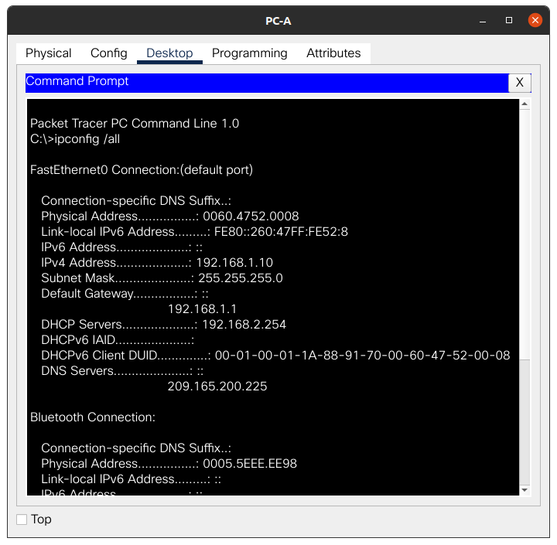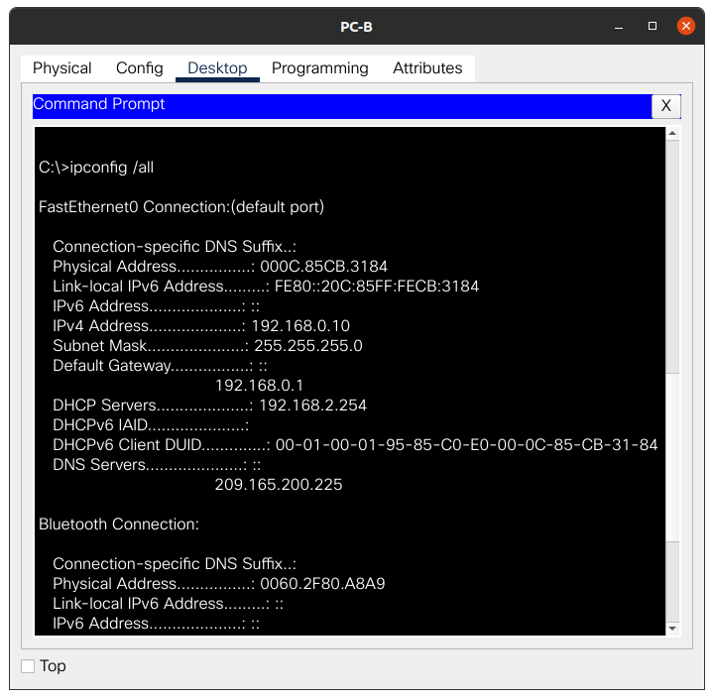

**Based on the DHCP pool that was configured on R2, what are the first available IP addresses that PC-A and PC-B can lease?**

.10 addresses.

***Step 4: Verify DHCP services and address leases on R2.***

1. **On R2, enter the show ip dhcp binding command to view DHCP address leases.**

**Along with the IP addresses that were leased, what other piece of useful client identification information is in the output?**

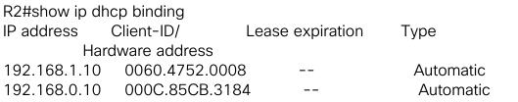

The hardware address and its expiration.

1. **On R2 enter the show ip dhcp pool command to view the DHCP pool settings.**

**In the output of the show ip dhcp pool command, what does the current index refer to?**

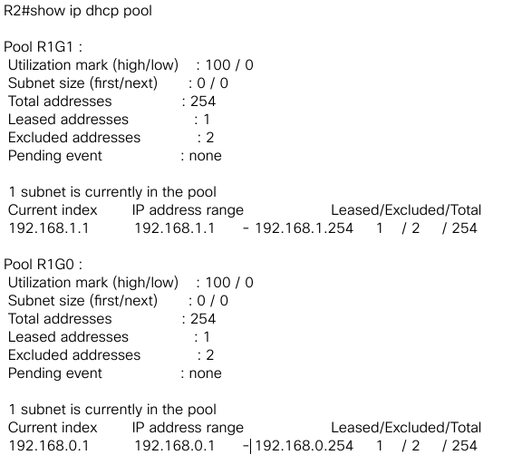

1. **On R2, enter the show run | begin dhcp command to view the DHCP configuration in the running configuration.**

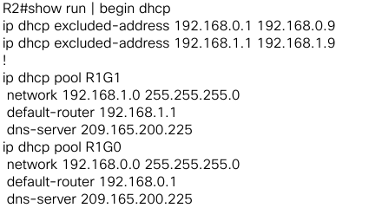

Reflection

**What do you think is the benefit of using DHCP relay agents instead of multiple routers acting as DHCP servers?**

You do not need to configure multiple DHCPs.

Configuration

**R1**

enable

config t

hostname R1

no ip domain-lookup

service password-encryption

enable secret class

banner motd #

Unauthorized access is strictly prohibited. #

line con 0

password cisco

login

logging synchronous

line vty 0 4

password cisco

login

int g0/0

ip add 192.168.0.1 255.255.255.0

no shut

int g0/1

ip add 192.168.1.1 255.255.255.0

no shut

int s0/1/0

ip add 192.168.2.253 255.255.255.252

clock rate 1280000

no shut

router rip

version 2

network 192.168.0.0

network 192.168.1.0

network 192.168.2.252

no auto-summary

interface g0/0

ip helper-address 192.168.2.254

interface g0/1

ip helper-address 192.168.2.254

**R2**

enable

config t

hostname R2

no ip domain-lookup

service password-encryption

enable secret class

banner motd #

Unauthorized access is strictly prohibited. #

line con 0

password cisco

login

logging synchronous

line vty 0 4

password cisco

login

int s0/1/0

ip add 192.168.2.254 255.255.255.252

no shut

int s0/1/1

ip add 209.165.200.226 255.255.255.224

clock rate 128000

no shut

router rip

version 2

network 192.168.2.252

redistribute static

no auto-summary

exit

ip route 0.0.0.0 0.0.0.0 209.165.200.225

ip dhcp excluded-address 192.168.0.1 192.168.0.9

ip dhcp excluded-address 192.168.1.1 192.168.1.9

ip dhcp pool R1G1

network 192.168.1.0 255.255.255.0

default-router 192.168.1.1

dns-server 209.165.200.225

exit

ip dhcp pool R1G0

network 192.168.0.0 255.255.255.0

default-router 192.168.0.1

dns-server 209.165.200.225

**ISP**

enable

config t

hostname ISP

no ip domain-lookup

service password-encryption

enable secret class

banner motd #

Unauthorized access is strictly prohibited. #

line con 0

password cisco

login

logging synchronous

line vty 0 4

password cisco

login

int s0/1/1

ip add 209.165.200.225 255.255.255.252

no shut

ip route 192.168.0.0 255.255.252.0 209.165.200.226