Lab 9.3.2.13 - Configuring and Verifying Extended ACLs

Part 2: Configure Devices and Verify Connectivity

**Step 7: Verify connectivity between devices.**

1. From PC-A ping PC-C and the loopback on R3





1. From R1, ping PC-C and the loopback on R3.

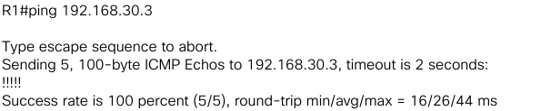

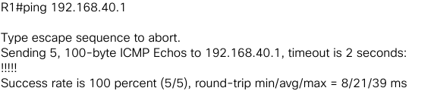

1. From PC-C, ping PC-A and the loopback on R1.





1. From R3, ping PC-A and the loopback on R1.

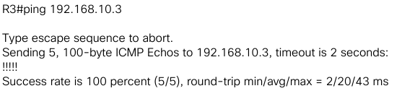

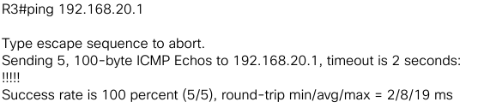

1. From PC-A, ping the loopback interfaces on the ISP.





1. From PC-C, ping the loopback interfaces on the ISP.





Part 3: Configure and Verify Extended Numbered and Named ACLs

**Step 1: Configure a numbered extended ACL on R1 for security policy numbers 1 and 2.**

What does the 80 signify in the command output listed above? **80 is the port that http uses.**

To what interface should ACL 100 be applied? In what direction should ACL 100 be applied? **On the s0/1/0 interface, with an *out* direction.**

1. Establish an ssh connection from PC-A to R3 using 10.2.2.1 for the IP address. Log in with admin and class for your credentials. *ssh -l admin 10.2.2.1*

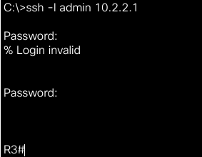

1. From the PC-A command prompt, issue a ping to 10.2.2.1. Explain your results.



**The ping was not successful because the only port that is allowed for 10.2.2.1 is 22 (ssh).**

**Step 2: Configure a named extended ACL on R3 for security policy number 3.**

From R3 privileged EXEC mode command prompt, issue the show ip interface s0/0/1 command. What, if any, is the name of the ACL? **WEB-POLICY.** In what direction is the ACL applied? ***Out.***

From PC-C command prompt, ping 209.165.200.225.



From PC-C command prompt, ping 10.1.1.1.



From PC-C command prompt, ping 209.165.201.1.



From PC-C command prompt, ping PC-A.



From PC-A command prompt, ping 209.165.200.225.



From PC-A command prompt, ping 209.165.201.1.



From PC-A command prompt, ping 10.1.1.1.



Part 4: Modify and Verify Extended ACLs

**Step 1: Modify ACL 100 on R1**

From R1 privileged EXEC mode, issue the show access-lists command. How many lines are there in this access list? **2 lines.**

<modifications>

Where did the new line that you just added appear in ACL 100? **As the third line.**

**Step 2: Modify ACL WEB-POLICY on R3**

From R3 privileged EXEC mode, issue the show access-lists command. How many lines are there in the access list? **2 lines**

<modifications>

**Step 3: Verify modified ACLs**

From PC-A, ping the IP address of PC-C.



From PC-C, ping the IP address of PC-A.



Reflection

Why is careful planning and testing of ACLs required? **Because it is very easy to block any important traffic that did not need to be blocked.**

Which type of ACL is better; standard or extended? **Both have their applications, standard is easier for general rules and extended for specific rules.**