# 41143117S 生科系古岷富

# DSCP Final Project – EDA: Airport Distance Analysis

## 1. Project Objective

In this project, I explored a dataset of global airports with the goal of analyzing the distance between different airport pairs. I wanted to understand how far major airports are from each other and to practice using Python libraries like geopy and matplotlib for data analysis and visualization.

## 2. Workflow Overview

The process I followed is summarized below:

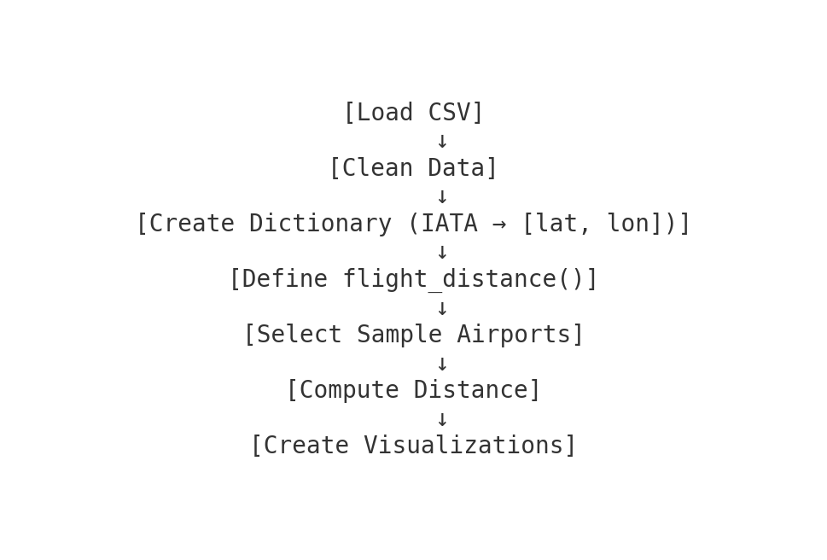

## 3. Code Logic and Method

I started by reading in a CSV file containing airport information, including IATA codes and coordinates. I filtered out entries missing valid data, and then created a dictionary that maps each airport code to its latitude and longitude. After that, I wrote a function called flight_distance() that uses geopy to calculate the distance between two airport locations. Finally, I selected a few airport pairs to compute and analyze their distances.

## 4. Data Visualizations

Here are two visualizations based on the airport data:

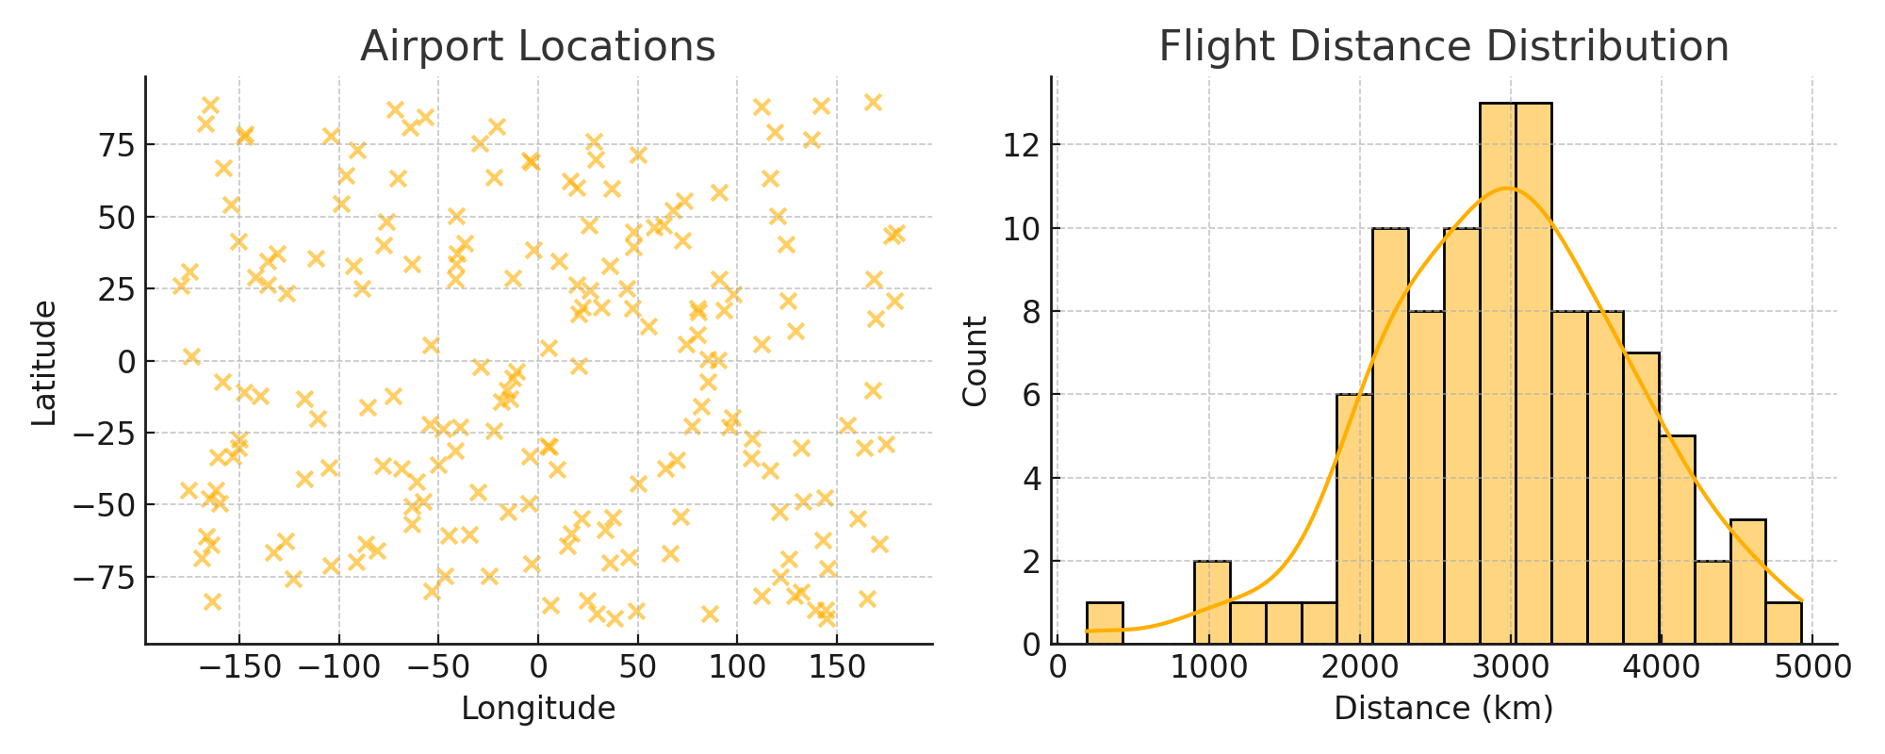

## 5. Reflections

This project helped me better understand how to work with real-world geographic data. If I had more time, I would explore clustering airports by region or plotting popular flight routes. I also learned how to transform raw CSV data into usable Python structures for analysis.

## 6. GitHub

## 7. Optional Video/Audio Script

The following is my transcript :

Hi, this is my final project for DSCP. I analyzed global airport data and created a tool to calculate the distance between two airports using Python. I also plotted some visualizations to better understand the data. You can find the full code and results on my GitHub page. Thank you!