01/22/2023, 8:30am, 10:30am: Sunday Worship

Online worship: https://www.maranatha.tv/live/videos/weekend-service-sunday-at-8-30am-37

Class Note: <https://static1.squarespace.com/static/5e4c80df9c80885b56806c76/t/63cc8f63544ad9429ba142ff/1674350447356/DanielNotes012223.pdf>



Today’s Topic: We want to see Jesus

# **John 12:12-33**

# **New International Version**

### Jesus Comes to Jerusalem as King

**12**The next day the great crowd that had come for the festival heard that Jesus was on his way to Jerusalem. **13**They took palm branches and went out to meet him, shouting,

“Hosanna![[a](https://www.biblegateway.com/passage/?search=John%2012%3A12-33&version=NIV#fen-NIV-26594a)]”

“Blessed is he who comes in the name of the Lord!”[[b](https://www.biblegateway.com/passage/?search=John%2012%3A12-33&version=NIV#fen-NIV-26594b)]

“Blessed is the king of Israel!”

**14**Jesus found a young donkey and sat on it, as it is written:

**15**“Do not be afraid, Daughter Zion;  
    see, your king is coming,  
    seated on a donkey’s colt.”[[c](https://www.biblegateway.com/passage/?search=John%2012%3A12-33&version=NIV#fen-NIV-26596c)]

**16**At first his disciples did not understand all this. Only after Jesus was glorified did they realize that these things had been written about him and that these things had been done to him.

**17**Now the crowd that was with him when he called Lazarus from the tomb and raised him from the dead continued to spread the word. **18**Many people, because they had heard that he had performed this sign, went out to meet him. **19**So the Pharisees said to one another, “See, this is getting us nowhere. Look how the whole world has gone after him!”

### Jesus Predicts His Death

**20**Now there were some Greeks among those who went up to worship at the festival. **21**They came to Philip, who was from Bethsaida in Galilee, with a request. “Sir,” they said, “we would like to see Jesus.” **22**Philip went to tell Andrew; Andrew and Philip in turn told Jesus.

**23**Jesus replied, “The hour has come for the Son of Man to be glorified. **24**Very truly I tell you, unless a kernel of wheat falls to the ground and dies, it remains only a single seed. But if it dies, it produces many seeds. **25**Anyone who loves their life will lose it, while anyone who hates their life in this world will keep it for eternal life. **26**Whoever serves me must follow me; and where I am, my servant also will be. My Father will honor the one who serves me.

**27**“Now my soul is troubled, and what shall I say? ‘Father, save me from this hour’? No, it was for this very reason I came to this hour. **28**Father, glorify your name!”

Then a voice came from heaven, “I have glorified it, and will glorify it again.” **29**The crowd that was there and heard it said it had thundered; others said an angel had spoken to him.

**30**Jesus said, “This voice was for your benefit, not mine. **31**Now is the time for judgment on this world; now the prince of this world will be driven out. **32**And I, when I am lifted up[[d](https://www.biblegateway.com/passage/?search=John%2012%3A12-33&version=NIV#fen-NIV-26613d)] from the earth, will draw all people to myself.” **33**He said this to show the kind of death he was going to die.

Explanation:

1. What is hosanna in the Bible?

It's from a Biblical Hebrew phrase meaning "**Pray, save us**."

2. What does it mean to be a daughter of Zion?

Biblical phrase: 'Daughter of Zion' generally refers to **Jerusalem or the Jewish people**.

3. Colt: **A colt is a young male donkey which is less than four years of age**.

Pray:

Lord, we pray to clear out the confusion with the name of Jesus.



Jesus was crucified before the Passover.

He was on the Donkey’s Colt.



**I. THE KING HAS COME - verses 12-19**

Explanation:



There handful stories in the Bible say about this.

You can see repeatedly in Bible.

This is the lamb selection day. We cannot find any fault on Jesus.

Jesus is a lamb for us. This is a national pride for Israel. This is the Jesus from Nazareth, North of Jerusalem. The whole Jerusalem city dancing and welcome Jesus. This is the people long for.

They are “Hosanna”. Bless the king of Israel.

Explanation:

**12**The next day the great crowd that had come for the festival heard that Jesus was on his way to Jerusalem. **13**They took palm branches and went out to meet him, shouting,

“Hosanna![[a](https://www.biblegateway.com/passage/?search=John%2012%3A12-33&version=NIV#fen-NIV-26594a)]”

“Blessed is he who comes in the name of the Lord!”[[b](https://www.biblegateway.com/passage/?search=John%2012%3A12-33&version=NIV#fen-NIV-26594b)]

“Blessed is the king of Israel!”

**14**Jesus found a young donkey and sat on it, as it is written:

**15**“Do not be afraid, Daughter Zion;  
    see, your king is coming,  
    seated on a donkey’s colt.”[[c](https://www.biblegateway.com/passage/?search=John%2012%3A12-33&version=NIV#fen-NIV-26596c)]

**16**At first his disciples did not understand all this. Only after Jesus was glorified did they realize that these things had been written about him and that these things had been done to him.

**17**Now the crowd that was with him when he called Lazarus from the tomb and raised him from the dead continued to spread the word. **18**Many people, because they had heard that he had performed this sign, went out to meet him. **19**So the Pharisees said to one another, “See, this is getting us nowhere. Look how the whole world has gone after him!”

Explanation:

**II. A DIFFERENT KIND OF KING**

Explanation:



People cheer him as different kind of king, not political king.

Some people cheer “crucified him”. King ride on a horse and come out as conquer.

Jesus is the humble king ride on a Donkey.

**III. BRING PEOPLE TO JESUS - verses 20-22**

Explanation:



People: “We would like to see Jesus.” Andrew brings Jesus to see them.

Andrew was Jesus first disciple. Andrew always bring people to Jesus.

Explanation:

**20**Now there were some Greeks among those who went up to worship at the festival. **21**They came to Philip, who was from Bethsaida in Galilee, with a request. “Sir,” they said, “we would like to see Jesus.” **22**Philip went to tell Andrew; Andrew and Philip in turn told Jesus.

Explanation:

**• Those who are wise will shine like the brightness of the heavens, and those who lead many to righteousness, like the stars for ever and ever. - Daniel 12:3**

Explanation:

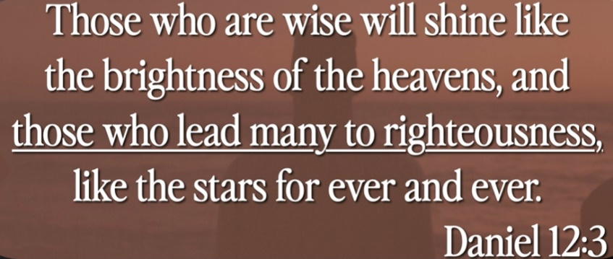

Explanation:

# **Daniel 12:3**

# **New International Version**

**3**Those who are wise[[a](https://www.biblegateway.com/passage/?search=Daniel%2012%3A3&version=NIV#fen-NIV-22085a)] will shine like the brightness of the heavens, and those who lead many to righteousness, like the stars for ever and ever.

Explanation:

Andrew is bright to show Jesus to people. Bring people to church.

1. What did Andrew do in the Bible?

Andrew was one of the four disciples who **came to Jesus on the Mount of Olives to ask about the signs of Jesus' return at the "end of the age"**. Eusebius in his Church History 3.1 quoted Origen as saying that Andrew preached in Scythia.

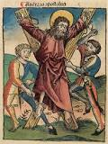

2. In the Bible, Andrew was **one of the Twelve Disciples of Jesus Christ and the brother of Simon Peter**. Andrew was the first apostle called by Jesus and the first to proclaim Jesus as the Messiah. He is the patron saint of Scotland and Russia

What was special about the Apostle Andrew?

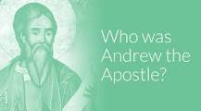

3. Andrew was **the first apostle Jesus called and the first apostle to claim Jesus was the Messiah**. Despite his seemingly important role as an early follower of Christ, Andrew is only mentioned 12 times in the entire New Testament—and four of those times are simply lists of the 12 apostles.

4. What was Peter in the Bible known for?

Peter is known for **denying Jesus three times**. Peter was the first apostle to go see Jesus' empty tomb. Peter took on a leadership role in the early church, after Jesus' ascension into heaven. The biblical books 1 Peter and 2 Peter are attributed to Peter.

5. What kind of person was Peter in the Bible?

Peter exhibits the character of **an outspoken leader of the disciples, willing to challenge Jesus actions and teachings** (John 13:6). Although quick to commit to Jesus' challenges (John 13:9), he is unsteady in demonstrating his commitment during Jesus' time of suffering (John 18:15, 25).

6. Why did God choose Peter?

Jesus chose Peter. The main reason could not be Peter's character of his strength, but rather **the strength of his faith**. Deep down he knew himself to be weak and imperfect, hence he was convinced that his total security and strength could only come from a power greater than his own

**IV. THE GLORY OF THE CROSS - verses 23-33**

Explanation:

1. Open heard,

2. Ask God to come. Hear the voice of God.

3. “Now the time is come. The voice is for your benefit, not mime.”

The crux is draw on me. Now, this is time for judge. Father will forgive what you did on me. Your sin will be washed away. You will remember my blood is done for you. The crux is defeating my sin. All you have do is to read the Bible and remember me. His die for us.

Explanation:

**23**Jesus replied, “The hour has come for the Son of Man to be glorified. **24**Very truly I tell you, unless a kernel of wheat falls to the ground and dies, it remains only a single seed. But if it dies, it produces many seeds. **25**Anyone who loves their life will lose it, while anyone who hates their life in this world will keep it for eternal life. **26**Whoever serves me must follow me; and where I am, my servant also will be. My Father will honor the one who serves me.

**27**“Now my soul is troubled, and what shall I say? ‘Father, save me from this hour’? No, it was for this very reason I came to this hour. **28**Father, glorify your name!”

Then a voice came from heaven, “I have glorified it, and will glorify it again.” **29**The crowd that was there and heard it said it had thundered; others said an angel had spoken to him.

**30**Jesus said, “This voice was for your benefit, not mine. **31**Now is the time for judgment on this world; now the prince of this world will be driven out. **32**And I, when I am lifted up[[d](https://www.biblegateway.com/passage/?search=John%2012%3A12-33&version=NIV#fen-NIV-26613d)] from the earth, will draw all people to myself.” **33**He said this to show the kind of death he was going to die.

Explanation:

Summary of Today’s Topic: We want to see Jesus

1. Nazareth Jesus come to Jerusalem and ride a donkey. Jesus is another kind of king, not political kind. The political king rides the horse, Jesus rides the donkey colt (small donkey).

2. Andrew (Peter Brother) introduce Jesus to people. Andrew was **the first apostle Jesus called and the first apostle to claim Jesus was the Messiah**.

3. We have three things to do:

a. Open heard, b. Ask God to come. Hear the voice of God. c. “Now the time is come. The voice is for your benefit, not mime.” The crux is draw on Jesus. Now, this is time for judge. Father will forgive what you did on me. Your sin will be washed away. You will remember my blood is done for you. The crux is defeating my sin. All you have do is to read the Bible and remember me. His die for us.