02/05/2023, 8:30am, 10:30am: Sunday Worship

Online worship: https://www.maranatha.tv/live/videos/weekend-service-sunday-at-8-30am-37

Class Note: <https://static1.squarespace.com/static/5e4c80df9c80885b56806c76/t/63df033307ab0a77b37c3d59/1675559738069/DanielNotes020523.pdf>



Today’s Topic: Dirty Feet

Explanation:

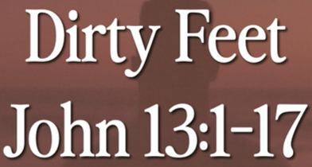

John 12:1-17 is a beautiful chapter in Bible.

Gregorian calendar

Hebrew calendar: Shevat month. Shevat is associated with tree. This month is about the harvest. We have trees in plant in the river of water. We inspect ourself about the tree and food.

Explanation:

# **John 13:1-17**

# **New International Version**

### Jesus Washes His Disciples’ Feet

**13**It was just before the Passover Festival. Jesus knew that the hour had come for him to leave this world and go to the Father. Having loved his own who were in the world, he loved them to the end.

**2**The evening meal was in progress, and the devil had already prompted Judas, the son of Simon Iscariot, to betray Jesus. **3**Jesus knew that the Father had put all things under his power, and that he had come from God and was returning to God; **4**so he got up from the meal, took off his outer clothing, and wrapped a towel around his waist. **5**After that, he poured water into a basin and began to wash his disciples’ feet, drying them with the towel that was wrapped around him.

**6**He came to Simon Peter, who said to him, “Lord, are you going to wash my feet?”

**7**Jesus replied, “You do not realize now what I am doing, but later you will understand.”

**8**“No,” said Peter, “you shall never wash my feet.”

Jesus answered, “Unless I wash you, you have no part with me.”

**9**“Then, Lord,” Simon Peter replied, “not just my feet but my hands and my head as well!”

**10**Jesus answered, “Those who have had a bath need only to wash their feet; their whole body is clean. And you are clean, though not every one of you.” **11**For he knew who was going to betray him, and that was why he said not every one was clean.

**12**When he had finished washing their feet, he put on his clothes and returned to his place. “Do you understand what I have done for you?” he asked them. **13**“You call me ‘Teacher’ and ‘Lord,’ and rightly so, for that is what I am. **14**Now that I, your Lord and Teacher, have washed your feet, you also should wash one another’s feet. **15**I have set you an example that you should do as I have done for you. **16**Very truly I tell you, no servant is greater than his master, nor is a messenger greater than the one who sent him. **17**Now that you know these things, you will be blessed if you do them.



Explanation:

This is the hour to leave this world and return to his father.

12 chapters for 7 years and 3 chapters for leaving this world.

The last meal before he went to the cross. One is significance is love. He love them completely.

He love them before he leaves this world.

Explanation:

**• And I pray that you are being rooted and established in love may have power, together with all the Lord’s holy people, to grasp how wide and long and high and deep is the love of Christ, and to know this love that surpasses knowledge. - Ephesians 3:17-19**

Explanation:

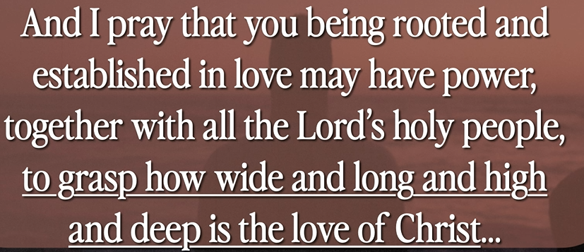



# **Ephesians 3:17-19**

# **New International Version**

**17**so that Christ may dwell in your hearts through faith. And I pray that you, being rooted and established in love, **18**may have power, together with all the Lord’s holy people, to grasp how wide and long and high and deep is the love of Christ, **19**and to know this love that surpasses knowledge—that you may be filled to the measure of all the fullness of God.

Explanation:

Before you come to this world. God already known you. His love is everywhere for you.

**I. DIRTY FEET**

Explanation:

The meal is the last meal in the world. The king should serve us.

Jesus is the humble king. He is serving us.

The Korea king carries the toilet all over the world.

You know who you are and you did what you do.

How do you love someone and serve someone for wash their feet.



You enter the home with dirty feet.

**• A dispute also arose among them as to which of them was considered the greatest. And He said to them, ‘The kings of the Gentiles exercise lordship over them, and those who exercise authority over them are called ‘benefactors.’ But not so among you; on the contrary, he who is greatest among you, let him be as the younger, and he who governs as he who serves. For who is greater, he who sits at the table, or he who serves? Is it not he who sits at the table? Yet I am among you as the One who serves. - Luke 22:24-27**

Explanation:

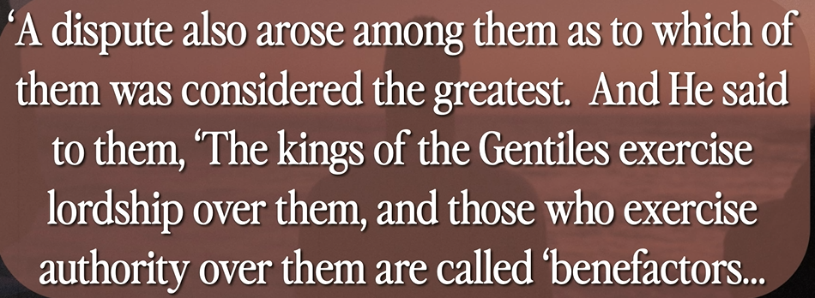

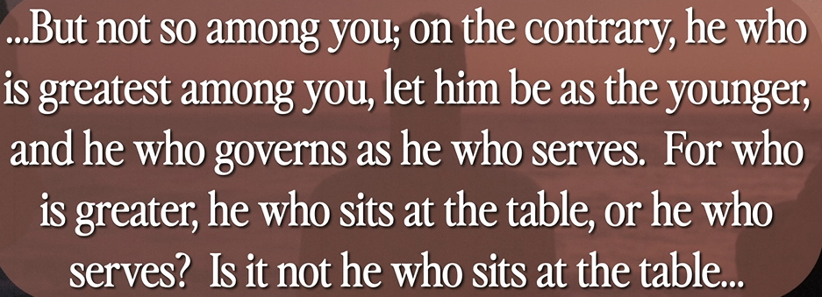



Explanation:

# **Luke 22:24-27**

# **New International Version**

**24**A dispute also arose among them as to which of them was considered to be greatest. **25**Jesus said to them, “The kings of the Gentiles lord it over them; and those who exercise authority over them call themselves Benefactors. **26**But you are not to be like that. Instead, the greatest among you should be like the youngest, and the one who rules like the one who serves. **27**For who is greater, the one who is at the table or the one who serves? Is it not the one who is at the table? But I am among you as one who serves.

Explanation:

When Jesus wash peter feet. Peter: “Are you sure you want to wash my feet?” Jesus: “I come to serve you.”

We have dirty feet and need Jesus to wash our feet.

**II. WASHED BY THE WORD**

**• Husbands, love your wives, just as Christ loved the church and gave himself up for her to make her holy, cleansing her by the washing with water through the word and to present her to Himself as a radiant church, without stain or wrinkle or any other blemish, but holy and blameless. - Ephesians 5:25-27**

Explanation:

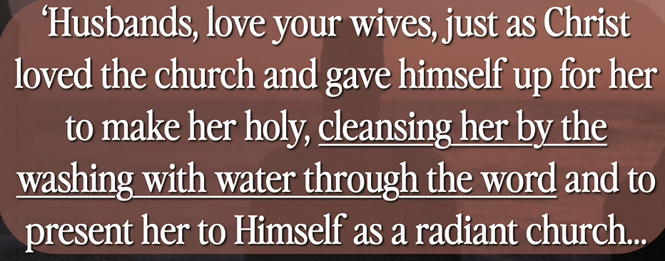

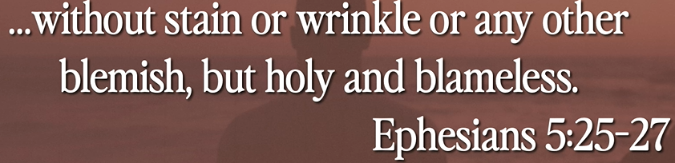

Explanation:

# **Ephesians 5:25-27**

# **New International Version**

**25**Husbands, love your wives, just as Christ loved the church and gave himself up for her **26**to make her holy, cleansing[[a](https://www.biblegateway.com/passage/?search=Ephesians%205%3A25-27&version=NIV#fen-NIV-29331a)] her by the washing with water through the word, **27**and to present her to himself as a radiant church, without stain or wrinkle or any other blemish, but holy and blameless.

Explanation:

Husband loves your wife wash their feet.

**III. A PARABLE AND PATTERN - verses 12-17**

Explanation:

**12**When he had finished washing their feet, he put on his clothes and returned to his place. “Do you understand what I have done for you?” he asked them. **13**“You call me ‘Teacher’ and ‘Lord,’ and rightly so, for that is what I am. **14**Now that I, your Lord and Teacher, have washed your feet, you also should wash one another’s feet. **15**I have set you an example that you should do as I have done for you. **16**Very truly I tell you, no servant is greater than his master, nor is a messenger greater than the one who sent him. **17**Now that you know these things, you will be blessed if you do them.

Explanation:

Do you understand that I done for you? You understand what I have done.

He humbles himself for serving. He loves heaven. He made himself nothing.

All other religious leaders are served by everybody. Jesus serves for us. Jesus is parable (a story) and humble. We surround Jesus Love. You are inherited the king Jesus and you serve your enemy.

Pray:

Thanks Lord come with us today. We can trust you in our mind and serve us.

Summary of today topic: “Jesus wash dirty feet for his 12 disciples in the last dinner”:

1. When Jesus wash Peter feet, Peter said to Jesus, "Lord, are You washing my feet?"

2. Jesus said to Peter, "What I am doing you do not understand now, but you will know after this."

3. Peter said to Jesus, "You shall never wash my feet!"

4. Jesus answered Peter, "If I do not wash you, you have no part with Me."

5. Peter said to Jesus, "Lord, not my feet only, but also my hands and my head!"

6. Jesus said to Peter, "Your feet are clean, but not all of you."

7. Jesus know someone betray Jesus; therefore, Jesus said, "You are not all clean."  
- John 13:6-11