02/19/2023, 8:30am, 10:30am: Sunday Worship

Online worship: https://www.maranatha.tv/live/videos/weekend-service-sunday-at-8-30am-37

Class Note:

<https://static1.squarespace.com/static/5e4c80df9c80885b56806c76/t/63f187033e1497697fe9283b/1676773132869/DanielNotes021923.pdf>

Today’s Topic: God’s Cure for Worry, Fear, and Anxiety



Explanation:

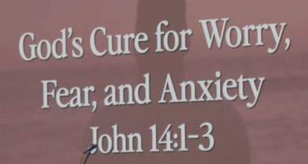



Pray:

Lord, your kingdom will come. Every conversation will be counted.

Joh chapter 13 to 17 are good to read.

Here, Peter tried to ignore Jesus three times.

Explanation:

John 14:1-3

### Jesus Comforts His Disciples

**14**“Do not let your hearts be troubled. You believe in God[[a](https://www.biblegateway.com/passage/?search=John%2014%3A1-3&version=NIV#fen-NIV-26670a)]; believe also in me. **2**My Father’s house has many rooms; if that were not so, would I have told you that I am going there to prepare a place for you? **3**And if I go and prepare a place for you, I will come back and take you to be with me that you also may be where I am.

**I. JESUS’ MESSAGE TO THOSE WITH TROUBLED HEARTS - verses 1-6**

Explanation:

**14**“Do not let your hearts be troubled. You believe in God[[a](https://www.biblegateway.com/passage/?search=John%2014%3A1-3&version=NIV#fen-NIV-26670a)]; believe also in me. **2**My Father’s house has many rooms; if that were not so, would I have told you that I am going there to prepare a place for you? **3**And if I go and prepare a place for you, I will come back and take you to be with me that you also may be where I am.

### Jesus the Way to the Father

**5**Thomas said to him, “Lord, we don’t know where you are going, so how can we know the way?”

**6**Jesus answered, “I am the way and the truth and the life. No one comes to the Father except through me.

Explanation:

Jesus, “Do to let your hearts in trouble.”



People shout and welcome Jesus when Jesus ride the donkey into the Jerusalem.

People are fear and anxiety about belief of God.

People worry the war between US and China in 2025. People worry about the job.

**II. JESUS SAYS, TRUST ME - verse 1B**

Explanation:

**14**“Do not let your hearts be troubled. You believe in God[[a](https://www.biblegateway.com/passage/?search=John%2014%3A1-3&version=NIV#fen-NIV-26670a)]; believe also in me.

Explanation:



Jesus says “Trust me”. To believe me and trust me.

**• Though you have not seen Him, you love Him; and even though you do not see Him now, you believe in Him and are filled with an inexpressible and glorious joy for you are receiving the end result of your faith, the salvation of your souls.- I Peter 1:8-9**

Explanation:

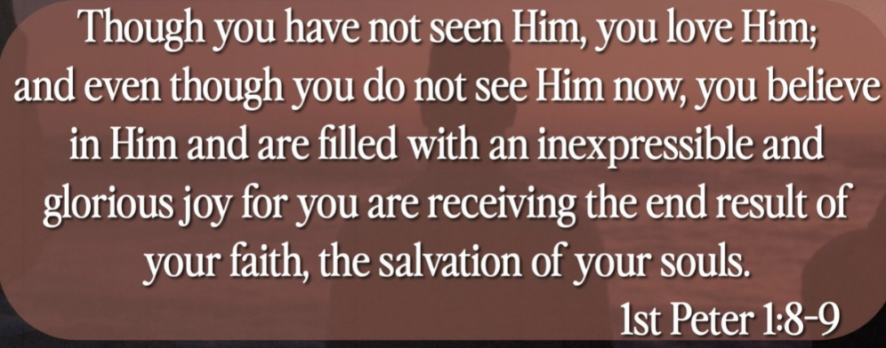

# **1 Peter 1:8-9**

# **New International Version**

**8**Though you have not seen him, you love him; and even though you do not see him now, you believe in him and are filled with an inexpressible and glorious joy, **9**for you are receiving the end result of your faith, the salvation of your souls.

Explanation:

Even though, you do not see Jesus. You believe in Jesus and filled with glorious.

Even you do not see physically in your side. You believe God and trust Jesus.

Jesus blessed us for 2000 years. Jesus promises us to come back.

**John Lennon: “I believe in God, but not as one thing, not as an old man in the sky. I believe that what people call God is something in all of us. I believe that what Jesus and Mohammed and Buddha and all the rest said was right. It's just that the translations have gone wrong.”**

**III. JESUS SAYS, “I’M COMING BACK FOR YOU” - verses 2-3**

Explanation:

**2**My Father’s house has many rooms; if that were not so, would I have told you that I am going there to prepare a place for you? **3**And if I go and prepare a place for you, I will come back and take you to be with me that you also may be where I am.

**• No eye has seen, no ear has heard, and no mind has imagined what God has prepared for those who love Him.- I Corinthians 2:9**

Explanation:

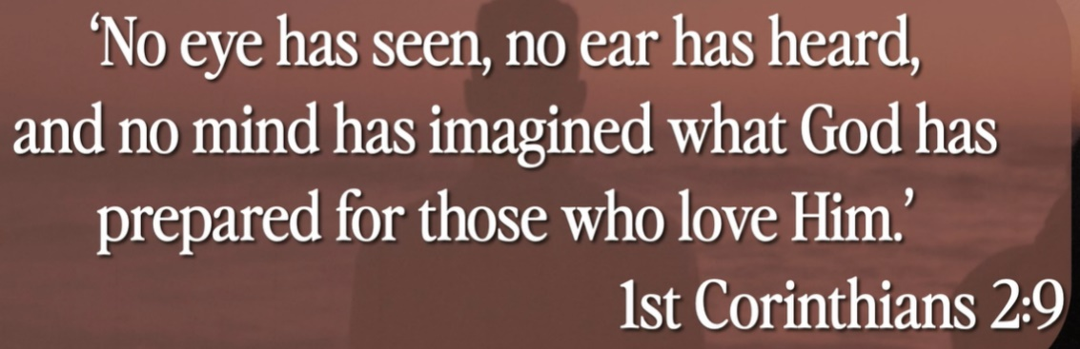

Explanation:

# **1 Corinthians 2:9**

# **New International Version**

**9**However, as it is written:

“What no eye has seen,  
    what no ear has heard,  
and what no human mind has conceived”[[a](https://www.biblegateway.com/passage/?search=1%20Corinthians%202%3A9&version=NIV#fen-NIV-28404a)]—  
    the things God has prepared for those who love him—

Explanation:

No more suffering, no more wars, no more security camera, no more sin, no more crime in heaven. Jesus prepares the rooms for everyone who believe Jesus.

**IV. AN ETERNAL HOME**

Explanation:



Explanation:

Jesus is preparing our eternal hone.

There something in your soul. Where is the mansion looks like? It is a track home? Jesus is going to prepare for us.

**• For we know that if the earthly tent we live in is destroyed, we have a building from God, an eternal house in heaven, not built by human hands. - 2 Corinthians 5:1**

Explanation:

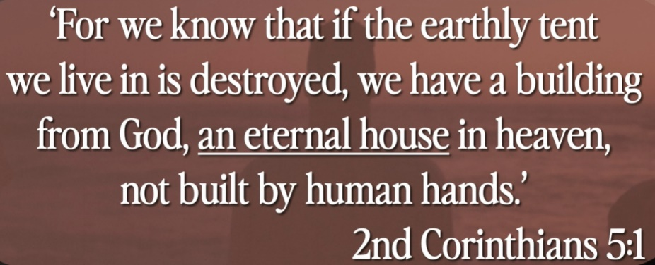

Explanation:

# **2 Corinthians 5:1**

# **King James Version**

**5**For we know that if our earthly house of this tabernacle were dissolved, we have a building of God, an house not made with hands, eternal in the heavens.

Explanation:

Corinthians (哥林多): Native live in Corinth. Corinth was capitol of Rome Province. Corinthians are famous for principle of fair and penalty. Corinth is significant because of apostle Paul’s missionary work.

Explanation:

If the tent is destroyed, the eternal home will build. Jesus is going to prepare a eternal room for us.

**V. THE JEWISH PERSPECTIVE**

Explanation:



Explanation:

The Jewish view of home, wedding, father of bribe for the new family.

Jesus, “This is the cup of new covenant with my blood which Jesus paid for.”

Similarly, In the wedding ceremony, Jesus said, “I am coming back to my father side and build the space for you.” Only my family know where is the room. The son excited the groom to their family.

**• For the Lord will descend from heaven with a shout, with the voice of an archangel, and with the trumpet of God. And the dead in Christ will rise first. Then we who are alive and remain shall be caught up together with them in the clouds to meet the Lord in the air. And thus, we shall always be with the Lord. Therefore comfort one another with these words. - I Thessalonians 4:16**

Explanation:

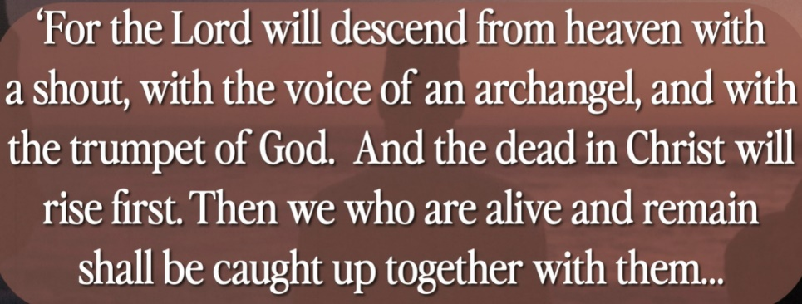

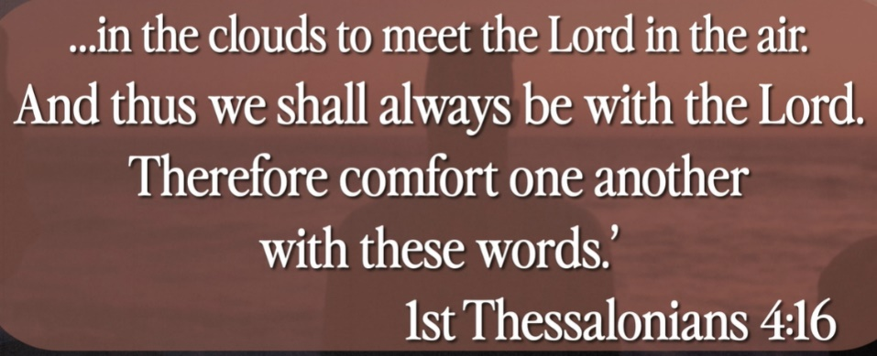

Explanation:

Thessalonian (帖撒罗尼迦): Thessalonians are native resident of Thessaloniki at Greece. In New Testament, there are two letters written by Paul to Christian of Thessalonica.

The bride room will come for you.

Jesus, “Trust me. Even though I left, I will come back and prepare the bride room for you.”

Summary of today topic: ”God’s Cure for Worry, Fear, and Anxiety”:

1. Corinthians (哥林多): Native live in Corinth. Corinth was capitol of Rome Province. Corinthians are famous for principle of fair and penalty. Corinth is significant because of apostle Paul’s missionary work.

2. Thessalonian (帖撒罗尼迦): Thessalonians are native resident of Thessaloniki at Greece. In New Testament, there are two letters written by Paul to Christian of Thessalonica.

3. When Jesus rides the donkey to go to the Jerusalem. People shout and welcome him.

4. Then Jesus prepares to die and prepare to be crucified.

5. People worry, anxious about the future. Jesus, “Do not worry. Trust me. Even though I left, I will come back and prepare the bride room for you.”

6. According to Jewish perspective, Father prepares the room for married couples. “Do not worry. I prepare for you and I will be back”