02/26/2023, 8:30am, 10:30am: Sunday Worship

Online worship: https://www.maranatha.tv/live/videos/weekend-service-sunday-at-8-30am-37

Class Note:

<https://static1.squarespace.com/static/5e4c80df9c80885b56806c76/t/63fab55d021cb92902a61d6b/1677374813481/DannyMCnotes2%3A26%3A23.pdf>



Today’s Topic: Prayer is th voice of the Church

Excerpt from Bible:

# **Romans 12:12**

# **New International Version**

**12**Be joyful in hope, patient in affliction, faithful in prayer.

Excerpt from Bible:

# **Acts 4:31**

# **New International Version**

**31**After they prayed, the place where they were meeting was shaken. And they were all filled with the Holy Spirit and spoke the word of God boldly.

Excerpt from Bible:

# **Psalm 34:18**

# **New International Version**

**18**The Lord is close to the brokenhearted and saves those who are crushed in spirit.

Pastor Danny Ramos:

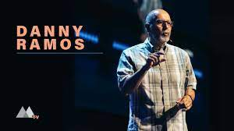

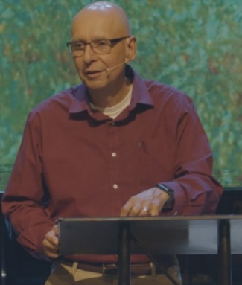

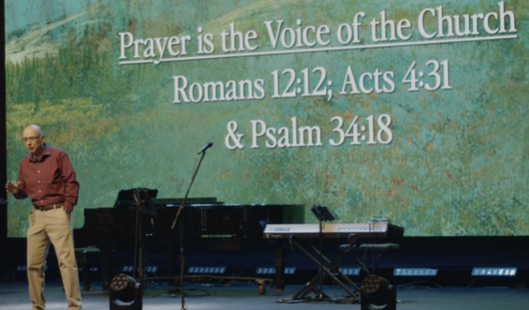

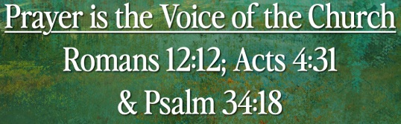

Explanation:

You are the voice of church,

You are the devoted prayer of Maranatha church.

Like the car, we need to rotate the tire and oil change from time to time.

We pray for people coughing around you.

Jesus was crucified and come back in three days. “I am not going to leave you here.”

We speak to God like speak to friends. Everyone pray is different.

Pray father to give us daily bread and love.

**“Prayer is a journey of our heart and mind to find our way to the table of God.” ~ Tyler Staton**

Explanation:

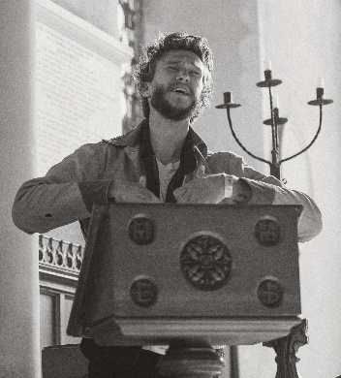

### **[Tyler Staton](https://www.tylerstaton.com/)**

[https://www.tylerstaton.com](https://www.tylerstaton.com/)

Bridgetown Church is a non-denominational, Spirit-enlivened church in the urban core of Portland, with a vision taken right off Jesus' praying lips. Tyler Staton is the lead pastor of Bridgetown church in Portland, Oregon.

Explanation:

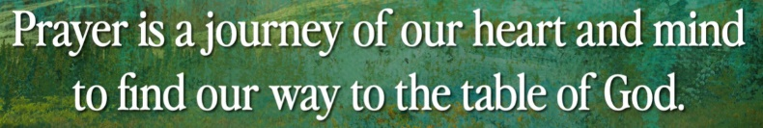

Pray by your own voice and will. Just like the manual transmission. Drive your own way. Stay in your lane and tie your seat belt.

**I. DEVOTED TO PRAYER - Romans 12:12**

Excerpt from Bible:

# **Romans 12:12**

# **New International Version**

**12**Be joyful in hope, patient in affliction, faithful in prayer.

Explanation:

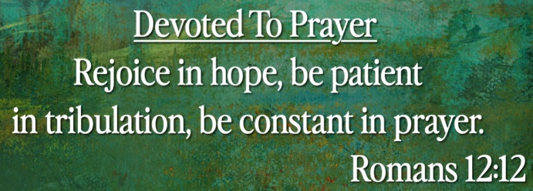

**• Rejoice in hope, be patient in tribulation, be constant in prayer.**

**“Devoted to pray will mean that you come to God often desperate and often delighted.” ~ John Piper**

Explanation:

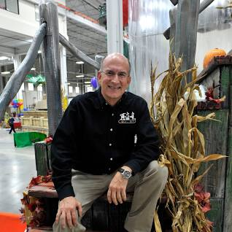

Explanation:

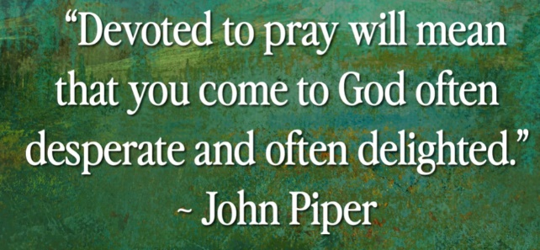

Come to God for devoted, desperate, and delighted pray. Pray will bring the God come to us.

**II. DEPENDENT ON PRAYER - Acts 4:31**

Excerpt from Bible:

# **Acts 4:31**

# **New International Version**

**31**After they prayed, the place where they were meeting was shaken. And they were all filled with the Holy Spirit and spoke the word of God boldly.

**• When they had prayed, the place in which they were gathered together was shaken, and they were all filled with the Holy Spirit and continued to speak the word of God with boldness.**

**III. COMFORTED BY PRAYER - Psalm 34:18**

Excerpt from Bible:

# **Psalm 34:18**

# **New International Version**

**18**The Lord is close to the brokenhearted and saves those who are crushed in spirit.

**• The LORD is near to the brokenhearted and saves the crushed in spirit.**

Explanation:

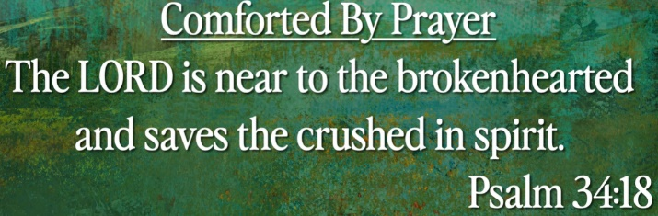

Explanation:

God did hear you but nothing happened.

**“We are not necessarily doubting that God will do the best for us; we are wondering how painful the best will turn out to be.” ~ C.S. Lewis**

Explanation:

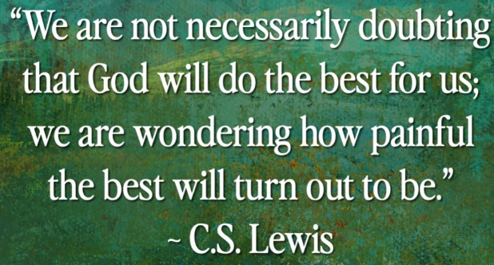

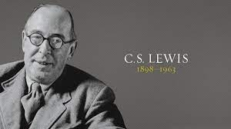

Summary of today topic: Prayer is th voice of the Church

Prayer is an act that seeks to activate a communication with God.

1. Prayer is a journey of our heart and mind to find God. Pray by your own voice and will. Just like the manual transmission. Drive your own way. . Stay in your lane and tie your seat belt.

2. When pray, we rejoice with hope, patient when we are in pain, faithful in mind, constant in pray.

3. Come to God for devoted, desperate, and delighted pray.

4. When we pray, the places are all filled with the Holy Spirit and speak the word of God.

5. The God is near to the brokenhearted and saves the spirit. God is hearing but sometimes do not respond.

6. We do not doubt that God will do the best for us.