03/05/2023, 8:30am, 10:30am: Sunday Worship

Online worship: https://www.maranatha.tv/live/videos/weekend-service-sunday-at-8-30am-37

Class Note:

<https://static1.squarespace.com/static/5e4c80df9c80885b56806c76/t/6403f5e77bb4393b737943e2/1677981165172/DanielNotes030523.pdf>



Today’s Topic: The Greater Life

Explanation:

What a blessing morning.

Hebrew month of this year: Sivan. Sivan mean “Season”.

You are the healing God, same living God.

Explanation:



Excerpt from Bible:

# **John 14:4-14**

# **New International Version**

**4**You know the way to the place where I am going.” Jesus the Way to the Father

**5**Thomas said to him, “Lord, we don’t know where you are going, so how can we know the way?”

**6**Jesus answered, “I am the way and the truth and the life. No one comes to the Father except through me. **7**If you really know me, you will know[[a](https://www.biblegateway.com/passage/?search=John%2014%3A4-14&version=NIV#fen-NIV-26676a)] my Father as well. From now on, you do know him and have seen him.”

**8**Philip said, “Lord, show us the Father and that will be enough for us.”

**9**Jesus answered: “Don’t you know me, Philip, even after I have been among you such a long time? Anyone who has seen me has seen the Father. How can you say, ‘Show us the Father’? **10**Do not you believe that I am in the Father, and that the Father is in me? The words I say to you I do not speak on my own authority. Rather, it is the Father, living in me, who is doing his work. **11**Believe me when I say that I am in the Father and the Father is in me; or at least believe on the evidence of the works themselves. **12**Very truly I tell you, whoever believes in me will do the works I have been doing, and they will do even greater things than these, because I am going to the Father. **13**And I will do whatever you ask in my name, so that the Father may be glorified in the Son. **14**You may ask me for anything in my name, and I will do it.

**I. THE NARROW WAY - verse 6**

Explanation:



Explanation:

**6**Jesus answered, “I am the way and the truth and the life. No one comes to the Father except through me.

Explanation:

All religious claim the way of life. Only Jesus said, I am the way.

Jesus claims the “I am the way.”

**II. THE ONLY WAY**

Explanation:



Explanation:

You may not believe the gravity. The gravity is everywhere no matter you believe or not. Every words have been proven is true. He is also the life.

Bio: Biological Life

Rauch: Spiritual life.

**• For whosoever shall call upon the name of the Lord shall be saved. - Romans 10:13**

Explanation:

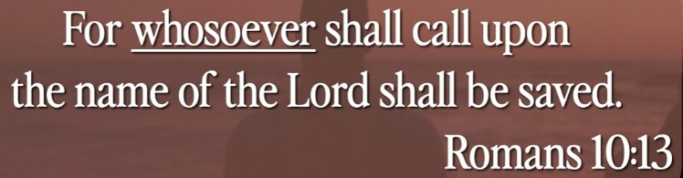

Explanation:

# **Romans 10:13**

# **New International Version**

**13**for, “Everyone who calls on the name of the Lord will be saved.”

Explanation:

This is easy version to call the Father.

**• One thing have I desired of the Lord and that will I seek after; that I may dwell in the house of the Lord all the days of my life, to behold the beauty of the Lord and to enquire in His temple. - Psalm 27:4**

Explanation:

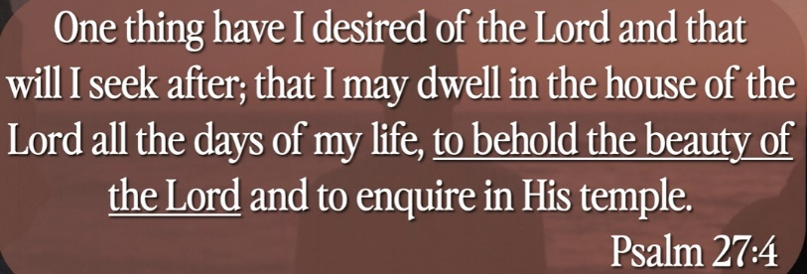

Explanation:

# **Psalm 27:4**

# **New International Version**

**4**One thing I ask from the Lord, this only do I seek: that I may dwell in the house of the Lord  
    all the days of my life, to gaze on the beauty of the Lord and to seek him in his temple.

Explanation:

Psalm: **詩篇**

Explanation:

Show me the way. Any time you get the present of the God, we will very please, I promise.

Keep the eye open with the god.

**III. THE REVELATION OF THE FATHER - verses 9-11**

Explanation:



Explanation:

**9**Jesus answered: “Don’t you know me, Philip, even after I have been among you such a long time? Anyone who has seen me has seen the Father. How can you say, ‘Show us the Father’? **10**Do not you believe that I am in the Father, and that the Father is in me? The words I say to you I do not speak on my own authority. Rather, it is the Father, living in me, who is doing his work. **11**Believe me when I say that I am in the Father and the Father is in me; or at least believe on the evidence of the works themselves.

**• No one has ever seen God, but the one and only Son, who is Himself God and is in closest relationship with the Father, has made Him known. - John 1:18**

Explanation:

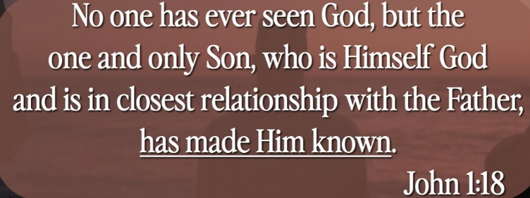

Explanation:

# **John 1:18**

# **New International Version**

**18**No one has ever seen God, but the one and only Son, who is himself God and[[a](https://www.biblegateway.com/passage/?search=John%201%3A18&version=NIV#fen-NIV-26063a)] is in closest relationship with the Father, has made him known.

Explanation:

No one has ever seen God except Jesus who is the son of God. The picture is clearer but still fuzzy.

**IV. THE GREATER LIFE - verses 12-14**

Explanation:



Explanation:

**12**Very truly I tell you, whoever believes in me will do the works I have been doing, and they will do even greater things than these, because I am going to the Father. **13**And I will do whatever you ask in my name, so that the Father may be glorified in the Son. **14**You may ask me for anything in my name, and I will do it.

Explanation:

The greater life is with greater way is to follow him. We ask for greater alignment with our experience with God. Jesus empty himself as a servant for human being. We align with God and walk in independently to the God world.

**• Now to Him who is able to do immeasurably more than all we ask or imagine, according to His power that is at work within us. - Ephesians 3:20**

Explanation:

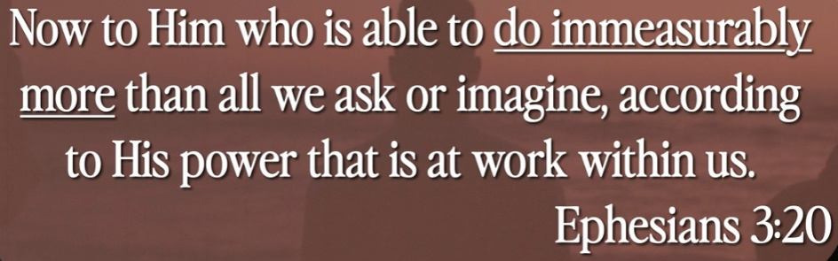

Explanation:

# **Ephesians 3:20**

# **New International Version**

**20**Now to him who is able to do immeasurably more than all we ask or imagine, according to his power that is at work within us,

Explanation:

Ephesians: 以弗所書

Explanation:

God is the partner to work with you.

Summary of Today’s Topic: The Greater Life

1. Hebrew Calendar of this month: Sivan: means “Season”

2. Hebrew words:

Bio: Biological Life

Rauch: Spiritual life.

3. No one has ever seen God except Jesus who is the son of God.

4. The greater life is with greater way is to follow God. We ask for greater alignment with our experience with God.

5. God is the partner to work you.