03/12/2023, 8:30am, 10:30am: Sunday Worship

Online worship: https://www.maranatha.tv/live/videos/weekend-service-sunday-at-8-30am-37

Class Note:

<https://static1.squarespace.com/static/5e4c80df9c80885b56806c76/t/640d28cee1eea35daa478e8a/1678584020756/DanielNotes031223.pdf>

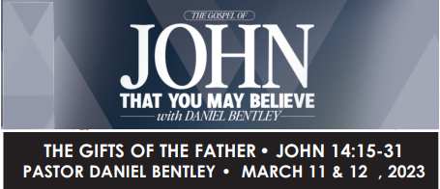

Today’s Topic: The Gifts of the Father

Explanation:

# **John 14:15-31**

# **New International Version**

### Jesus Promises the Holy Spirit

**15**“If you love me, keep my commands. **16**And I will ask the Father, and he will give you another advocate to help you and be with you forever— **17**the Spirit of truth. The world cannot accept him, because it neither sees him nor knows him. But you know him, for he lives with you and will be[[a](https://www.biblegateway.com/passage/?search=John%2014%3A15-31&version=NIV#fen-NIV-26686a)] in you. **18**I will not leave you as orphans; I will come to you. **19**Before long, the world will not see me anymore, but you will see me. Because I live, you also will live. **20**On that day you will realize that I am in my Father, and you are in me, and I am in you. **21**Whoever has my commands and keeps them is the one who loves me. The one who loves me will be loved by my Father, and I too will love them and show myself to them.”

**22**Then Judas (not Judas Iscariot) said, “But, Lord, why do you intend to show yourself to us and not to the world?”

**23**Jesus replied, “Anyone who loves me will obey my teaching. My Father will love them, and we will come to them and make our home with them. **24**Anyone who does not love me will not obey my teaching. These words you hear are not my own; they belong to the Father who sent me.

**25**“All this I have spoken while still with you. **26**But the Advocate, the Holy Spirit, whom the Father will send in my name, will teach you all things and will remind you of everything I have said to you. **27**Peace I leave with you; my peace I give you. I do not give to you as the world gives. Do not let your hearts be troubled and do not be afraid.

**28**“You heard me say, ‘I am going away and I am coming back to you.’ If you loved me, you would be glad that I am going to the Father, for the Father is greater than I. **29**I have told you now before it happens, so that when it does happen you will believe. **30**I will not say much more to you, for the prince of this world is coming. He has no hold over me, **31**but he comes so that the world may learn that I love the Father and do exactly what my Father has commanded me.

“Come now; let us leave.

Explanation:

Advocate: direction

**Judas Iscariot:** Judas Iscariot is one of the original Twelve Apostles of Jesus Christ. Judas betrayed Jesus.

Announcement:

Maranatha TV is in the transition of moving into YouTube due to three reasons:

1. YouTube is Free

2. YouTube is big and we want to go into the world to meet more people

3. We can mentor more people.

Pray:

We overflow the spirit and power of life.

We discuss “The Gifts of the Father”.

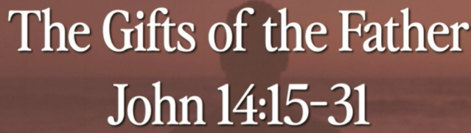

Father gives us the incredible gift. The gift of love is obedient.

The love and obedient are two sided. The 10-commandment is obedient.

**Does the LORD delight in burnt offerings and sacrifices as much as in obeying the LORD? To obey is better than sacrifice, and to heed is better than the fat of rams.’ - I Samuel 15:22**

Explanation:

# **1 Samuel 15:22**

# **New International Version**

**22**But Samuel replied: “Does the Lord delight in burnt offerings and sacrifices  
    as much as in obeying the Lord?  
To obey is better than sacrifice, and to heed is better than the fat of rams.

Explanation:

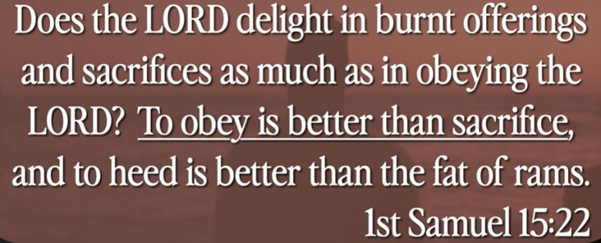

We want to obey is better than the sacrifice.

The obedient is better.

**I. THE GIFT OF THE HOLY SPIRIT - verses 16-18**

Explanation:

**16**And I will ask the Father, and he will give you another advocate to help you and be with you forever— **17**the Spirit of truth. The world cannot accept him, because it neither sees him nor knows him. But you know him, for he lives with you and will be[[a](https://www.biblegateway.com/passage/?search=John%2014%3A15-31&version=NIV#fen-NIV-26686a)] in you. **18**I will not leave you as orphans; I will come to you.

Explanation:



What is the holy spirit? “The spirit of truth.”

In the court room, Jesus was sentenced to death.

**• The Spirit itself bears witness with our spirit that we are children of God, and if children, then heirs of God and joint heirs with Christ, if only we suffer with Him so that we may also be glorified with Him. - Romans 8:16**

Explanation:

# **Romans 8:16**

# **New International Version**

**16**The Spirit himself testifies with our spirit that we are God’s children.

Explanation:

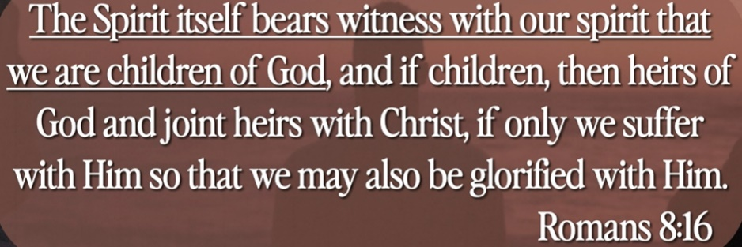

The holy spirit witness we are children of God. The Bible is hard to understand and is full of holy spirit. The Bible reveal and remind us the holy spirit.

**II. THE SPIRIT WITH US, IN US, AND UPON US - verse17c**

Explanation:

— **17**the Spirit of truth. The world cannot accept him, because it neither sees him nor knows him. But you know him, for he lives with you and will be[[a](https://www.biblegateway.com/passage/?search=John%2014%3A15-31&version=NIV#fen-NIV-26686a)] in you.

Explanation:

Wind, breath, and spirit are the same word in Hebrew.

**• You will receive power when the Holy Spirit comes on you; and you will be My witnesses in Jerusalem, and in all Judea and Samaria, and to the ends of the earth. - Acts 1:8**

Explanation:

# **Acts 1:8**

# **New International Version**

**8**But you will receive power when the Holy Spirit comes on you; and you will be my witnesses in Jerusalem, and in all Judea and Samaria, and to the ends of the earth.”

Explanation:

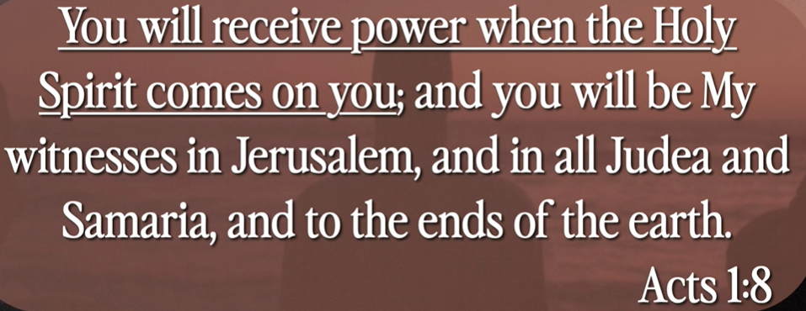

The Holy spirit come into us.

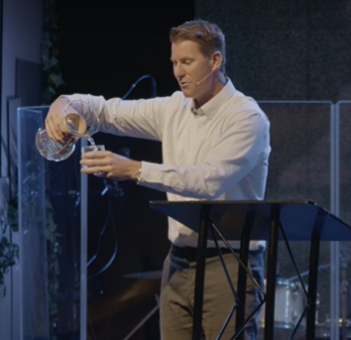

The holy spirit is fill with us and overflow. Holy spirit spills it out and fill it up.

**III. THE GIFT OF HIS PRESENCE - verses 19-24**

Explanation:

**19**Before long, the world will not see me anymore, but you will see me. Because I live, you also will live. **20**On that day you will realize that I am in my Father, and you are in me, and I am in you. **21**Whoever has my commands and keeps them is the one who loves me. The one who loves me will be loved by my Father, and I too will love them and show myself to them.”

**22**Then Judas (not Judas Iscariot) said, “But, Lord, why do you intend to show yourself to us and not to the world?”

**23**Jesus replied, “Anyone who loves me will obey my teaching. My Father will love them, and we will come to them and make our home with them. **24**Anyone who does not love me will not obey my teaching. These words you hear are not my own; they belong to the Father who sent me.

Explanation:

You obedient, then holy spirit

1. Present

2. spread out

3. fill it up.

**• Do you not know that your bodies are temples of the Holy Spirit, who is in you, whom you have received from God? You are not your own; you were bought at a price. Therefore, honor God with your bodies. - I Corinthians 6:19-20**

Explanation:

# **1 Corinthians 6:19-20**

# **New International Version**

**19**Do you not know that your bodies are temples of the Holy Spirit, who is in you, whom you have received from God? You are not your own; **20**you were bought at a price. Therefore, honor God with your bodies.

Explanation:

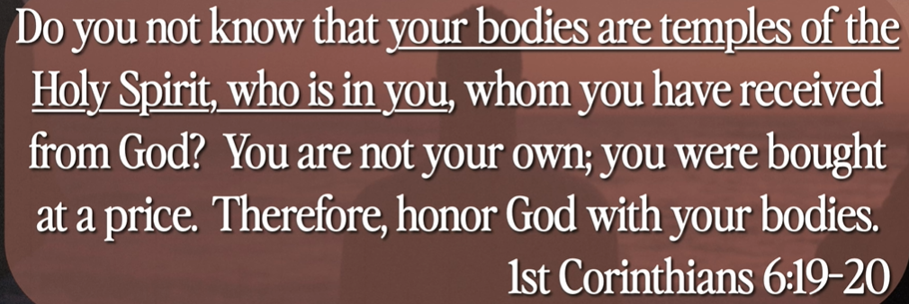

Your body is the home of the Holy Spirit.

**IV. THE GIFT OF HIS PEACE - verses 27-31**

Explanation:

**27**Peace I leave with you; my peace I give you. I do not give to you as the world gives. Do not let your hearts be troubled and do not be afraid.

**28**“You heard me say, ‘I am going away and I am coming back to you.’ If you loved me, you would be glad that I am going to the Father, for the Father is greater than I. **29**I have told you now before it happens, so that when it does happen you will believe. **30**I will not say much more to you, for the prince of this world is coming. He has no hold over me, **31**but he comes so that the world may learn that I love the Father and do exactly what my Father has commanded me.

“Come now; let us leave.

Explanation:



Pray the Lord, let the peace holy spirt come into your life. This holy spirit keeps you secure and peace. The holy spirit defeats the devil. His victory is our victory. The holy spirit stops the turbulent of the life.

Summary of Today Topic: The Gifts of the Father

1. Announcement: Maranatha TV is in the transition of moving into YouTube due to three reasons:

1). YouTube is Free

2). YouTube is big and we want to go into the world to meet more people

3). We can mentor more people.

2. What is the holy spirit? “The spirit of truth.”

3. The holy spirit witness we are children of God. The Bible is hard to understand and is full of holy spirit.

4. The Holy spirit come around us. Wind, breath, and spirit are the same word in Hebrew.

5. The Holy spirit come into us. The holy spirit is fill with us and overflow.

6. You obedient, then holy spirit

1). Present

2). spread out

3). fill it up.

7. Your body is the home of the Holy Spirit.

8. Pray the Lord, let the peace holy spirt come into your life. This holy spirit keeps you secure and peace. The holy spirit defeats the devil. His victory is our victory. The holy spirit stops the turbulent of the life.