03/19/2023, 8:30am, 10:30am: Sunday Worship

Online worship: https://www.maranatha.tv/live/videos/weekend-service-sunday-at-8-30am-37

Class Note:

<https://static1.squarespace.com/static/5e4c80df9c80885b56806c76/t/640d28cee1eea35daa478e8a/1678584020756/DanielNotes031223.pdf>



Today’s Topic: Finding Peace in the Chaos

Explanation:



Explanation:

Over the years, people try to bring peace to world, no matter Vietnamese war, etc.

Bible excerption:

# **John 14:27**

# **New International Version**

**27**Peace I leave with you; my peace I give you. I do not give to you as the world gives. Do not let your hearts be troubled and do not be afraid.

Explanation:

Peace of mind and peach of desire.

**I. THE WORLD’S PEACE**

Explanation:



Explanation:

Everyone needs a vocation and better job. Every one need a vacation to solve problem. All of them bring the peace we want. No matter where are you, you can go to everywhere you want.

Hawaii has bird singing, blue sky, etc.

There are external circumstances. You lost your job, the peace goes away.

The peace is fragile.

**II. A DIFFERENT KIND OF PEACE**

Explanation:



Jesus said, “I give you the peace.”

Jesus gives us different kind of peace. It is not external peace.

Jesus gives us the internal world of peace to conquer the world.

In Hebrew, Shalom, “good bye with peace.”

**III. TWO EXPRESSIONS OF GOD’S PEACE**

Explanation:



Peace with God and Peace of God.

**• ‘Therefore, since we have been justified through faith, we have peace with God through our Lord Jesus Christ. Through whom we have gained access by faith into this grace in which we now stand. And we boast in the hope of the glory of God.’ - Romans 5:1-2**

Bible excerption:

# **Romans 5:1-2**

# **New International Version**

### Peace and Hope

**5**Therefore, since we have been justified through faith, we[[a](https://www.biblegateway.com/passage/?search=Romans+5%3A1-2&version=NIV#fen-NIV-28049a)] have peace with God through our Lord Jesus Christ, **2**through whom we have gained access by faith into this grace in which we now stand. And we[[b](https://www.biblegateway.com/passage/?search=Romans+5%3A1-2&version=NIV#fen-NIV-28050b)] boast in the hope of the glory of God.

Explanation:

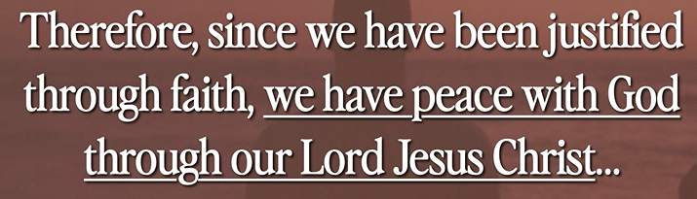

Bible excerption:

**• Do not be anxious about anything, but in every situation, by prayer and petition, with thanksgiving, present your requests to God. And the peace of God, which transcends all understanding, will guard your hearts and your minds in Christ Jesus. - Philippians 4:7-8**

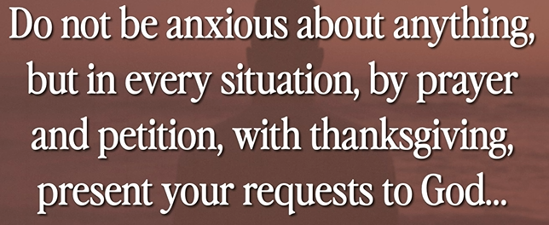

Explanation:

This is peace of God.

The enemy constantly attack us. The sin attack peace.

Bible excerption:

# **Philippians 4:7-8**

# **New International Version**

**7**And the peace of God, which transcends all understanding, will guard your hearts and your minds in Christ Jesus.

**8**Finally, brothers and sisters, whatever is true, whatever is noble, whatever is right, whatever is pure, whatever is lovely, whatever is admirable—if anything is excellent or praiseworthy—think about such things.

Explanation:

**IV. THREE ENEMIES THAT WANT TO ROB YOU OF YOUR PEACE**

Explanation:

**• But the wicked are like a tossing sea; for it cannot be quiet, and its waters toss up mire and dirt. There is no peace, says my God, for the wicked. - Isaiah 57:21**

Bible excerption:

# **Isaiah 57:21**

# **New International Version**

**21**“There is no peace,” says my God, “for the wicked.”

Explanation:

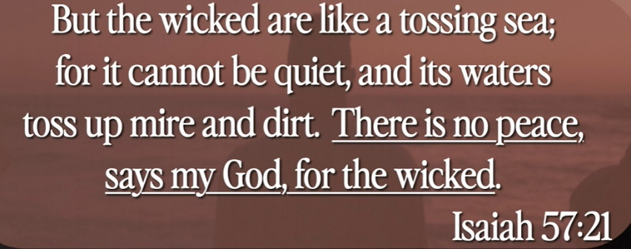

You have no peace when compromise the sin. Sin attack peace.

The peace wrack into the water. All kinds of wicked are come to you.

Pray the Lord. Lord gives us the power and love. God with you.

Jesus says, “My peace that give to you.”

**V. HOW TO WALK IN PERFECT PEACE**

Explanation:



Explanation:

Walk in Peace, In Hebrew, we say, “Shalom, Shalom”. It is a perfect peace.

Reposition our heart, eye, and mind.

Look at outside world, read the news, you get the stress.

Look at inside mind, you get the depress.

Look at God, you got the peace. He is Lord of shepherd with Love, heal, secure, sanctify, with peace.

Explanation:

**• You will keep him in perfect peace, whose mind is stayed on You, because he trusts in You. Trust in the Lord forever, for in Yah, the Lord, is everlasting strength. - Isaiah 26:3**

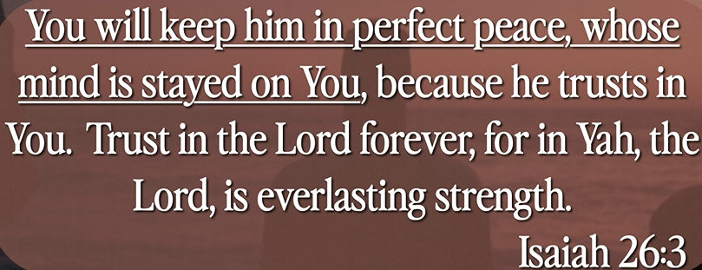

Explanation:

Reposition in your eye and mind.

Bible excerption:

# **Isaiah 26:3**

# **New International Version**

**3**You will keep in perfect peace those whose minds are steadfast, because they trust in you.

Summary of today topic “Finding Peace in the Chaos”:

1. Hebrew “Shalom” means “Good-bye or hello with peace”.

2. Two expression of Peace

a). Peace with God: We live peace with God.

b). Peace of God: Pray with God together.

3. Walk in Peace, In Hebrew, we say, “Shalom, Shalom”. It is a perfect peace.

4. Reposition our heart, eye, and mind.

5. Look at outside world, read the news, you get the stress.

6. Look at inside mind, you get the depress.

7. Look at God, you got the peace. He is Lord of shepherd with Love, heal, secure, sanctify, with peace.