03/26/2023, 8:30am, 10:30am: Sunday Worship

Online worship: https://www.youtube.com/watch?v=YUu361APPYA

Class Note:

<https://static1.squarespace.com/static/5e4c80df9c80885b56806c76/t/641f8f553286de61a4663b17/1679789914614/DanielNotes032623.pdf>



Today topic:

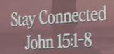

Bible Excerption:

# **John 15:1-8**

# **New International Version**

### The Vine and the Branches

**15**“I am the true vine, and my Father is the gardener. **2**He cuts off every branch in me that bears no fruit, while every branch that does bear fruit he prunes[[a](https://www.biblegateway.com/passage/?search=John%2015%3A1-8&version=NIV#fen-NIV-26702a)] so that it will be even more fruitful. **3**You are already clean because of the word I have spoken to you. **4**Remain in me, as I also remain in you. No branch can bear fruit by itself; it must remain in the vine. Neither can you bear fruit unless you remain in me.

**5**“I am the vine; you are the branches. If you remain in me and I in you, you will bear much fruit; apart from me you can do nothing. **6**If you do not remain in me, you are like a branch that is thrown away and withers; such branches are picked up, thrown into the fire and burned. **7**If you remain in me and my words remain in you, ask whatever you wish, and it will be done for you. **8**This is to my Father’s glory, that you bear much fruit, showing yourselves to be my disciples.

Explanation:

This is the week before Easter.

Jesus uses the Vine and Branch Metaphor.

Jesus: “I am the vine and you are the branch.”

Jesus is the shepherd. There are points of connection. Branch is completely dependent for the vine. The purpose of the vine is to produce fruit. Jesus here is

**I. GOD’S DESIRE FOR YOUR LIFE IS FRUITFULNESS**

Explanation:



Genesis: Be fruitful. Bear more fruit. God desire for you is beautiful.

**The fruit of the Spirit is love, joy, peace, patience, kindness, goodness, faithfulness, gentleness, and self-control. - Galatians 5:22-23**

Explanation:

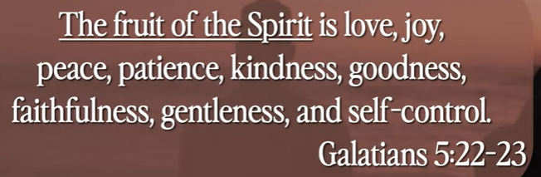

The inside of your heart. The seed of apple will translate into Apple.

Bible Excerption:

# **Galatians 5:22-23**

# **New International Version**

**22**But the fruit of the Spirit is love, joy, peace, forbearance, kindness, goodness, faithfulness, **23**gentleness and self-control. Against such things there is no law.

**So that you may live a life worthy of the Lord and please Him in every way: bearing fruit in every good work, growing in the knowledge of God. - Colossians 1:10-11**

Explanation:

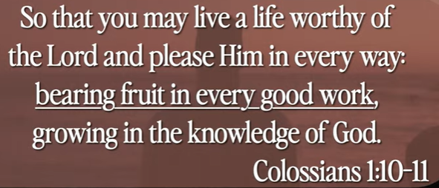

When you work hard, the fruit are extension of your work.

You bear fruit with hard and good work. You grow in the knowledge of God.

Bible Excerption:

# **Colossians 1:10-11**

# **New International Version**

**10**so that you may live a life worthy of the Lord and please him in every way: bearing fruit in every good work, growing in the knowledge of God, **11**being strengthened with all power according to his glorious might so that you may have great endurance and patience,

**The fruit of the righteous is a tree of life, and the one who is wise saves lives. - Proverbs 11:30**

Bible Excerption:

# **Proverbs 11:30**

# **New International Version**

**30**The fruit of the righteous is a tree of life,  
    and the one who is wise saves lives.

**II. GOD’S ROLE IN MAXIMIZING OUR FRUITFULNESS - verse - 2-3**

Explanation:



Explanation:

The God work is to trim or cut off of the useless branches.

Some death branches have to be cut out. These branches will be hinder the fruits.

This will bring our attention, to cut them out. We want to fruit to grow above the ground, not grow the root under the ground. We lift our eyes.

Bible Excerption:

**2**He cuts off every branch in me that bears no fruit, while every branch that does bear fruit he prunes[[a](https://www.biblegateway.com/passage/?search=John%2015%3A1-8&version=NIV#fen-NIV-26702a)] so that it will be even more fruitful. **3**You are already clean because of the word I have spoken to you.

**Set your minds on things above, not on earthly things. For you died, and your life is now hidden with Christ in God. - Colossians 3:2-3**

Explanation:

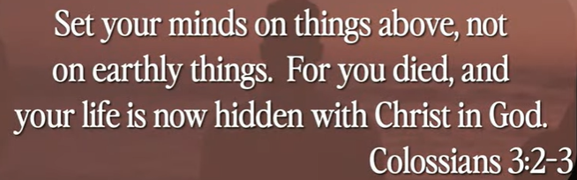

God cut the branches and let the branches grow up above the ground and bring more fruit for us.

The pruning process is never stop. God cut the branches and clean up the branches.

Bible Excerption:

# **Colossians 3:2-3**

# **New International Version**

**2**Set your minds on things above, not on earthly things. **3**For you died, and your life is now hidden with Christ in God.

**• How can a young man cleanse his way, by taking heed according to Your word. With my whole heart I have sought You; Oh, let me not wander from Your commandments! Your word I have hidden in my heart, that I might not sin against You. - Psalm 119:9-11**

Explanation:





Explanation:

When you open your world, God will cut the unless branches, clean up for you. in the God world.

The oppose of cutting is thriving. You are constantly comparing yourself with surrounding people.

These are all the fruits.

**III. YOUR ROLE IN MAXIMIZING FRUITFULNESS - verse 4-5**

Explanation:

**4**Remain in me, as I also remain in you. No branch can bear fruit by itself; it must remain in the vine. Neither can you bear fruit unless you remain in me.

**5**“I am the vine; you are the branches. If you remain in me and I in you, you will bear much fruit; apart from me you can do nothing.

**• Cease striving and know that I am God; I will be exalted among the nations, I will be exalted in the earth. - Psalm - 46:10**

Explanation:



Explanation:

Striving: obtain something.

Exalted: raise high.

Stop try to get something from God. God is the high on nations and earth.

IV. KEYS TO CULTIVATING CONNECTION - verse 7

Explanation:



Bible excerption:

**7**If you remain in me and my words remain in you, ask whatever you wish, and it will be done for you

Explanation:

How to connect with God?

God, I am wholly dependent on you.

Instead of busy in studying and etc., you settle down in house.

You watch your pray and communicating with your God.

You constantly exercise the way to connect with God.

Summary of today topic: “Stay connected”

1. The God work is to trim or cut off of the useless branches. Some death branches have to be cut out. These branches will be hinder the fruits. We want to fruit to grow above the ground, not grow the root under the ground. We lift our eyes.

2. Open and empty your mind, God will cut the unless branches, clean up for you in the God world.

3. The thriving opposite of cutting, you try to get something from others. We stop thriving in God world. We stay quiet and pray. God will you out.

4. How to stay connected with pray for God? Pray your wish and keep the God word. The God will be done for you.

5. We have clear picture this morning: we pray and joy with Jesus. Stay connected with God every day,