04/03/2023, 8:30am, 10:30am: Sunday Worship

Online worship: https://www.youtube.com/watch?v=YUu361APPYA

Class Note:

https://static1.squarespace.com/static/5e4c80df9c80885b56806c76/t/6428d0202c5ffd32926216ff/1680396327074/DanielNotes040223.pdf



Explanation:

1. This Thursday is Passover.

2. This month (April) is Nissan in Hebrew Calendar. Nissan is the first of year. Nissan means “The beginning of Miracle.”

Explanation:



Bible Excerption:

# **Luke 19:29-44**

# **New International Version**

**29**As he approached Bethphage and Bethany at the hill called the Mount of Olives, he sent two of his disciples, saying to them, **30**“Go to the village ahead of you, and as you enter it, you will find a colt tied there, which no one has ever ridden. Untie it and bring it here. **31**If anyone asks you, ‘Why are you untying it?’ say, ‘The Lord needs it.’”

**32**Those who were sent ahead went and found it just as he had told them. **33**As they were untying the colt, its owners asked them, “Why are you untying the colt?”

**34**They replied, “The Lord needs it.”

**35**They brought it to Jesus, threw their cloaks on the colt and put Jesus on it. **36**As he went along, people spread their cloaks on the road.

**37**When he came near the place where the road goes down the Mount of Olives, the whole crowd of disciples began joyfully to praise God in loud voices for all the miracles they had seen:

**38**“Blessed is the king who comes in the name of the Lord!”[[a](https://www.biblegateway.com/passage/?search=Luke%2019%3A29-44&version=NIV#fen-NIV-25770a)]

“Peace in heaven and glory in the highest!”

**39**Some of the Pharisees in the crowd said to Jesus, “Teacher, rebuke your disciples!”

**40**“I tell you,” he replied, “if they keep quiet, the stones will cry out.”

**41**As he approached Jerusalem and saw the city, he wept over it **42**and said, “If you, even you, had only known on this day what would bring you peace—but now it is hidden from your eyes. **43**The days will come upon you when your enemies will build an embankment against you and encircle you and hem you in on every side. **44**They will dash you to the ground, you and the children within your walls. They will not leave one stone on another, because you did not recognize the time of God’s coming to you.”

**I. A DAY OF PREPARATION - verses 29-37**

Explanation:



During the Passover, Jewish people prepare the lamb for the family.

Bible Excerption:

**29**As he approached Bethphage and Bethany at the hill called the Mount of Olives, he sent two of his disciples, saying to them, **30**“Go to the village ahead of you, and as you enter it, you will find a colt tied there, which no one has ever ridden. Untie it and bring it here. **31**If anyone asks you, ‘Why are you untying it?’ say, ‘The Lord needs it.’”

**32**Those who were sent ahead went and found it just as he had told them. **33**As they were untying the colt, its owners asked them, “Why are you untying the colt?”

**34**They replied, “The Lord needs it.”

**35**They brought it to Jesus, threw their cloaks on the colt and put Jesus on it. **36**As he went along, people spread their cloaks on the road.

**37**When he came near the place where the road goes down the Mount of Olives, the whole crowd of disciples began joyfully to praise God in loud voices for all the miracles they had seen:

Explanation:

Every Jewish family bring the lamb to home in the Passover period and make sure the lamb is good.

**II. JESUS PRESENTS HIMSELF AS GOD’S LAMB**

Explanation:



Jesus presents himself as God’s Lamb.

Jesus sacrifice himself for us. Jesus shed of blood of himself. God provide the Jesus as the lamb.

Passover is the annual celebration. Jesus sacrifice himself as the lamb to shed the sin of world people.

**• Do not weep! See, the Lion of the tribe of Judah, the Root of David, has triumphed. He is able to open the scroll and its seven seals. Then I saw a Lamb, looking as if it had been slain, standing at the center of the throne, encircled by the four living creatures and the elders. - Revelation 5:1-6**

Explanation:

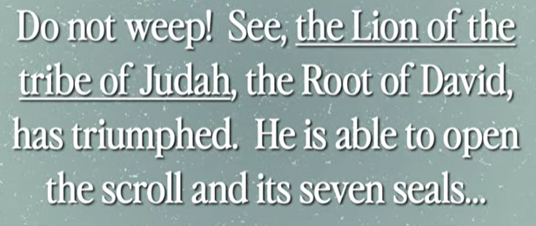

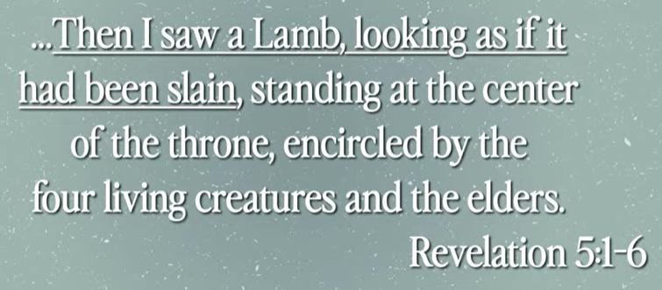

Vocabulary:

Weep: cry

Explanation:

Jesus declares the entire world to present himself as the God’s lamb.

Bible Excerption:

# **Revelation 5:1-6**

# **New International Version**

### The Scroll and the Lamb

**5**Then I saw in the right hand of him who sat on the throne a scroll with writing on both sides and sealed with seven seals. **2**And I saw a mighty angel proclaiming in a loud voice, “Who is worthy to break the seals and open the scroll?” **3**But no one in heaven or on earth or under the earth could open the scroll or even look inside it. **4**I wept and wept because no one was found who was worthy to open the scroll or look inside. **5**Then one of the elders said to me, “Do not weep! See, the Lion of the tribe of Judah, the Root of David, has triumphed. He is able to open the scroll and its seven seals.”

**6**Then I saw a Lamb, looking as if it had been slain, standing at the center of the throne, encircled by the four living creatures and the elders. The Lamb had seven horns and seven eyes, which are the seven spirits[[a](https://www.biblegateway.com/passage/?search=Revelation%205%3A1-6&version=NIV#fen-NIV-30787a)] of God sent out into all the earth.

**III. JESUS PRESENTS HIMSELF AS ISRAEL’S KING**

Explanation:

Jesus is the king of Israel. He sacrifices for the whole world. He is not political king but king of kingdom of God. He came to bring the peace of inner heart but not the political peace. He came to Jerusalem for five days and crucified for us.

Bible Excerption:

**• Rejoice greatly, daughter Zion! Shout, daughter Jerusalem! See, your King comes to you, righteous and victorious, lowly, and riding on a donkey, on a colt, the foal of a donkey. - Zechariah 9:9**

# **Zechariah 9:9**

# **New International Version**

### The Coming of Zion’s King

**9**Rejoice greatly, Daughter Zion! Shout, Daughter Jerusalem! See, your king comes to you,  
    righteous and victorious, lowly, and riding on a donkey, on a colt, the foal of a donkey.

Explanation:

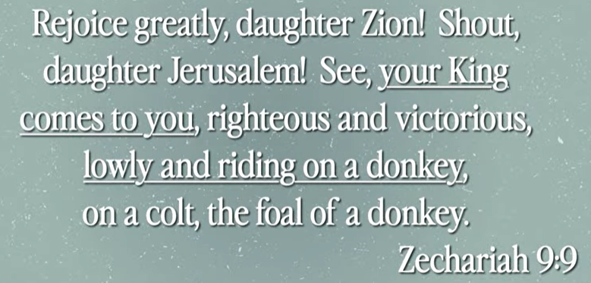

Vocabulary:

Zechariah: 撒迦利亚书

**IV. A DAY OF CELEBRATION - verse 38**

Bible Excerption:

**38**“Blessed is the king who comes in the name of the Lord!” “Peace in heaven and glory in the highest!”

**• The stone the builders rejected has become the cornerstone; the LORD has done this, and it is marvelous in our eyes. The LORD has done it this very day: let us rejoice today and be glad. - Psalm 118:22-24**

Vocabulary:

Psalm: 赞美诗

Explanation:

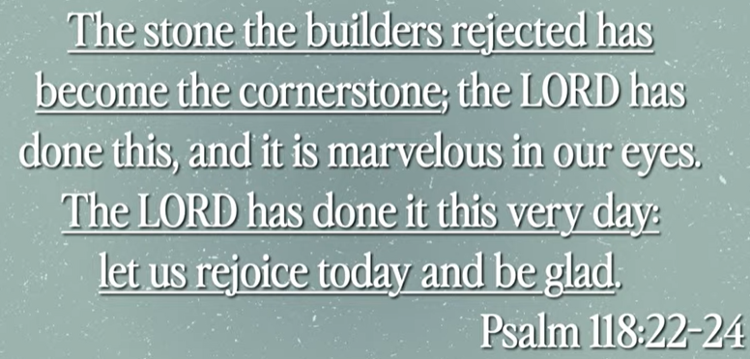

Bible Excerption:

# **Psalm 118:22-24**

# **New International Version**

**22**The stone the builders rejected has become the cornerstone;  
**23**the Lord has done this, and it is marvelous in our eyes.  
**24**The Lord has done it this very day; let us rejoice today and be glad.

**V. A DAY OF LAMENTATION - verse 41-44**

Explanation:



Vocabulary:

Lamentation: 悲叹

Explanation:

The religious leader is trying to kill Jesus. Jesus rides the donkey

Bible Excerption:

**41**As he approached Jerusalem and saw the city, he wept over it **42**and said, “If you, even you, had only known on this day what would bring you peace—but now it is hidden from your eyes. **43**The days will come upon you when your enemies will build an embankment against you and encircle you and hem you in on every side. **44**They will dash you to the ground, you and the children within your walls. They will not leave one stone on another, because you did not recognize the time of God’s coming to you.”

**VI. LIVING WITH ANTICIPATION**

Explanation:



Explanation:

We live with Jesus with anticipation.

Summary of today topic “The Triumphal Entry”:

1. This Thursday is Passover.

2. This month (April) is Nissan in Hebrew Calendar. Nissan is the first of year. Nissan means “The beginning of Miracle.”

3. During the Passover, Jewish people prepare the lamb for the family.

4. Jesus presents himself as God’s Lamb. Jesus sacrifice himself for us. Jesus shed of blood of himself. God provide the Jesus as the lamb.

5. Passover is the annual celebration. Jesus sacrifice himself as the lamb to shed the sin of world people.

6. Do not cry: Jesus declares the entire world to present himself as the God’s lamb.

7. Jesus is the king of Israel. He sacrifices for the whole world. He is not political king but king of kingdom of God. He came to bring the peace of inner heart but not the political peace. He came to Jerusalem for five days and crucified for us.

8. The religious leader is trying to kill Jesus. Jesus rides the donkey into Jerusalem and crucified in five days.

9. We live with Jesus with anticipation.