04/09/2023, 8:30am, 10:30am: Sunday Worship

<https://www.youtube.com/watch?v=YgpkKCTMRAE>

Class Note:

<https://static1.squarespace.com/static/5e4c80df9c80885b56806c76/t/64320a339725441dbda55e23/1681001011672/Study+Notes+-John+Series.pdf>



Explanation:



Baptize: Make the Outward to Christian and inward belief to Jesus.

200 years ago in human history, Jesus sacrifices for us.

Bible excerption:

# **John 20:1-18**

# **New International Version**

### The Empty Tomb

**20**Early on the first day of the week, while it was still dark, Mary Magdalene went to the tomb and saw that the stone had been removed from the entrance. **2**So she came running to Simon Peter and the other disciple, the one Jesus loved, and said, “They have taken the Lord out of the tomb, and we don’t know where they have put him!”

**3**So Peter and the other disciple started for the tomb. **4**Both were running, but the other disciple outran Peter and reached the tomb first. **5**He bent over and looked in at the strips of linen lying there but did not go in. **6**Then Simon Peter came along behind him and went straight into the tomb. He saw the strips of linen lying there, **7**as well as the cloth that had been wrapped around Jesus’ head. The cloth was still lying in its place, separate from the linen. **8**Finally the other disciple, who had reached the tomb first, also went inside. He saw and believed. **9**(They still did not understand from Scripture that Jesus had to rise from the dead.) **10**Then the disciples went back to where they were staying.

### Jesus Appears to Mary Magdalene

**11**Now Mary stood outside the tomb crying. As she wept, she bent over to look into the tomb **12**and saw two angels in white, seated where Jesus’ body had been, one at the head and the other at the foot.

**13**They asked her, “Woman, why are you crying?”

“They have taken my Lord away,” she said, “and I don’t know where they have put him.” **14**At this, she turned around and saw Jesus standing there, but she did not realize that it was Jesus.

**15**He asked her, “Woman, why are you crying? Who is it you are looking for?”

Thinking he was the gardener, she said, “Sir, if you have carried him away, tell me where you have put him, and I will get him.”

**16**Jesus said to her, “Mary.”

She turned toward him and cried out in Aramaic, “Rabboni!” (which means “Teacher”).

**17**Jesus said, “Do not hold on to me, for I have not yet ascended to the Father. Go instead to my brothers and tell them, ‘I am ascending to my Father and your Father, to my God and your God.’”

**18**Mary Magdalene went to the disciples with the news: “I have seen the Lord!” And she told them that he had said these things to her.

**• The Spirit of the Lord is on Me, because He has anointed Me to proclaim good news to the poor. He has sent Me to proclaim freedom for the prisoners and recovery of sight to the blind, to set the oppressed free, to proclaim the year of the Lord’s Favor. - Luke 4:18**

Bible excerption:

# **Luke 4:18**

# **New International Version**

**18**“The Spirit of the Lord is on me, because he has anointed me to proclaim good news to the poor. He has sent me to proclaim freedom for the prisoners and recovery of sight for the blind, to set the oppressed free,

Explanation:

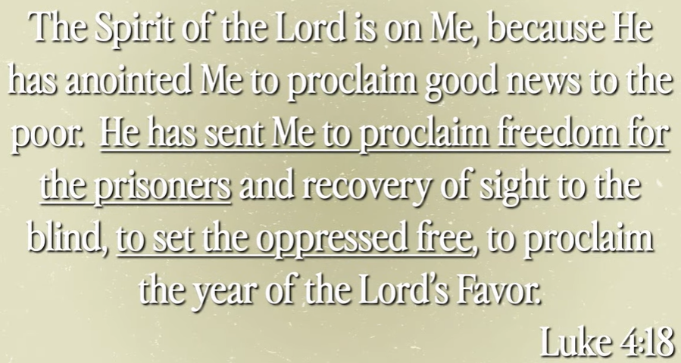

Jesus is alive and give us freedom.

We want to talk today.

**I. MARY’S EXPERIENCE AT THE EMPTY TOMB - verses 1-2**

Bible excerption:

**20**Early on the first day of the week, while it was still dark, Mary Magdalene went to the tomb and saw that the stone had been removed from the entrance. **2**So she came running to Simon Peter and the other disciple, the one Jesus loved, and said, “They have taken the Lord out of the tomb, and we don’t know where they have put him!”

Explanation:



Mary Magdalene is one of the followers of Jesus. She went to Jesus’s tomb. She found the gate stone is removed and tomb is empty. Mary Magdalene run to Peter Simon and John for help.

**II. PETER AND JOHN’S JOURNEY TO FAITH - verses 3-4**

Bible excerption:

**3**So Peter and the other disciple started for the tomb. **4**Both were running, but the other disciple outran Peter and reached the tomb first.

Explanation:

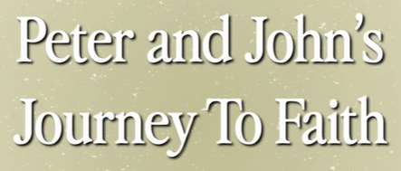

Peter Simon and John started their journey to believe. They run into the tomb. They cannot find Jesus body. They write down the evidence. Peter and John are then gone away and the Mary Magdalene is back.

**• The sheep hear His voice; and He calls His own sheep by name and leads them out. - John 10:3**

Bible excerption:

# **John 10:3**

# **New International Version**

**3**The gatekeeper opens the gate for him, and the sheep listen to his voice. He calls his own sheep by name and leads them out.

Explanation:

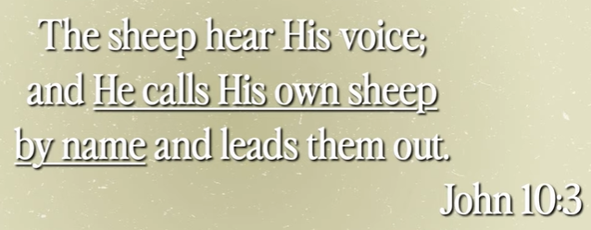

The God know all of us and he call our name.

**III. YOU CAN BE SET FREE TODAY**



Explanation:

**• The Spirit of God, who raised Jesus from the dead lives in you. - Romans 8:11**

Bible excerption:

# **Romans 8:11**

# **New International Version**

**11**And if the Spirit of him who raised Jesus from the dead is living in you, he who raised Christ from the dead will also give life to your mortal bodies because of[[a](https://www.biblegateway.com/passage/?search=Romans+8%3A11+&version=NIV#fen-NIV-28128a)] his Spirit who lives in you.

Explanation:

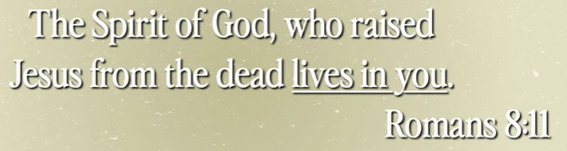

The spirit of God who raised Jesus from dead and sprit lives in you.

**• Since the children have flesh and blood, He too shared in their humanity so that by His death He might break the power of Him who holds the power of death—that is the devil – and free those who all their lives were held in slavery by their fear of death. - Hebrews 2:14-15**

Bible excerption:

# **Hebrews 2:14-15**

# **New International Version**

**14**Since the children have flesh and blood, he too shared in their humanity so that by his death he might break the power of him who holds the power of death—that is, the devil— **15**and free those who all their lives were held in slavery by their fear of death.

Explanation:

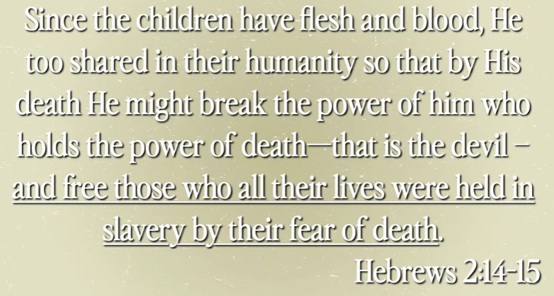

Jesus has human being body has flesh and blood. When his body is dead, he is free and break out the spirit power.

Summary of today topic “Free Indeed”:

1. In human history, Jesus was crucified for us 2000 years ago.

2. Jesus is alive and give us freedom. We want to talk today.

3. Mary Magdalene is one of the followers of Jesus. She went to Jesus’s tomb. She found the gate stone is removed and tomb is empty. Mary Magdalene run to Peter Simon and John for help.

4. Peter Simon and John started their journey to believe. They run into the tomb. They cannot find Jesus body. They write down the evidence. Peter and John are then gone away and the Mary Magdalene is back.

5. The spirit of God who raised Jesus from dead and sprit lives in you.

6. Jesus has human being body has flesh and blood. When his body is dead, he is free and break out the spirit power.