04/16/2023, 8:30am, 10:30am: Sunday Worship

<https://www.youtube.com/watch?v=Cz9TsuC4F0s>

Class Note: Guest Speaker, Pastor Ron Brown. No class notes for this week.

Introducing pastor:

1. Joy is the gift of Jesus.

2. Daniel Bentley is outside for priest. Pastor Ron Brown will be the speaker today.

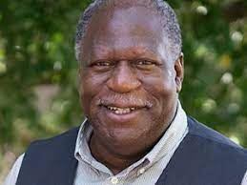

Pastor Ron Brown.

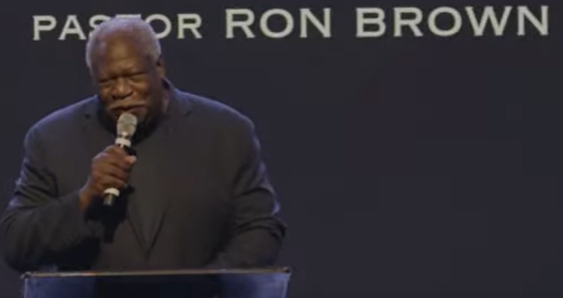

God is good and all the time.

Today’s Topic: “The healer is in the house”

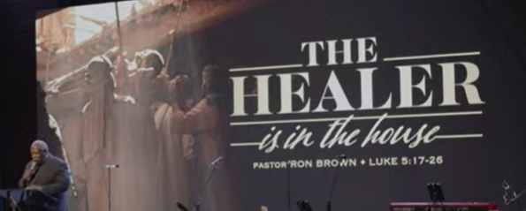

Luke 5:17-26

# **Luke 5:17-26**

# **New International Version**

### Jesus Forgives and Heals a Paralyzed Man

**17**One day Jesus was teaching, and Pharisees and teachers of the law were sitting there. They had come from every village of Galilee and from Judea and Jerusalem. And the power of the Lord was with Jesus to heal the sick. **18**Some men came carrying a paralyzed man on a mat and tried to take him into the house to lay him before Jesus. **19**When they could not find a way to do this because of the crowd, they went up on the roof and lowered him on his mat through the tiles into the middle of the crowd, right in front of Jesus.

**20**When Jesus saw their faith, he said, “Friend, your sins are forgiven.”

**21**The Pharisees and the teachers of the law began thinking to themselves, “Who is this fellow who speaks blasphemy? Who can forgive sins but God alone?”

**22**Jesus knew what they were thinking and asked, “Why are you thinking these things in your hearts? **23**Which is easier: to say, ‘Your sins are forgiven,’ or to say, ‘Get up and walk’? **24**But I want you to know that the Son of Man has authority on earth to forgive sins.” So, he said to the paralyzed man, “I tell you, get up, take your mat and go home.” **25**Immediately he stood up in front of them, took what he had been lying on and went home praising God. **26**Everyone was amazed and gave praise to God. They were filled with awe and said, “We have seen remarkable things today.”

Vocabulary:

Blasphemy: 亵渎

Explanation:

Some man come in and carry a paralyzed man in the house and see Jesus.

# **Romans 14:17**

# **New International Version**

**17**For the kingdom of God is not a matter of eating and drinking, but of righteousness, peace, and joy in the Holy Spirit.

Explanation:

The healer knocks your door.

Summary of today topic “The healer is in the house”:

1. Pastor Daniel Bentley is outside for priest. Pastor Ron Brown is the guest speaker. There is no class notes for today’s worship.

2. Today topic is “The healer is in the house”. In Luke 5:18, some man come in and carry a paralyzed man in the house and see Jesus. Jesus healed the paralyzed man and Jesus forgive the sin of man. In the past, only God can forgive the sin of people. People wonder how Jesus get the power to heal people and forgive sin.

3. Luke 5:23 describes that Jesus has the power to heal people in the house and forgive the sin of people. Jesus inherit power from God. He asked the paralyzed people to go home. God is good and all the time. The healer has come to your house all days.