04/23/2023, 8:30am, 10:30am: Sunday Worship

<https://www.youtube.com/watch?v=Cz9TsuC4F0s>

Class Note:

<https://static1.squarespace.com/static/5e4c80df9c80885b56806c76/t/64447a579c367a7d19d41757/1682209368064/Daniel+Notes+042323.pdf>



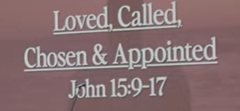

Bible excerption:

# John 15:9-17

# New International Version

9“As the Father has loved me, so have I loved you. Now remain in my love. 10If you keep my commands, you will remain in my love, just as I have kept my Father’s commands and remain in his love. 11I have told you this so that my joy may be in you and that your joy may be complete. 12My command is this: Love each other as I have loved you. 13Greater love has no one than this: to lay down one’s life for one’s friends. 14You are my friends if you do what I command. 15I no longer call you servants, because a servant does not know his master’s business. Instead, I have called you friends, for everything that I learned from my Father I have made known to you. 16You did not choose me, but I chose you and appointed you so that you might go and bear fruit—fruit that will last—and so that whatever you ask in my name the Father will give you. 17This is my command: Love each other.

**I. YOU ARE LOVED - verse 9**

Bible Excerption:

9“As the Father has loved me, so have I loved you. Now remain in my love.

Explanation:



God is Father and love his son. Father love is everlasting and never ending, un-comprehendible and unbounded. Father love is no bounded capacity. There is no pre-approval. Building the identity that people around you. You do not need approval from God to get the love.

**• There is no fear in love; but perfect love casts out fear because fear involves torment. But he who fears has not been made perfect in love. We love Him because He first loved us. - I John 4:18-19**

# Bible excerption:

# **1 John 4:18-19**

# **New International Version**

**18**There is no fear in love. But perfect love drives out fear, because fear has to do with punishment. The one who fears is not made perfect in love. **19**We love because he first loved us.

Explanation:

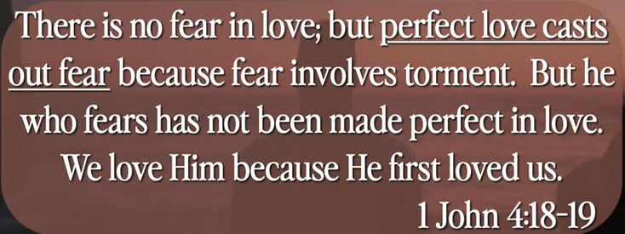

Perfect love out here. There is no fear in love. But perfect love drives out fear, because fear has to do with punishment. The one who fears is not made perfect in love.

Father love is like a 3,160 tons per second waterfall in Niagara Fall.

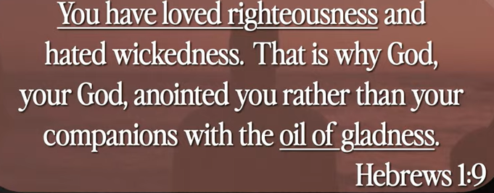

Jesus’ love is unconditional. He loves everybody without condition.

**• For scarcely for a righteous man will one die; yet perhaps for a good man someone would even dare to die. But God demonstrates His own love toward us, in that while we were still sinners, Christ died for us. - Romans 5:7-8**

# Bible excerption:

# **Romans 5:7-8**

# **New International Version**

**7**Very rarely will anyone die for a righteous person, though for a good person someone might possibly dare to die. **8**But God demonstrates his own love for us in this: While we were still sinners, Christ died for us.

Explanation:

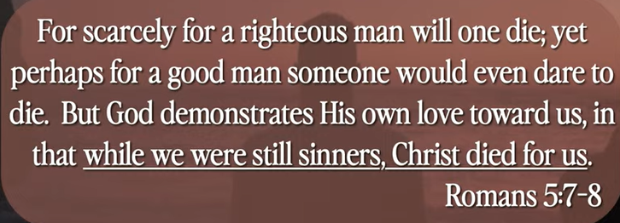

Jesus dies for us to clean up the sin. He forgives everyone in the world.

**II. YOU ARE CALLED - verse 15**

# Bible excerption:

15I no longer call you servants, because a servant does not know his master’s business. Instead, I have called you friends, for everything that I learned from my Father I have made known to you.

Explanation:



Jesus is the only one to call you.

**III. YOU ARE CHOSEN AND APPOINTED - verses 16-17**

# Bible excerption:

16You did not choose me, but I chose you and appointed you so that you might go and bear fruit—fruit that will last—and so that whatever you ask in my name the Father will give you. 17This is my command: Love each other.

Explanation:



**• You are a chosen people, a royal priesthood, a holy nation, God’s special possession, that you may declare the praises of Him who called you out of darkness into His wonderful light. - I Peter 2:9**

# Bible excerption:

# **1 Peter 2:9**

# **New International Version**

**9**But you are a chosen people, a royal priesthood, a holy nation, God’s special possession, that you may declare the praises of him who called you out of darkness into his wonderful light.

Explanation:

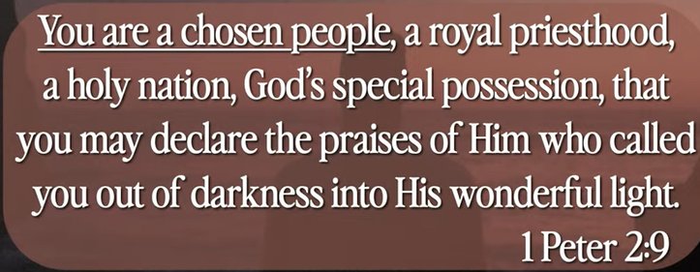

Summary of today topic “Loved, Called, Chosen, and Appointed”:

1. God is Father and love his son. Father love is everlasting and never ending, un-comprehendible and unbounded. Father love is no bounded capacity. There is no pre-approval. Building the identity that people around you. You do not need approval from God to get the love.

2. There is no fear in love. But perfect love drives out fear, because fear has to do with punishment. The one who fears is not made perfect in love.

Father love is like a 3,160 tons per second waterfall in Niagara Fall.

3. Jesus’ love is unconditional. He loves everybody without condition.

4. Jesus dies for us to clean up the sin. He forgives everyone in the world.

5. You are a chosen people by God. You are appointed from God.