04/30/2023, 8:30am, 10:30am: Sunday Worship

<https://www.youtube.com/watch?v=v9J87_vIbH8>

Class Note: N/A

Guest speaker: Jim Clark

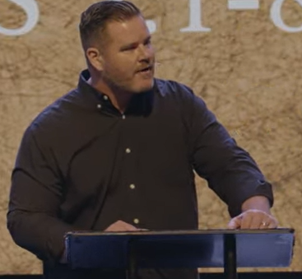

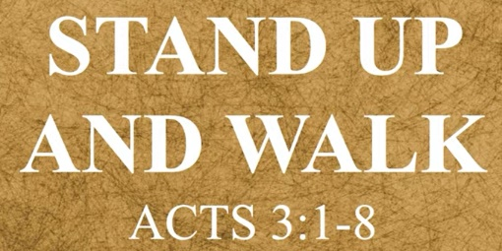

Bible Excerption:

# **Acts 3:1-8**

# **New International Version**

### Peter Heals a Lame Beggar

**3**One day Peter and John were going up to the temple at the time of prayer—at three in the afternoon. **2**Now a man who was lame from birth was being carried to the temple gate called Beautiful, where he was put every day to beg from those going into the temple courts. **3**When he saw Peter and John about to enter, he asked them for money. **4**Peter looked straight at him, as did John. Then Peter said, “Look at us!” **5**So the man gave them his attention, expecting to get something from them.

**6**Then Peter said, “Silver or gold I do not have, but what I do have I give you. In the name of Jesus Christ of Nazareth, walk.” **7**Taking him by the right hand, he helped him up, and instantly the man’s feet and ankles became strong. **8**He jumped to his feet and began to walk. Then he went with them into the temple courts, walking and jumping, and praising God.

Vocabulary:

Lame: crippled (瘸)

Summary of Today Topic: “Stand up and Walk”

1. Pastor Daniel Bentley is in Israel now for preaching. Jim Clark is today speaker.

2. There is a beggar whose ankle and feet are crippled.

3. Peter said, “I have no money but I have name of Jesus Christ”, “Stand up and walk”. The ankles and feet of beggar become stronger. The beggar jumped and began to walk. The beggar went into temple, walking, jumping, ad praising God.

4. Literally, this example is a miracle of physical heals which shows the power of glorify God.

5. Christian walk out with spirit. Spirit is not money but is a life changing treasure. We can bring in all kinds of arguments or we just surrender to Jesus and God. God loves us and sends his son to die for us and clean up our sin. It is time to come back to him with relationship with God.