05/06-07/2023, 8:30am, 10:30am: Sunday Worship

<https://www.youtube.com/watch?v=58p5agJj0Es&t=302s>

Class Note: https://static1.squarespace.com/static/5e4c80df9c80885b56806c76/t/6456ebc66477264d236cf885/1683418055028/Danny+notes050723.pdf



JOHN 4:7-10; 16-18 (39:52/1:41:00)

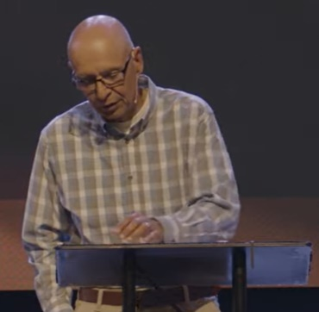



Bible Excerption:

# **John 4:7-10**

# **New International Version**

**7**When a Samaritan woman came to draw water, Jesus said to her, “Will you give me a drink?” **8**(His disciples had gone into the town to buy food.) **9**The Samaritan woman said to him, “You are a Jew and I am a Samaritan woman. How can you ask me for a drink?” (For Jews do not associate with Samaritans.[[a](https://www.biblegateway.com/passage/?search=John%204%3A7-10&version=NIV#fen-NIV-26166a)]) **10**Jesus answered her, “If you knew the gift of God and who it is that asks you for a drink, you would have asked him and he would have given you living water.”

# **John 4:16-18**

# **New International Version**

**16**He told her, “Go, call your husband and come back.” **17**“I have no husband,” she replied.

Jesus said to her, “You are right when you say you have no husband. **18**The fact is, you have had five husbands, and the man you now have is not your husband. What you have just said is quite true.”

Explanation:

**Exodus 34:6 - And the Lord passed by before him, and proclaimed, The Lord, The Lord God, merciful and gracious, longsuffering, and abundant in goodness and truth.**

Bible Excerption:

# **Exodus 34:6**

# **New International Version**

**6**And he passed in front of Moses, proclaiming, “The Lord, the Lord, the compassionate and gracious God, slow to anger, abounding in love and faithfulness,

Explanation:

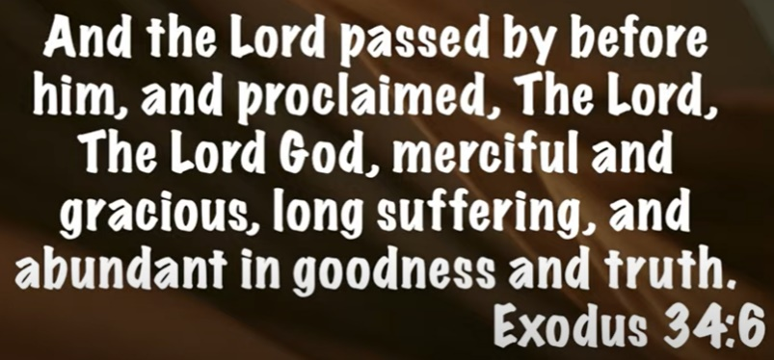

**“God’s love is like an ocean; you can see its beginning, but not its end”. ~ Rick Warren**

Explanation:



**“When someone who owes me absolutely nothing, chooses to give me absolutely everything.” ~ Michael Card**



Bible Excerption:

Explanation:

**• John 1:14 - And the Word became flesh and dwelt among us, and we have seen his glory, glory as of the only Son from the Father, full of grace and truth.**

Bible Excerption:

# **John 1:14**

# **New International Version**

**14**The Word became flesh and made his dwelling among us. We have seen his glory, the glory of the one and only Son, who came from the Father, full of grace and truth.

Explanation:

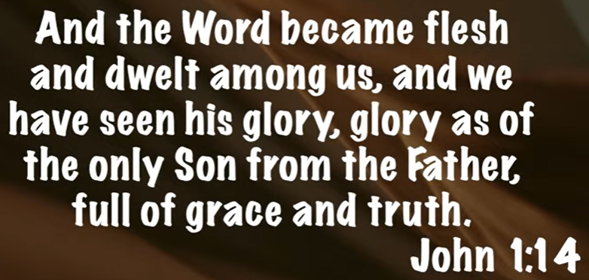

**• Romans 2:4 - Don’t you see how wonderfully kind, tolerant, and patient God is with you? Does this mean nothing to you? Can’t you see that his kindness is intended to turn you from your sin?**

Bible Excerption:

# **Romans 2:4**

# **New International Version**

**4**Or do you show contempt for the riches of his kindness; forbearance and patience, not realizing that God’s kindness is intended to lead you to repentance?

Explanation:



**A. JOHN 4**

**I. GOD’S GRACE - verses 7-10**

Bible Excerption:

# **John 4:7-10**

# **New International Version**

**7**When a Samaritan woman came to draw water, Jesus said to her, “Will you give me a drink?” **8**(His disciples had gone into the town to buy food.) **9**The Samaritan woman said to him, “You are a Jew and I am a Samaritan woman. How can you ask me for a drink?” (For Jews do not associate with Samaritans.[[a](https://www.biblegateway.com/passage/?search=John%204%3A7-10&version=NIV#fen-NIV-26166a)]) **10**Jesus answered her, “If you knew the gift of God and who it is that asks you for a drink, you would have asked him and he would have given you living water.”

Explanation: (1:10:00/1:41:00)



Samaria people like to help and very generous.

We have to extend the love to outside the community.

**If I am only willing to love the people who are nice to me, the ones who see things the way I do, and avoid all the rest, it is like reading every other page of the Bible and thinking I know what it says. ~ Bob Goff**

Explanation: (1:12:00/1:41:00)



We have to think the way that Jesus asks for living water. Forgiven the sin of our life.

**II. GOD’S TRUTH - verses 16-18**

Bible Excerption:

# **John 4:16-18**

# **New International Version**

**16**He told her, “Go, call your husband and come back.”

**17**“I have no husband,” she replied.

Jesus said to her, “You are right when you say you have no husband. **18**The fact is, you have had five husbands, and the man you now have is not your husband. What you have just said is quite true.”

Explanation: (1:14:12/1:41:00)



The woman has five husbands but the woman said you have no husband.

**• Grace doesn’t overlook truth – it meets guilt with mercy.**

Explanation:



**• John 3:17 - For God did not send his Son into the world to condemn the world, but in order that the world might be saved through him**

Bible Excerption:

# **John 4:3-17**

# **New International Version**

**3**So he left Judea and went back once more to Galilee.

**4**Now he had to go through Samaria. **5**So he came to a town in Samaria called Sychar, near the plot of ground Jacob had given to his son Joseph. **6**Jacob’s well was there, and Jesus, tired as he was from the journey, sat down by the well. It was about noon.

**7**When a Samaritan woman came to draw water, Jesus said to her, “Will you give me a drink?” **8**(His disciples had gone into the town to buy food.)

**9**The Samaritan woman said to him, “You are a Jew and I am a Samaritan woman. How can you ask me for a drink?” (For Jews do not associate with Samaritans.[[a](https://www.biblegateway.com/passage/?search=JOHN+4%3A3-17&version=NIV#fen-NIV-26166a)])

**10**Jesus answered her, “If you knew the gift of God and who it is that asks you for a drink, you would have asked him and he would have given you living water.”

**11**“Sir,” the woman said, “you have nothing to draw with and the well is deep. Where can you get this living water? **12**Are you greater than our father Jacob, who gave us the well and drank from it himself, as did also his sons and his livestock?”

**13**Jesus answered, “Everyone who drinks this water will be thirsty again, **14**but whoever drinks the water I give them will never thirst. Indeed, the water I give them will become in them a spring of water welling up to eternal life.”

**15**The woman said to him, “Sir, give me this water so that I won’t get thirsty and have to keep coming here to draw water.”

**16**He told her, “Go, call your husband and come back.”

**17**“I have no husband,” she replied.

Jesus said to her, “You are right when you say you have no husband.

Explanation:



Summary of Today Topic: “This is the way”

1. God is merciful, gracious, and abundant in goodness and truth.

2. God’s love is like an ocean; you can see its beginning, but not its end.

3. God owes us nothing, God gives us everything.

4. We can see the glory of the grace and truth of Jesus.

5. John 4: 4-10, Samaria people like to help and very generous. Jesus asks the drinking water from Samaria woman. We have to extend the love to outside the community.

6. John 4:16-18, the woman said she has no husband but actually she has five husbands.

7. John 3:17: God did not send his Son Jesus to condemn world. Jesus saved the world.