05/13-14/2023, 7:30pm, 8:30am: Sunday Worship

https://www.youtube.com/watch?v=ao5ds3GJcTs&t=793s

Class Note: N/A

37:59/1:34:00

Pastor Daniel Bentley

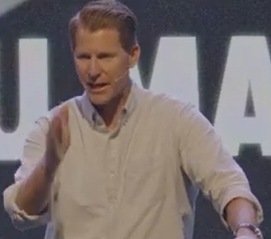

46:30/1:34:00

Happy Mother day. Last week, I went to Israel Holy land. We plant vine in Samaria.



Israel has incredible defense rocket shield.

53:00/1:34:00

Today’s Topic: Following Jesus in a world that does not belong to us.

John 15:18-16:3

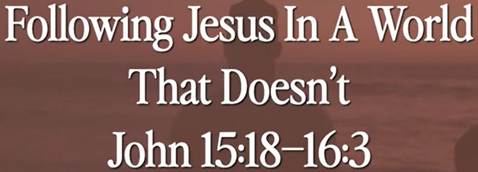

# **John 15:18-16:3**

# **New International Version**

### The World Hates the Disciples

**18**“If the world hates you, keep in mind that it hated me first. **19**If you belonged to the world, it would love you as its own. As it is, you do not belong to the world, but I have chosen you out of the world. That is why the world hates you. **20**Remember what I told you: ‘A servant is not greater than his master.’[[a](https://www.biblegateway.com/passage/?search=John+15%3A18-16%3A3+&version=NIV#fen-NIV-26720a)] If they persecuted me, they will persecute you also. If they obeyed my teaching, they will obey yours also. **21**They will treat you this way because of my name, for they do not know the one who sent me. **22**If I had not come and spoken to them, they would not be guilty of sin; but now they have no excuse for their sin. **23**Whoever hates me hates my Father as well. **24**If I had not done among them the works no one else did, they would not be guilty of sin. As it is, they have seen, and yet they have hated both me and my Father. **25**But this is to fulfill what is written in their Law: ‘They hated me without reason.’[[b](https://www.biblegateway.com/passage/?search=John+15%3A18-16%3A3+&version=NIV#fen-NIV-26725b)]

### The Work of the Holy Spirit

**26**“When the Advocate comes, whom I will send to you from the Father—the Spirit of truth who goes out from the Father—he will testify about me. **27**And you also must testify, for you have been with me from the beginning.

**16**“All this I have told you so that you will not fall away. **2**They will put you out of the synagogue; in fact, the time is coming when anyone who kills you will think they are offering a service to God. **3**They will do such things because they have not known the Father or me.

Explanation:

The whole world hates you. They me first.

55:00/1:34:00



The world is anti-god.

56:00/1:34:00

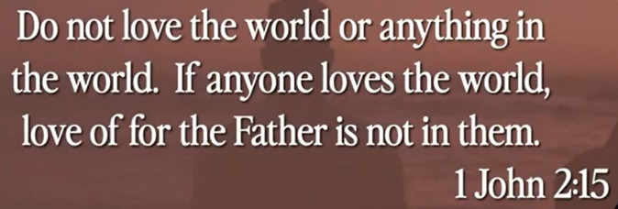

Explanation:

You do not belong to this world.

57:00/1:34:00



Explanation:

ET movie: “ET”

ET does not belong here.

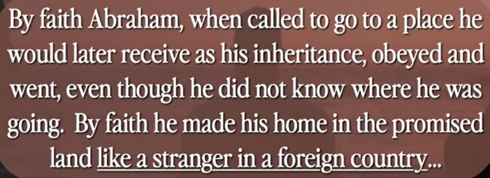

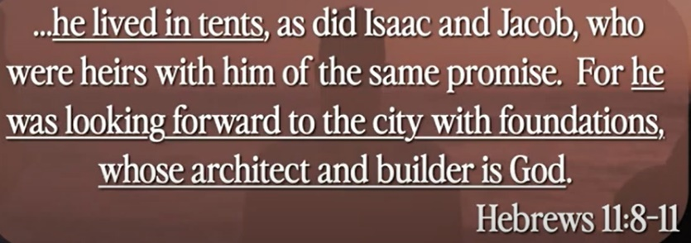

How do we live in the world without being contaminated?

How do we live in the world without being in part of them?

First approach, Christian creates a group and remove or isolate from the world.

Second approach, Christian participates to the world. Try to embrace into the world.

Isolation or Participate is the answer. How Christian join the world?

We are heavenly combustor. We are not hold together and eagerly to heaven.

We are in the world, we are not isolated, we are permeate in the world.



Jesus left the heaven and go to world for 33.5 years and go back to heaven. Jesus gives us the great revelation.

Spier man uncle, “Great power comes great responsibility.”

We have similar “Revelation brings Responsibility.”

1:12:00/1:34:00

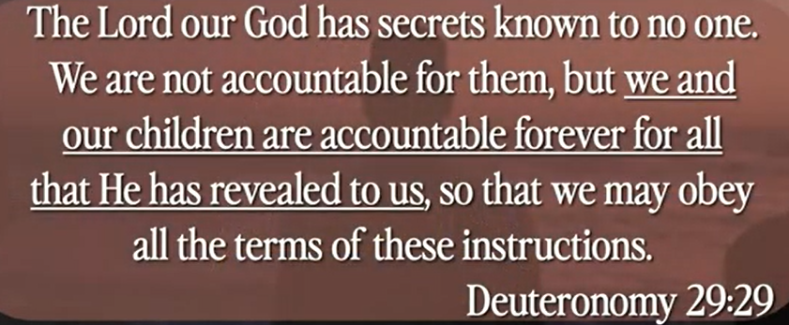

God has secrets to us; we are not accountable for the secretes.

We are accountable for the world.

There is a connection that we are accountable.

1:14:00/1:34:00



We focus on the ministry of the Holy Spirit.

The son magnifies the father.

We have great firecracker in washing DC.

The firework magnifies the monument.

1:20:00/1:34:00

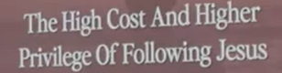

There is a high cost to follow Jesus.

There is also a higher privilege of following Jesus.

Christians are killed, churches are destroyed before in several centuries.

Now, we are blessed.

We want to be passion, love, and permeate the world.

Summary of today topic: “Following Jesus in a world that does not belong to us”

1. Christians live in the hostile world that Christians do not belong to it.

2. In ET movie, ET does not belong to earth. ET is eagerly to go home.

3. How do we live in the world without being contaminated? How do we live in the world without being in part of them?

4. In Spiderman movie, uncle said, “Great power comes with great responsibility.” For Christian, Jesus left the heaven and go to world for 33.5 years and go back to heaven. Jesus gives us the great revelation, “Revelation brings Responsibility.”

5. God has secrets to us; we are not accountable for the secretes.

We are accountable for the world. There is a connection that we are accountable.

6. When we have great firecracker in washing DC. The firework magnifies the monument. In the revelation, Jesus magnifies the father. In the same scenario, we focus on the ministry of the Holy Spirit.

7. There is a high cost to follow Jesus. Millions of Christians are killed and churches are destroyed in the past several centuries, now, we are blessed. We want to be passion, love, and permeate the world.

.