05/21/2023, 7:30pm, 8:30am: Sunday Worship

<https://www.youtube.com/watch?v=gMwFN8VPMDA>

Class Note: <https://static1.squarespace.com/static/5e4c80df9c80885b56806c76/t/64696299a3859e7199cbeebc/1684628121812/Daniel+Notes+052123.pdf>

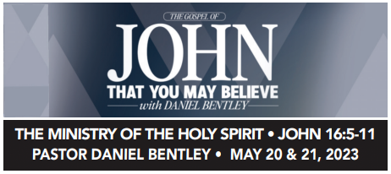

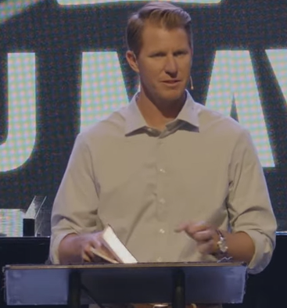

Today topic: The ministry of the Holy Spirit

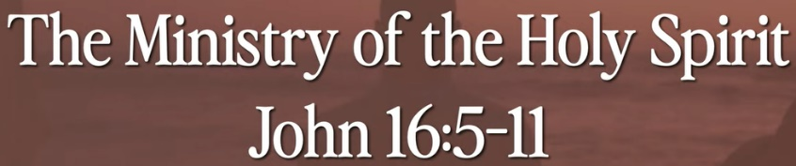

Bible Excerption:

# **John 16:5-11**

# **New International Version**

**5**but now I am going to him who sent me. None of you asks me, ‘Where are you going?’ **6**Rather, you are filled with grief because I have said these things.

**7**But very truly I tell you, it is for your good that I am going away.

Unless I go away, the Advocate will not come to you; but if I go, I will send him to you.

**8**When he comes, he will prove the world to be in the wrong about sin and righteousness and judgment:

**9**about sin, because people do not believe in me;

**10**about righteousness, because I am going to the Father, where you can see me no longer;

**11**and about judgment, because the prince of this world now stands condemned.

Explanation:

Ministry: Service

**I. THE MINISTRY OF THE HOLY SPIRIT - verse 7**



Bible Excerption:

**7**But very truly I tell you, it is for your good that I am going away. Unless I go away, the Advocate will not come to you; but if I go, I will send him to you

Explanation:

Advocate: helper or protector.

The helper come dramatically after Jesus.

**• ‘Do you not know that your bodies are temples of the Holy Spirit, who is in you, whom you have received from God? You are not your own.’ - I Corinthians 6:19**

Bible Excerption:

# **1 Corinthians 6:19**

# **New International Version**

**19**Do you not know that your bodies are temples of the Holy Spirit, who is in you, whom you have received from God? You are not your own;

Explanation:

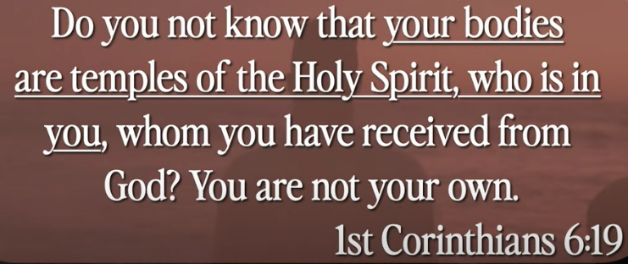

You do not come to church. Your body is the church.

Body holds holy spirit.

**II. THE SPIRIT COMES TO CONVICT OF SIN - VERSES 8-11**

Bible Excerption:

**8**When he comes, he will prove the world to be in the wrong about sin and righteousness and judgment: **9**about sin, because people do not believe in me; **10**about righteousness, because I am going to the Father, where you can see me no longer; **11**and about judgment, because the prince of this world now stands condemned.

Explanation:



Holy spirit come to judge your sin.

Belief is Root. Behavior is the symptom.

When you believe God, your behavior will be naturally changed.

When judge, everything you done wrong, betray etc. will appear.

Sin: anything against the religious or code of ethics.

**III. THE SPIRIT COMES TO CONVICT OF RIGHTEOUSNESS**

Explanation:

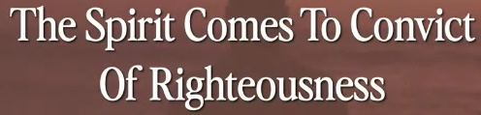

Do I done enough to go to heaven? The Holy Spirit come to judge you the right or wrong.

**• God made Him who had no sin to be sin for us, so that in Him we might become the righteousness of God. - II Corinthians 5:21**

Bible Excerption

# **2 Corinthians 5:21**

# **New International Version**

**21**God made him who had no sin to be sin[[a](https://www.biblegateway.com/passage/?search=II+Corinthians+5%3A21&version=NIV#fen-NIV-28899a)] for us, so that in him we might become the righteousness of God.

Explanation:

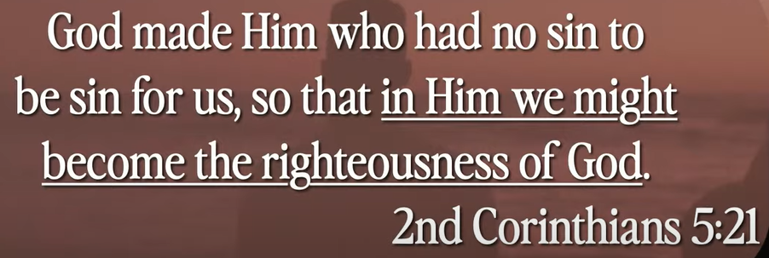

God made Jesus sin and crucified for us.

**IV. THE SPIRIT COMES TO CONVICT OF JUDGEMENT**

Explanation:

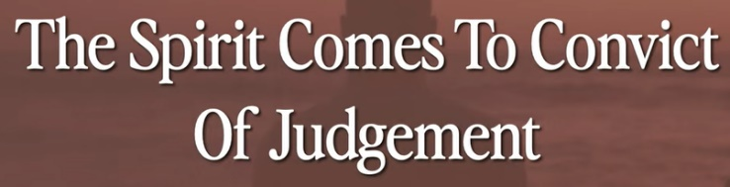

We do not have to worry the sin because Jesus already crucified for us.

**• When you were dead in your sins and in the uncircumcision of your flesh, God made you alive with Christ. He forgave us all our sins, having canceled the charge of our legal indebtedness, which stood against us and condemned us; he has taken it away, nailing it to the cross. And having disarmed the powers and authorities, He made a public spectacle of them, triumphing over them by the cross. - Colossians 2:13-15**

Bible Excerption

# **Colossians 2:13-15**

# **New International Version**

**13**When you were dead in your sins and in the uncircumcision of your flesh, God made you[[a](https://www.biblegateway.com/passage/?search=Colossians+2%3A13-15&version=NIV#fen-NIV-29508a)] alive with Christ. He forgave us all our sins, **14**having canceled the charge of our legal indebtedness, which stood against us and condemned us; he has taken it away, nailing it to the cross. **15**And having disarmed the powers and authorities, he made a public spectacle of them, triumphing over them by the cross.

Explanation:

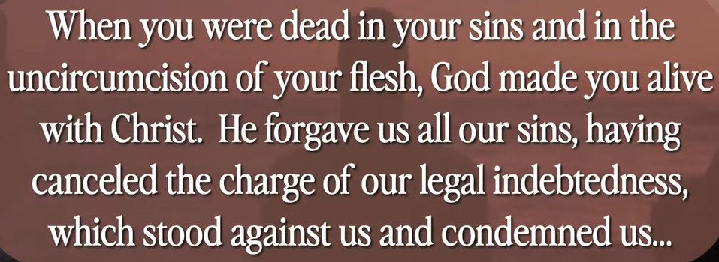

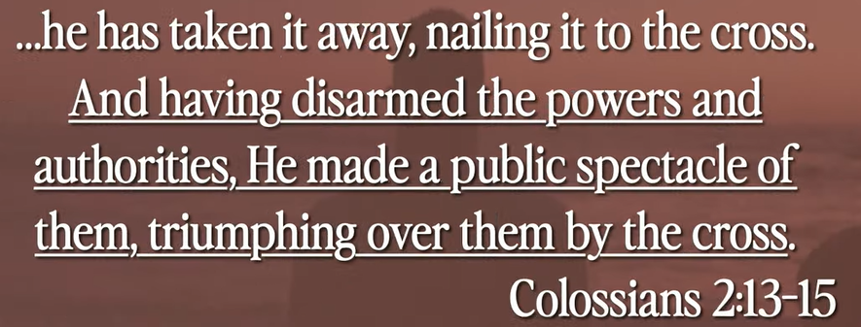

When Jesus crucified, our sins are cleared.

Jesus forgave our sins and take the sins away from us and nail the sin on the cross.

Jesus made a public spectacle (scene) with power and authorities to remove the sine for us.

Summary of today topic: “The ministry of the Holy Spirit”

1. What is sin?

Anything against the religious or code of ethics.

2. “Ministry” means “service”. “Holy spirit” means God. “The ministry of holy spirit” means “God gives us some service”.

3. What kinds of service that God give us?

When we die, God judge the sin for everybody.

4. God send his son Jesus to earth. When Jesus crucified, Jesus made a public spectacle (scene) and announcement with power and authorities to remove the sin for us.

5. Jesus forgave our sins and take the sins away from us

6. The sins are nailed on the cross and gone with Jesus died.