05/28/2023, 8:30am, 10:30am: Sunday Worship

<https://www.youtube.com/watch?v=L8x5nOqn04o>

Class Note: <https://static1.squarespace.com/static/5e4c80df9c80885b56806c76/t/6472958c25ef0950ac29b120/1685230989138/daniel+notes+052823.pdf>

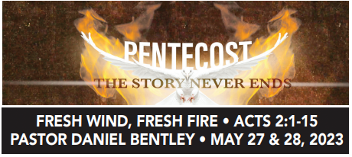

(47:42/1:44:25)

Bible Excerption:

# **Acts 2:1-15**

# **New International Version**

The Holy Spirit Comes at Pentecost

**2**When the day of Pentecost came, they were all together in one place. **2**Suddenly a sound like the blowing of a violent wind came from heaven and filled the whole house where they were sitting. **3**They saw what seemed to be tongues of fire (圣灵降临;火舌) that separated and came to rest on each of them. **4**All of them were filled with the Holy Spirit and began to speak in other tongues (方言) as the Spirit enabled them. **5**Now there were staying in Jerusalem God-fearing Jews from every nation under heaven. **6**When they heard this sound, a crowd came together in bewilderment, because each one heard their own language being spoken. **7**Utterly amazed, they asked: “Aren’t all these who are speaking Galileans? **8**Then how is it that each of us hears them in our native language? **9**Parthians, Medes and Elamites; residents of Mesopotamia, Judea and Cappadocia, Pontus and Asia,[[b](https://www.biblegateway.com/passage/?search=Acts%202%3A1-15&version=NIV#fen-NIV-26959b)] **10**Phrygia and Pamphylia, Egypt and the parts of Libya near Cyrene; visitors from Rome **11**(both Jews and converts to Judaism); Cretans and Arabs—we hear them declaring the wonders of God in our own tongues!” **12**Amazed and perplexed, they asked one another, “What does this mean?”

**13**Some, however, made fun of them and said, “They have had too much wine.” Peter Addresses the Crowd

**14**Then Peter stood up with the Eleven, raised his voice and addressed the crowd: “Fellow Jews and all of you who live in Jerusalem, let me explain this to you; listen carefully to what I say. **15**These people are not drunk, as you suppose. It is only nine in the morning!

Vocabulary:

Pentecost (五旬节) [also called Whit Sunday (圣灵降临节), Whitsunday or [Whitsun](https://en.wikipedia.org/wiki/Whitsun)] is a [Christian](https://en.wikipedia.org/wiki/Christianity) holiday which takes place on the 50th day[[a]](https://en.wikipedia.org/wiki/Pentecost#cite_note-InclCount-2) (the seventh Sunday) after [Easter Sunday](https://en.wikipedia.org/wiki/Easter_Sunday). It commemorates the descent of the [Holy Spirit](https://en.wikipedia.org/wiki/Holy_Spirit) upon the [Apostles](https://en.wikipedia.org/wiki/Apostles_in_the_New_Testament) (使徒) and other followers of [Jesus Christ](https://en.wikipedia.org/wiki/Jesus_Christ) while they were in [Jerusalem](https://en.wikipedia.org/wiki/Jerusalem_during_the_Second_Temple_Period) celebrating the [Feast (盛宴) of Weeks](https://en.wikipedia.org/wiki/Feast_of_Weeks), as described in the [Acts of the Apostles](https://en.wikipedia.org/wiki/Acts_of_the_Apostles) (Acts 2:1–31).

tongues of fire (圣灵降临;火舌): God words like fires separated all the apostles.

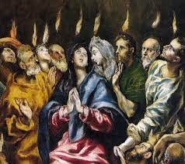

Explanation:

(48:32/1:44:25)

I never feel that powerful just now. My daughter is third grader. She said, “We have all kinds of cheeses. Bu the last one is Jesus.” Next Monday is memorial day.

**• But you will receive power when the Holy Spirit comes on you; and you will be my witnesses in Jerusalem, and in all Judea and Samaria, and to the ends of the earth. - Acts 1:8**

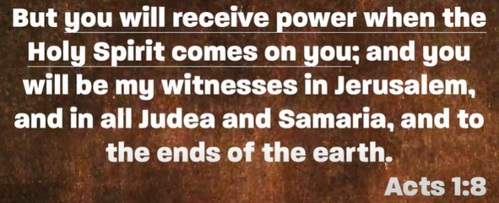

Bible Excerption:

# **Acts 1:8**

# **New International Version**

**8**But you will receive power when the Holy Spirit comes on you; and you will be my witnesses in Jerusalem, and in all Judea and Samaria, and to the ends of the earth.”

Explanation:

From Holy Spirit, we will receive the dynamite power. Holy Spirit is essential for the power.

When you connect the power, you can transform the power. The Holy Spirit tab in, we have power.

What is Pentecost?

**• Behold how good and how pleasant it is for brethren to dwell together in unity! It is like the precious oil upon the head, running down on the beard, the beard of Aaron, running down on the edge of his garments. It is like the dew of Hermon, descending upon the mountains of Zion; for there the LORD commanded the blessing, life forevermore. - Psalm 133:1-3**

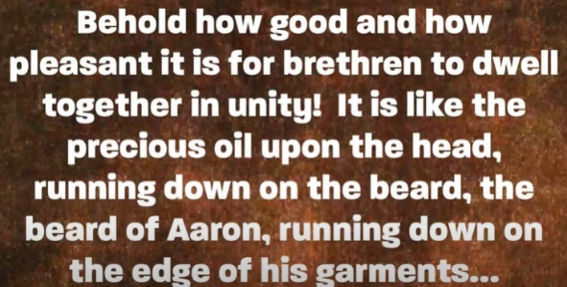

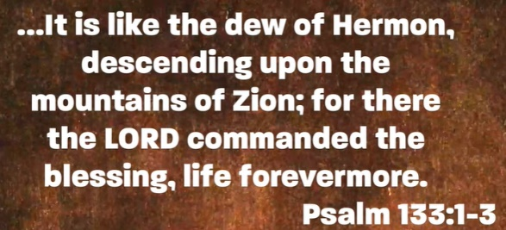

Vocabulary:

Behold: 看

Bible Excerption:

# **Psalm 133**

# **New International Version**

### Psalm 133

#### A song of ascents. Of David.

**1**How good and pleasant it is when God’s people live together in unity!

**2**It is like precious oil poured on the head, running down on the beard, running down on Aaron’s beard, down on the collar of his robe.  
**3**It is as if the dew of Hermon were falling on Mount Zion.  
For there the Lord bestows his blessing, even life forevermore.

Explanation:

The power explodes like mighty wind.

**I. THE MIGHTY RUSHING WIND - verses 2**

Bible Excerption:

**2**When the day of Pentecost came, they were all together in one place. **2**Suddenly a sound like the blowing of a violent wind came from heaven and filled the whole house where they were sitting.

Explanation:



Holy spirit is on the move we cannot see. The storm blow and spirit come down. Everyone is born through the spirit. We cannot see the wind but we can see the tree move.

**• Tongues of fire**

Tongues of fire (圣灵降临火舌):

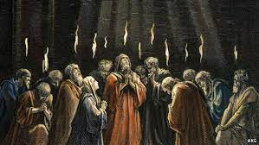

Bible Excerption:

Explanation:



**II. THEY ALL BEGAN TO SPEAK IN UNKNOWN LANGUAGES - verses 4-5**

Bible Excerption:

**4**All of them were filled with the Holy Spirit and began to speak in other tongues[[a](https://www.biblegateway.com/passage/?search=Acts%202%3A1-15&version=NIV#fen-NIV-26954a)] as the Spirit enabled them. **5**Now there were staying in Jerusalem God-fearing Jews from every nation under heaven.

Explanation:

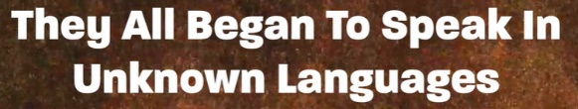

The people in the Pentecost Sunday. The tongues is 17 languages from different counties.

**III. COMING UNDER THE INFLUENCE - verses 13-17**

Bible Excerption:

# **Acts 2:13-17**

# **New International Version**

**13**Some, however, made fun of them and said, “They have had too much wine.”

### Peter Addresses the Crowd

**14**Then Peter stood up with the Eleven, raised his voice and addressed the crowd: “Fellow Jews and all of you who live in Jerusalem, let me explain this to you; listen carefully to what I say. **15**These people are not drunk, as you suppose. It is only nine in the morning! **16**No, this is what was spoken by the prophet Joel:

**17**“‘In the last days, God says, I will pour out my Spirit on all people. Your sons and daughters will prophesy, your young men will see visions, your old men will dream dreams.

Explanation:



**• Do not get drunk on wine, which leads to debauchery. Instead, be filled with the Spirit. - Ephesians 5:18**

Bible Excerption:

# **Ephesians 5:18**

# **New International Version**

**18**Do not get drunk on wine, which leads to debauchery. Instead, be filled with the Spirit,

Explanation:

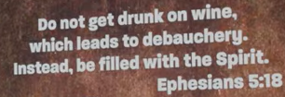

**IV. HOLY SPIRIT COME**

Explanation:

Summary of today topic: “Fresh wind, fresh fire.”

1. From Holy Spirit, we will receive the dynamite power. Holy Spirit is essential for the power.

When you connect the power, you can transform the power. The Holy Spirit tab in, we have power.

2. What is Pentecost?

2.1 Pentecost (五旬节) [also called Whit Sunday (圣灵降临节), Whitsunday or [Whitsun](https://en.wikipedia.org/wiki/Whitsun)] is a [Christian](https://en.wikipedia.org/wiki/Christianity) holiday which takes place on the 50th day (the seventh Sunday) after [Easter Sunday](https://en.wikipedia.org/wiki/Easter_Sunday).

2.2 In Pentecost, the [Holy Spirit](https://en.wikipedia.org/wiki/Holy_Spirit) come on the [Apostles](https://en.wikipedia.org/wiki/Apostles_in_the_New_Testament) (使徒) and other followers in 10 days. The combination of fast into one heart and power come from Holy Spirit.

3. Holy spirit is on the move we cannot see. The storm blow and spirit come down. Everyone is born through the spirit. We cannot see the wind but we can see the tree move.

4. What is “Tongues of Fire (圣灵降临;火舌)”?

In the Pentecost Sunday, God dialect like fire burns separated among the apostles.

5. The people in the Pentecost Sunday. The tongues are dialect from 17 languages from different counties.