06/04/2023, 8:30am, 10:30am: Sunday Worship

<https://www.youtube.com/watch?v=1QytQ8Tstbo>

Class Note: <https://static1.squarespace.com/static/5e4c80df9c80885b56806c76/t/647bd90f9c2ddd18a104965c/1685838095453/Daniel+Notes+060423.pdf>

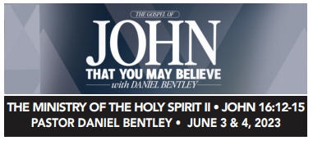

Bible Excerption:

# **John 16:12-15**

# **New King James Version**

**12**“I still have many things to say to you, but you cannot bear *them* now. **13**However, when He, the Spirit of truth, has come, He will guide you into all truth; for He will not speak on His own *authority,* but whatever He hears He will speak; and He will tell you things to come. **14**He will glorify Me, for He will take of what is Mine and declare *it* to you. **15**All things that the Father has are Mine. Therefore I said that He [[a](https://www.biblegateway.com/passage/?search=John%2016%3A12-15&version=NKJV#fen-NKJV-26742a)]will take of Mine and declare *it* to you.

Explanation:

This Wednesday, “We will gather, we will worship, and God will come.”

We are in Sivan month (June) of Jewish calendar.

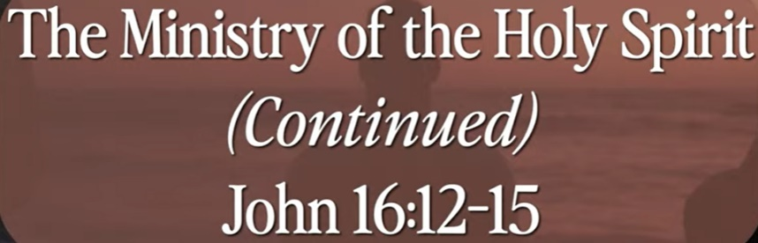

God is upon me for yours.

God has three steps for Holy Spirits:

Inspiration, Illumination, revelation.

Holy spirt will guide you all the truth.

**I. INSPIRATION - verses 12-15**

Explanation:



We do not really know what is God plan.

Later on, we will all clear about what God means.

The Bible is divinely inspiration from God.

**• All Scripture is inspired by God and is useful to teach us what is true and to make us realize what is wrong in our lives. It corrects us when we are wrong and teaches us to do what is right. - II Timothy 3:16**

Bible Excerption:

# **2 Timothy 3:16**

# **New King James Version**

**16**All Scripture *is* given by inspiration of God, and *is* profitable for doctrine, for reproof, for correction, for [[a](https://www.biblegateway.com/passage/?search=II+Timothy+3%3A16+&version=NKJV#fen-NKJV-29870a)]instruction in righteousness,

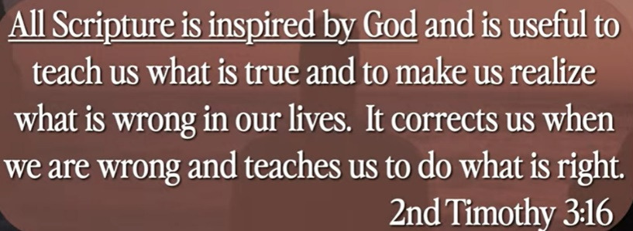

Explanation:

This book is come from heaven.

All scripture is inspired by God. It tells us when we are wrong and teaches us to do what is right.

Bible is 66 books and collected for 16 hundreds of years and translated into 700 languages.

**II. ILLUMINATION - verse 13b**

Bible Excerption:

**13**However, when He, the Spirit of truth, has come, He will guide you into all truth; for He will not speak on His own *authority,* but whatever He hears He will speak; and He will tell you things to come.

Explanation:



Illumination come from Greek works, enlightening.

God highlight his word all the time but we may not aware of it.

**III. REVELATION - verses 13c-14**

**13**However, when He, the Spirit of truth, has come, He will guide you into all truth; for He will not speak on His own *authority,* but whatever He hears He will speak; and He will tell you things to come. **14**He will glorify Me, for He will take of what is Mine and declare *it* to you.

Explanation:

The revelation is from Jesus Christ. God give Jesus Christ to show his servants.

Jesus glorified God and tell us the things to come. Jesus’ word is from alpha to omega, Jesus tells us everything about the heaven.

The John book shows inspiration, illumination, and a revelation.



Summary of today topic: “The Ministry of Holy Spirit (II)”

God’s Holy spirit comes into three steps:

1. Inspiration: The Bible is divinely inspiration from God. Bible contains 66 books, collected from 1600 years, and translate into 700 languages.

2. Illumination: The illumination word come from Greek word enlightening. God highlight his words to us all the time but we may not aware of it.

3. Revelation: Jesus Christ, show his servant, glorified God, salvation, and tell us the things will come. Jesus tells us from Alpha to Omega, everything about the heave.