06/11/2023, 6:00pm, Saturday/8:30am, Sunday Worship

<https://www.youtube.com/watch?v=70CBWLBDsTc>

Class Note: <https://static1.squarespace.com/static/5e4c80df9c80885b56806c76/t/648513a974ae007e6994b2a1/1686442921262/Daniel+Notes+061123.pdf>



(45:56/1:39:30)

Explanation:

We discussed John 16:16-33.



Bible Exception:

**John 16:16-33**

**New International Version**

The Disciples’ Grief Will Turn to Joy **16**Jesus went on to say, “In a little while you will see me no more, and then after a little while you will see me.” **17**At this, some of his disciples said to one another, “What does he mean by saying, ‘In a little while you will see me no more, and then after a little while you will see me,’ and ‘Because I am going to the Father’?” **18**They kept asking, “What does he mean by ‘a little while’? We don’t understand what he is saying.”**19**Jesus saw that they wanted to ask him about this, so he said to them, “Are you asking one another what I meant when I said, ‘In a little while you will see me no more, and then after a little while you will see me’? **20**Very truly I tell you, you will weep and mourn while the world rejoices. You will grieve, but your grief will turn to joy. **21**A woman giving birth to a child has pain because her time has come; but when her baby is born, she forgets the anguish because of her joy that a child is born into the world. **22**So with you: Now is your time of grief, but I will see you again and you will rejoice, and no one will take away your joy. **23**In that day you will no longer ask me anything. Very truly I tell you, my Father will give you whatever you ask in my name. **24**Until now you have not asked for anything in my name. Ask and you will receive, and your joy will be complete.

**25**“Though I have been speaking figuratively, a time is coming when I will no longer use this kind of language but will tell you plainly about my Father. **26**In that day you will ask in my name. I am not saying that I will ask the Father on your behalf. **27**No, the Father himself loves you because you have loved me and have believed that I came from God. **28**I came from the Father and entered the world; now I am leaving the world and going back to the Father.”

**29**Then Jesus’ disciples said, “Now you are speaking clearly and without figures of speech. **30**Now we can see that you know all things and that you do not even need to have anyone ask you questions. This makes us believe that you came from God.”

**31**“Do you now believe?” Jesus replied. **32**“A time is coming and in fact has come when you will be scattered, each to your own home. You will leave me all alone. Yet I am not alone, for my Father is with me.

**33**“I have told you these things, so that in me you may have peace. In this world you will have trouble. But take heart! I have overcome the world.”

**I. JOY THAT CAN’T BE SHAKEN - verses 16-22**

Bible Exception:

### The Disciples’ Grief Will Turn to Joy

**16**Jesus went on to say, “In a little while you will see me no more, and then after a little while you will see me.”

**17**At this, some of his disciples said to one another, “What does he mean by saying, ‘In a little while you will see me no more, and then after a little while you will see me,’ and ‘Because I am going to the Father’?” **18**They kept asking, “What does he mean by ‘a little while’? We don’t understand what he is saying.”

**19**Jesus saw that they wanted to ask him about this, so he said to them, “Are you asking one another what I meant when I said, ‘In a little while you will see me no more, and then after a little while you will see me’? **20**Very truly I tell you, you will weep and mourn while the world rejoices. You will grieve, but your grief will turn to joy. **21**A woman giving birth to a child has pain because her time has come; but when her baby is born she forgets the anguish because of her joy that a child is born into the world. **22**So with you: Now is your time of grief, but I will see you again and you will rejoice, and no one will take away your joy.

Explanation:

You will not see me a little while. No one can take the joy from you.

The angel will transform the joy.

**• Weeping may endure for a night, but joy comes in the morning. - Psalm 30:5**



Bible Exception:

# **Psalm 30:5**

# **New International Version**

**5**For his anger lasts only a moment, but his favor lasts a lifetime;  
weeping may stay for the night, but rejoicing comes in the morning.

Explanation:

No matter how hard in the night, the joy will come in the morning.

You pray for joy. Joy will come in the morning.

**II. IN A LITTLE WHILE…**

Explanation:



In a little while, you will see me. I am coming soon.

**• But you must not forget this one thing, dear friends: a day is like a thousand years to the Lord, and a thousand years is like a day. The Lord isn’t really being slow about His promise, as some people think. No, He is being patient for your sake. He doesn’t want anyone to be destroyed but wants everyone to repent. - II Peter 3:8-9**

Explanation:

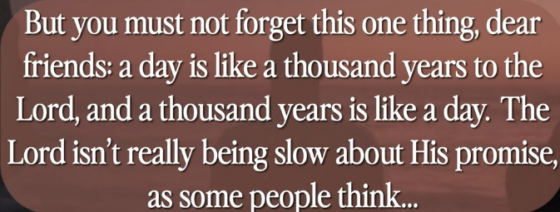

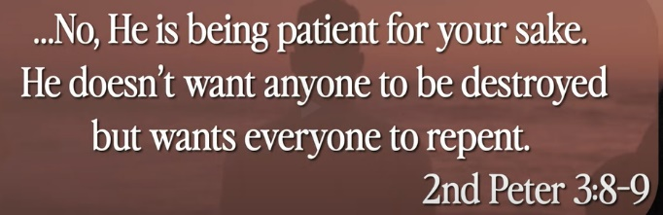

Why is taking so long? To god, a day like a thousand years for human being.

We can rejoice any suffering during the years. No more suffering in waiting.

It takes longer to see Jesus. We will see Jesus. It takes longer. This is incredible opportunity.

To pray is to access the heavy resources. God knows what you pray. God will complete your pray with joy in his name. This is radical revolution.

Bible Exception

# **2 Peter 3:8-9**

# **New International Version**

**8**But do not forget this one thing, dear friends: With the Lord a day is like a thousand years, and a thousand years are like a day. **9**The Lord is not slow in keeping his promise, as some understand slowness. Instead, he is patient with you, not wanting anyone to perish, but everyone to come to repentance.

**• Therefore, since we have a great high priest who has ascended into heaven, Jesus the Son of God, let us hold firmly to the faith we profess…’ ‘Let us then approach God’s throne of grace with confidence, so that we may receive mercy and find grace to help us in our time of need. - Hebrews 4:14 & 16**

Bible Exception

# **Hebrews 4:14-16**

# **New International Version**

### Jesus the Great High Priest

**14**Therefore, since we have a great high priest who has ascended into heaven,[[a](https://www.biblegateway.com/passage/?search=Hebrews+4%3A14-16&version=NIV#fen-NIV-30029a)] Jesus the Son of God, let us hold firmly to the faith we profess. **15**For we do not have a high priest who is unable to empathize with our weaknesses, but we have one who has been tempted in every way, just as we are—yet he did not sin. **16**Let us then approach God’s throne of grace with confidence, so that we may receive mercy and find grace to help us in our time of need.

Explanation:

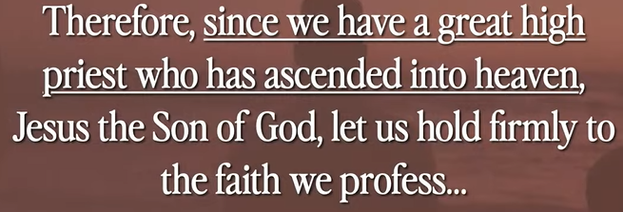

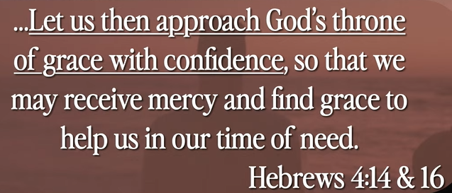

Vocabulary:

Profess: 宣称, declare

Explanation:

Pray for the God, he will respond you. God will not respond you unless you pray.

You pray with Jesus’ name. God will respond you.

**III. PEACE THAT CAN’T BE TAKEN - verses 29-33**

Bible Exception

# **John 16:29-33**

# **New International Version**

**29**Then Jesus’ disciples said, “Now you are speaking clearly and without figures of speech. **30**Now we can see that you know all things and that you do not even need to have anyone ask you questions. This makes us believe that you came from God.”

**31**“Do you now believe?” Jesus replied. **32**“A time is coming and in fact has come when you will be scattered, each to your own home. You will leave me all alone. Yet I am not alone, for my Father is with me.

**33**“I have told you these things, so that in me you may have peace. In this world you will have trouble. But take heart! I have overcome the world.”

Explanation:



True peace can not be taken. It is a gift from Jesus and God.

**• But God raised Him from the dead, freeing Him from the agony of death, because it was impossible for death to keep its hold on Him. - Acts 2:24**

Bible Exception

# **Acts 2:24**

# **New International Version**

**24**But God raised him from the dead, freeing him from the agony of death, because it was impossible for death to keep its hold on him.

Explanation:

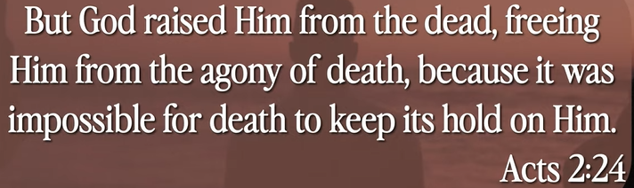

Summary of today topic: “Joy and Peace in the Troubled World.”

1. Before Jesus is crucified, he said, “It will take a while to see me again. “When the night will be over and you will see me in the morning.”

2. Why take so long to see Jesus again? For God, one day takes one thousand years for human being.

3. Acts: “God raised Jesus from the dead, freeing Jesus from the pain of death.”

4. “Peace that Jesus given to us cannot be taken”.

5. Pray is th0e only way to access heaven resource, pray for God, God will respond.