06/17/2023, 6:00pm, Saturday/8:30am, Sunday Worship

<https://www.youtube.com/watch?v=JfSWokr2GL0>

Class Note: <https://static1.squarespace.com/static/5e4c80df9c80885b56806c76/t/648e4f4edec9b927ee05a69b/1687048015029/Daniel+Notes061823.pdf>



(47:35/1:44:25)

Bible Exception:

### Jesus Prays to Be Glorified

**17**After Jesus said this, he looked toward heaven and prayed:

“Father, the hour has come. Glorify your Son, that your Son may glorify you. **2**For you granted him authority over all people that he might give eternal life to all those you have given him. **3**Now this is eternal life: that they know you, the only true God, and Jesus Christ, whom you have sent. **4**I have brought you glory on earth by finishing the work you gave me to do. **5**And now, Father, glorify me in your presence with the glory I had with you before the world began.

Explanation:

Welcome online family. Happy Father day weekend.

Thanks you father to open your scripter.





Model prayer:

This model prayer, also called “The Lord's Prayer,” covers every aspect of prayer. It can be divided into two parts.

The first three components of the prayer deal with God's glory: “Hallowed be Your name,” “Your Kingdom come,” and “Your will be done.”

The second three components of the model prayer deal with our need.

Lord Player: What are the words of the Lord's prayer?

Our Father, who art in heaven, hallowed be thy name; thy kingdom come; thy will be done on earth as it is in heaven. Give us this day our daily bread; and forgive us our trespasses as we forgive those who trespass against us; and lead us not into temptation, but deliver us from evil. Amen.

**I. A GLORIOUS PRAYER**

Explanation:



**II. WHERE IS ETERNAL LIFE FOUND? - verses 2-3**

Bible Exception:

**2**For you granted him authority over all people that he might give eternal life to all those you have given him. **3**Now this is eternal life: that they know you, the only true God, and Jesus Christ, whom you have sent.

Explanation:



Jesus thought about the eternal life: This is only true God

**III. KNOWING THE ONE TRUE GOD**

Bible Exception:

Explanation:



**• They know the truth about God because He has made it obvious to them. For ever since the world was created, people have seen the earth and sky. Through everything God made, they can clearly see His invisible qualities—His eternal power and divine nature. So they have no excuse for not knowing God. - Romans 1:19-20**

Bible Exception:

# **Romans 1:19-20**

# **New International Version**

**19**since what may be known about God is plain to them, because God has made it plain to them. **20**For since the creation of the world God’s invisible qualities—his eternal power and divine nature—have been clearly seen, being understood from what has been made, so that people are without excuse.

Explanation:

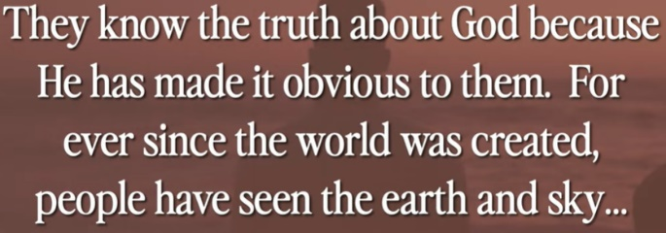

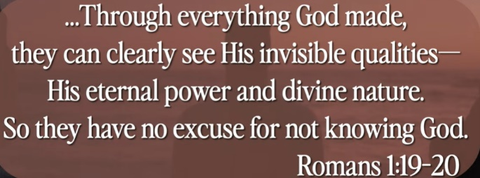

God reveal himself in everywhere. Sunshine and sunset.

God is complete and fully understand. Jesus came down from heaven and showed us what is Gid like for 33 years. Do you know him?

**IV. THE ONLY QUESTION THAT REALLY MATTERS**

Bible Exception:

Explanation:



The question is: Do you really know him? Do you know by Jesus?

Personal, Experience

**• So let us press on to know the Lord - Hosea 6:3**

Bible Exception:

# **Hosea 6:3**

# **New International Version**

**3**Let us acknowledge the Lord; let us press on to acknowledge him. As surely as the sun rises, he will appear; he will come to us like the winter rains, like the spring rains that water the earth.”

Explanation:



We press on deeper, longer, continue to grow, to know God.

It is infinity grow. It takes millions of years, still continue to know God.

**V. THE WORK IS FINISHED - verse 4**

Bible Exception:

**4**I have brought you glory on earth by finishing the work you gave me to do.

Explanation:



**• The reason the Son of God appeared was to destroy the devil’s work. -I John 3:8**

Bible Exception:

# **1 John 3:8**

# **New International Version**

**8**The one who does what is sinful is of the devil, because the devil has been sinning from the beginning. The reason the Son of God appeared was to destroy the devil’s work.

Explanation:

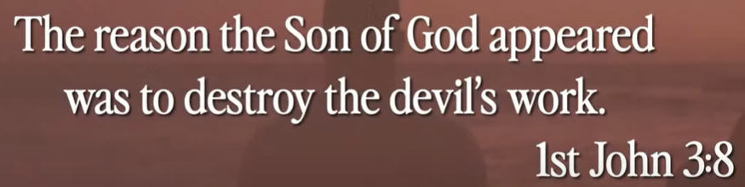

Jesus came is to destroy the devil’s work. The devil work is to cheat, fraud, earthquake, etc. Jesus come down the world just to destroy the devil’s world.

Summary of today’s topic: “How to have Eternal Life”

1. What is Model prayer (Lord Prayer)?

Ans: The model prayer, also called “The Lord's Prayer,” covers every aspect of prayer. It can be divided into two parts.

1. The first three components of the prayer deal with God's glory: “Hallowed be Your name,” “Your Kingdom come,” and “Your will be done.”
2. The second three components of the model prayer deal with our need.
3. Lord Player Example: Our Father, who art in heaven, hallowed be your name; your kingdom come; you will be done on earth as it is in heaven. Give us this day our daily bread; and forgive us our trespasses as we forgive those who trespass against us; and lead us not into temptation, but deliver us from evil. Amen.

2. Where is Eternal life?

Ans:

a) The question is: Do you really know God? Do you know Jesus?

b) We press on deeper, longer, continue to grow, to know God. It is infinity grow. It takes millions of years, still continue to know God.

3. Where is important of eternal life?

Ans:

The important thing is Jesus came down from Heaven and destroy the devil’s work. The devil work is to cheat, fraud, earthquake, etc. Jesus come down the world just to destroy the devil’s world. This is an incredible gift from God. We believe he is coming back soon.