06/25/2023, 6:00pm, Saturday/8:30am, 10:30am, Sunday Worship

https://www.youtube.com/watch?v=L4WDrriuBrg

Class Note: <https://static1.squarespace.com/static/5e4c80df9c80885b56806c76/t/64978c3a297cff6342829972/1687653434377/Daniel+Notes062523.pdf>





(43:20/1:35:10)

Bible Exception:

# **John 17:6-19**

# **New International Version**

### Jesus Prays for His Disciples

**6**“I have revealed you[[a](https://www.biblegateway.com/passage/?search=John%2017%3A6-19&version=NIV#fen-NIV-26766a)] to those whom you gave me out of the world. They were yours; you gave them to me and they have obeyed your word. **7**Now they know that everything you have given me comes from you. **8**For I gave them the words you gave me and they accepted them. They knew with certainty that I came from you, and they believed that you sent me. **9**I pray for them. I am not praying for the world, but for those you have given me, for they are yours. **10**All I have is yours, and all you have is mine. And glory has come to me through them. **11**I will remain in the world no longer, but they are still in the world, and I am coming to you. Holy Father, protect them by the power of[[b](https://www.biblegateway.com/passage/?search=John%2017%3A6-19&version=NIV#fen-NIV-26771b)] your name, the name you gave me, so that they may be one as we are one. **12**While I was with them, I protected them and kept them safe by[[c](https://www.biblegateway.com/passage/?search=John%2017%3A6-19&version=NIV#fen-NIV-26772c)] that name you gave me. None has been lost except the one doomed to destruction so that Scripture would be fulfilled.

**13**“I am coming to you now, but I say these things while I am still in the world, so that they may have the full measure of my joy within them. **14**I have given them your word and the world has hated them, for they are not of the world any more than I am of the world. **15**My prayer is not that you take them out of the world but that you protect them from the evil one. **16**They are not of the world, even as I am not of it. **17**Sanctify them by[[d](https://www.biblegateway.com/passage/?search=John%2017%3A6-19&version=NIV#fen-NIV-26777d)] the truth; your word is truth. **18**As you sent me into the world, I have sent them into the world. **19**For them I sanctify myself, that they too may be truly sanctified.

Explanation:

Spinal pain can be recovered through the pray without surgery.

Pray:

Father will come alive from heaven. In the Jesus name, amen.

Today topic:

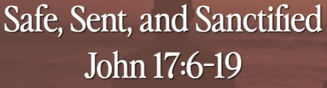

I am not praying for the world. I am praying to you. All I have is yours. All you have is mine.

Sanctified: 成圣的

Jesus does not protect the whole world. Jesus only protected you. We are in the security system.

**I. JESUS PRAYS FOR US TO BE SAFE - verses 6-12**

Bible Exception:

**6**“I have revealed you to those whom you gave me out of the world. They were yours; you gave them to me and they have obeyed your word. **7**Now they know that everything you have given me comes from you. **8**For I gave them the words you gave me and they accepted them. They knew with certainty that I came from you, and they believed that you sent me. **9**I pray for them**. I am not praying for the world, but for those you have given me, for they are yours.** **10**All I have is yours, and all you have is mine. And glory has come to me through them. **11**I will remain in the world no longer, but they are still in the world, and I am coming to you. Holy Father, protect them by the power of your name, the name you gave me, so that they may be one as we are one. **12**While I was with them, **I protected them and kept them safe by that name you gave me**. None has been lost except the one doomed to destruction so that Scripture would be fulfilled.

Explanation:

**• Indeed, He who watches over Israel will neither slumber nor sleep. The LORD watches over you—the Lord is your shade at your right hand. - Psalm 121:4-5**

Bible Exception:

# **Psalm 121:4-5**

# **New International Version**

**4**indeed, he who watches over Israel will neither slumber nor sleep. **5**The Lord watches over you — the Lord is your shade at your right hand;

Explanation:

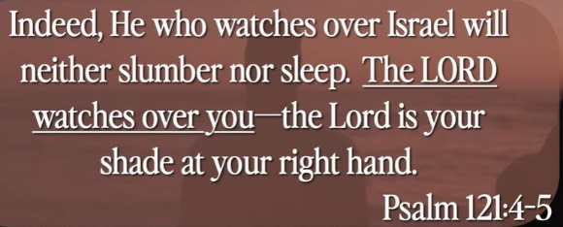

Vocabulary:

Slumber: 睡眠

**• The name of the Lord is a strong tower; the righteous run into it and are safe. - Proverbs 18:10**

Bible Exception:

# **Proverbs 18:10**

# **New International Version**

**10**The name of the Lord is a fortified tower; the righteous run to it and are safe.

Explanation:

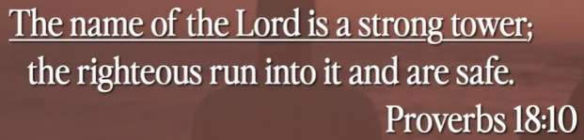

**II. JESUS PRAYS FOR US TO BE SENT - verses 14-18**

Bible Exception:

**14**I have given them your word and the world has hated them, for they are not of the world any more than I am of the world. **15**My prayer is not that you take them out of the world but that you protect them from the evil one. **16**They are not of the world, even as I am not of it. **17**Sanctify them by[[d](https://www.biblegateway.com/passage/?search=John%2017%3A6-19&version=NIV#fen-NIV-26777d)] the truth; your word is truth. **18**As you sent me into the world, I have sent them into the world. **19**For them I sanctify myself, that they too may be truly sanctified.

Explanation:



Sometimes,

**• How then, can they call on the one they have not believed in? And how can they believe in the one of whom they have not heard? And how can they hear without someone preaching to them? - Romans 10:14**

Bible Exception:

# **Romans 10:14**

# **New International Version**

**14**How, then, can they call on the one they have not believed in? And how can they believe in the one of whom they have not heard? And how can they hear without someone preaching to them?

Explanation:

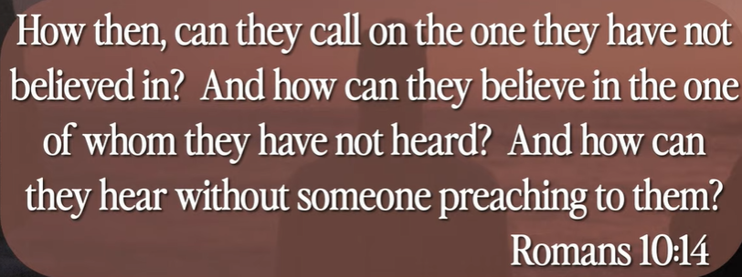

**• Do not love the world or the things in the world. If anyone loves the world, the love of the Father is not in him. For all that is in the world, the desires of the flesh and the desires of the eyes and pride of life, is not from the Father but is from the world. And the world is passing away along with its desires, but whoever does the will of God abides forever - I John 2:15-17**

Bible Exception:

# **1 John 2:15-17**

# **New International Version**

### On Not Loving the World

**15**Do not love the world or anything in the world. If anyone loves the world, love for the Father[[a](https://www.biblegateway.com/passage/?search=I+John+2%3A15-17+&version=NIV#fen-NIV-30566a)] is not in them. **16**For everything in the world—the lust of the flesh, the lust of the eyes, and the pride of life—comes not from the Father but from the world. **17**The world and its desires pass away, but whoever does the will of God lives forever.

Explanation:

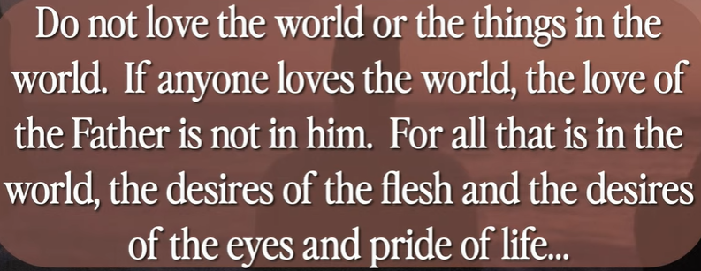

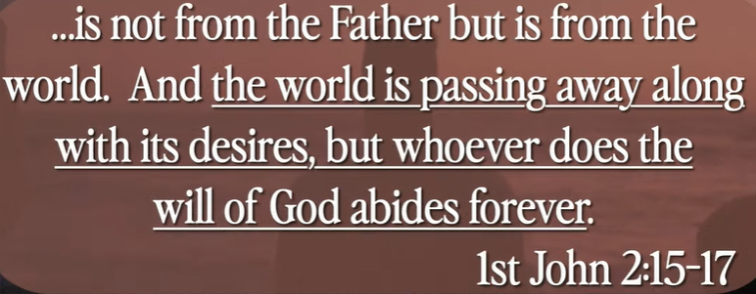

We love and live the world which have the Lord abided forever. Exactly like the Jesus.

How do you manage to do that?

**III. JESUS PRAYS FOR US TO BE SANCTIFIED - verses 17- 19**

Bible Exception:

**17**Sanctify them by the truth; your word is truth. **18**As you sent me into the world, I have sent them into the world. **19**For them I sanctify myself, that they too may be truly sanctified.

Explanation:



What is that? You are sanctified by Jesus with the truth. Jesus’ word is truth. We sent Jesus to the real world from heaven.

**• Let the word of Christ dwell in you richly, teaching and admonishing one another in all wisdom, singing psalms and hymns and spiritual songs, with thankfulness in your hearts to God. - Colossians 3:16**

Bible Exception:

# **Colossians 3:16**

# **New International Version**

**16**Let the message of Christ dwell among you richly as you teach and admonish one another with all wisdom through psalms, hymns, and songs from the Spirit, singing to God with gratitude in your hearts.

Explanation:

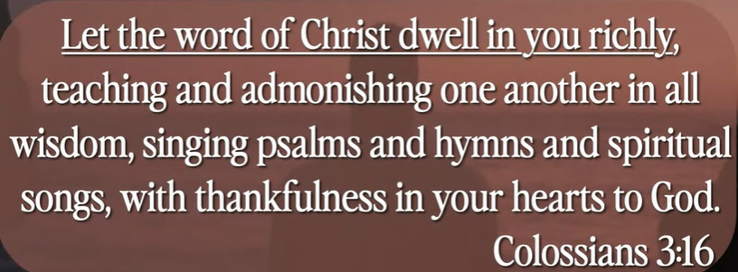

Summary of today topic: Safe, Sent, and Sanctified

1. In John 17:6-19, Jesus does not protect the whole world. Jesus only protects us who believe him. Jesus was sent from heaven to earth for us. Jesus is sanctified to the heaven.

2. You are safe and sanctified with Jesus.