07/09/2023, 6pm, Saturday, 8:30am, 10:30am, Sunday Worship

<https://www.youtube.com/watch?v=c7jj97Pj9VM>

Class Note:

<https://static1.squarespace.com/static/5e4c80df9c80885b56806c76/t/64a5f7b5f5f6ab5b63f4c2ce/1688598453754/Notes+7%3A9.pdf>



Bible excerption:

# **John 8:1-11**

# **King James Version**

**8**Jesus went unto the mount of Olives. **2**And early in the morning he came again into the temple, and all the people came unto him; and he sat down, and taught them.

**3**And the scribes and Pharisees brought unto him a woman taken in adultery; and when they had set her in the midst, **4**They say unto him, Master, this woman was taken in adultery, in the very act. **5**Now Moses in the law commanded us, that such should be stoned: but what sayest thou?

**6**This they said, tempting him, that they might have to accuse him. But Jesus stooped down, and with his finger wrote on the ground, as though he heard them not.

**7**So when they continued asking him, he lifted up himself, and said unto them, He that is without sin among you, let him first cast a stone at her.

**8**And again he stooped down, and wrote on the ground.

**9**And they which heard it, being convicted by their own conscience, went out one by one, beginning at the eldest, even unto the last: and Jesus was left alone, and the woman standing in the midst.

**10**When Jesus had lifted up himself, and saw none but the woman, he said unto her, Woman, where are those thine accusers? hath no man condemned thee?

**11**She said, No man, Lord. And Jesus said unto her, Neither do I condemn thee: go, and sin no more.

Explanation:

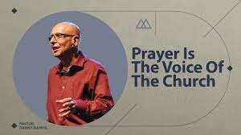

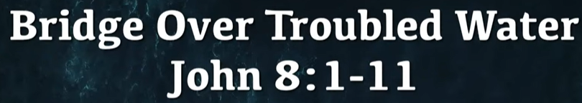

**I. GOD DOESN’T TREAT US AS OUR SINS DESERVE**

Bible excerption:

Explanation:

**• Psalm 103:10 - He does not deal with us according to our sins, nor repay us according to our iniquities.**

Bible excerption:

# **Psalm 103:10**

# **King James Version**

**10**He hath not dealt with us after our sins; nor rewarded us according to our iniquities.

Vocabulary:

hath: 有

iniquities: 罪孽

Explanation:

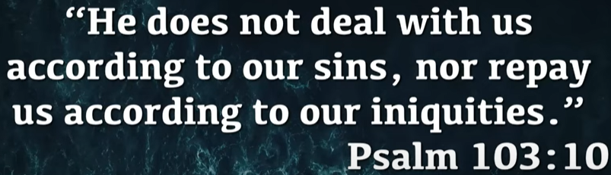

**II. THE CONDEMNED WOMAN – verses 1-11**

Bible excerption:

Jesus went unto the mount of Olives. **2**And early in the morning he came again into the temple, and all the people came unto him; and he sat down, and taught them.

**3**And the scribes and Pharisees brought unto him a woman taken in adultery; and when they had set her in the midst, **4**They say unto him, Master, this woman was taken in adultery, in the very act. **5**Now Moses in the law commanded us, that such should be stoned: but what sayest thou?

**6**This they said, tempting him, that they might have to accuse him. But Jesus stooped down, and with his finger wrote on the ground, as though he heard them not.

**7**So when they continued asking him, he lifted up himself, and said unto them, He that is without sin among you, let him first cast a stone at her.

**8**And again he stooped down, and wrote on the ground.

**9**And they which heard it, being convicted by their own conscience, went out one by one, beginning at the eldest, even unto the last: and Jesus was left alone, and the woman standing in the midst.

**10**When Jesus had lifted up himself, and saw none but the woman, he said unto her, Woman, where are those thine accusers? hath no man condemned thee?

**11**She said, No man, Lord. And Jesus said unto her, Neither do I condemn thee: go, and sin no more.

Explanation:

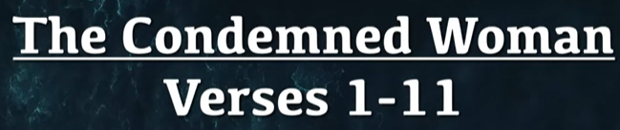

**A. THE TEMPLE – verses 1-2**

Bible excerption:

Jesus went unto the mount of Olives. **2**And early in the morning he came again into the temple, and all the people came unto him; and he sat down, and taught them.

Explanation:

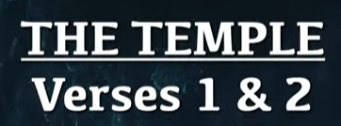

**• “Sound preaching arises out of two loves — love of the Word of God and love of people—and from them both a desire to show people God’s glorious grace.” ~ Timothy Keller**

Bible excerption:

Explanation:

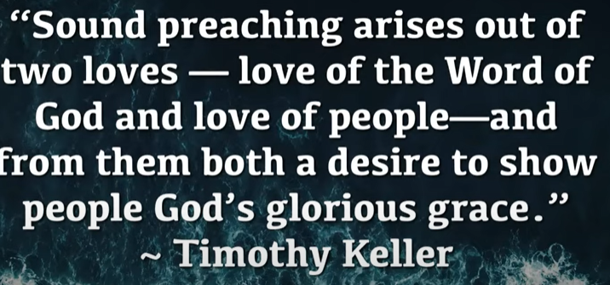

**B. THE QUESTION - verses 3-5**

Bible excerption:

**3**And the scribes and Pharisees brought unto him a woman taken in adultery; and when they had set her in the midst, **4**They say unto him, Master, this woman was taken in adultery, in the very act. **5**Now Moses in the law commanded us, that such should be stoned: but what sayest thou?

Vocabulary:

Scribes: 文士

Pharisee: 法利赛人

Adultery: 通奸

Very act: 非常行为

Explanation:



**• “The law discovers the disease; the Gospel gives the remedy.” ~ Martin Luther**

Bible excerption:

Explanation:

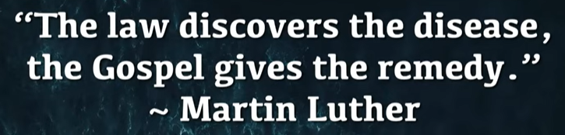

**C. THE RESPONSE - verses 6-7**

Bible excerption:

**6**This they said, tempting him, that they might have to accuse him. But Jesus stooped down, and with his finger wrote on the ground, as though he heard them not.

**7**So when they continued asking him, he lifted up himself, and said unto them, He that is without sin among you, let him first cast a stone at her.

Explanation:

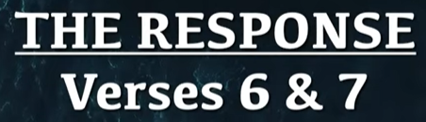

**D. THE REVEAL - verses 8-9**

Bible excerption:

**8**And again he stooped down, and wrote on the ground.

**9**And they which heard it, being convicted by their own conscience, went out one by one, beginning at the eldest, even unto the last: and Jesus was left alone, and the woman standing in the midst.

Explanation:

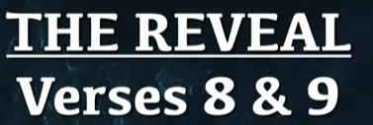

**E. THE CHARGE - verses 10-11**

Bible excerption:

**10**When Jesus had lifted up himself, and saw none but the woman, he said unto her, Woman, where are those thine accusers? hath no man condemned thee?

**11**She said, No man, Lord. And Jesus said unto her, Neither do I condemn thee: go, and sin no more.

Vocabulary:

Thine: 你的

Accuser: 控告者

Condemn: 谴责

Thee: 你

Explanation:

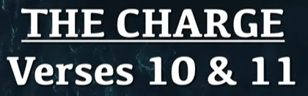

Summary of today worship “Bridge Over Troubled Water”

1. “Bridge Over Troubled Water” is a song released in January 1970 on [Columbia Records](https://en.wikipedia.org/wiki/Columbia_Records).

2. Human beings are in trouble with sin. God loves people and does not treat our sins as deserve. The law finds the sins, the gospel saves the sins.

3. A woman is trouble with adultery (通奸) and brought to the temple. No man condemns her. Jesus clears her sin.