07/16/2023, 6pm, Saturday, 8:30am, 10:30am, Sunday Worship

<https://www.youtube.com/watch?v=plZqXI7w4QI>

Class Note:

<https://static1.squarespace.com/static/5e4c80df9c80885b56806c76/t/64b338d0e9d4ce7639d01d94/1689467088565/Daniel+Notes071623.pdf>



Bible Excerption:

# **John 17:20-26**

# **New International Version**

### Jesus Prays for All Believers

**20**“My prayer is not for them alone. I pray also for those who will believe in me through their message, **21**that all of them may be one, Father, just as you are in me and I am in you. May they also be in us so that the world may believe that you have sent me. **22**I have given them the glory that you gave me, that they may be one as we are one— **23**I in them and you in me—so that they may be brought to complete unity. Then the world will know that you sent me and have loved them even as you have loved me.

**24**“Father, I want those you have given me to be with me where I am, and to see my glory, the glory you have given me because you loved me before the creation of the world.

**25**“Righteous Father, though the world does not know you, I know you, and they know that you have sent me. **26**I have made you known to them, and will continue to make you known in order that the love you have for me may be in them and that I myself may be in them.”

Explanation:

We are here with open heart. The holy full into our soul. Let your kingdom come.

John 17, Jesus prays the church with Father.



Jesus, “Father, I want those you gaven me to be with me.” “I have made you known to them”.

I talk about all the church, not the local church.

**I. JESUS PRAYS THAT WE WOULD BE ONE - verses 21-23**

Bible Excerption:

**21**that all of them may be one, Father, just as you are in me and I am in you. May they also be in us so that the world may believe that you have sent me. **22**I have given them the glory that you gave me, that they may be one as we are one— **23**I in them and you in me—so that they may be brought to complete unity. Then the world will know that you sent me and have loved them even as you have loved me.

Explanation:



We are the one which unify with god. “I am in them and you in me”.

**• This is good, and pleases God our Savior, who wants all people to be saved and to come to a knowledge of the truth. - I Timothy 2:3-4**

Bible Excerption:

# **1 Timothy 2:3-4**

# **New International Version**

**3**This is good, and pleases God our Savior, **4**who wants all people to be saved and to come to a knowledge of the truth.

Explanation:



This is good. God wants all people to be saved.

That make unity so powerful. Gid is visible but you cannot see God.

Unify with god is so powerful. We must thrive for the unity. How do we come together with God?

**• There is one body and one Spirit—just as you were called to one hope at your calling—one Lord, one faith, one baptism, one God and Father of all, who is above all and through all and in all. - Ephesians 4:5-6**

Bible Excerption:

# **Ephesians 4:5-6**

# **New International Version**

**5**one Lord, one faith, one baptism; **6**one God and Father of all, who is over all and through all and in all.

Explanation:

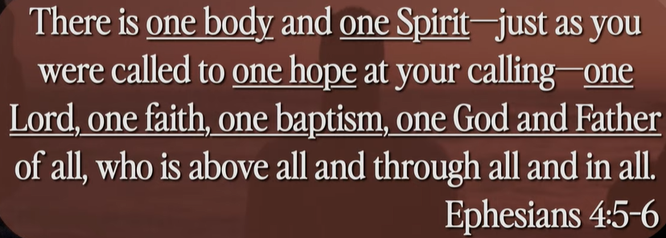

Unify is one body, one spirit, one hope, one Lord, one faith, one baptism, one God, one Father. We must unity, not liberty but Sharity.

**II. THE BASIS OF OUR UNITY - verse 21**

Bible Excerption:

**21**that all of them may be one, Father, just as you are in me and I am in you. May they also be in us so that the world may believe that you have sent me.

Explanation:



The Lord of God and us are the one. There is only one God. The three (trinity) Father, Jesus, sprit, are all together. The spirt point to son, the son point to father, the three are together. Scatter group individual. We brought them together. Glue different materials together. The definition of unity is one unit of perfect, such like Football team. We unify them together. They all have one share purpose “To win the game.” That is the same of the church. We have different functions. We gather together just have one purpose. We are the one. We unify together.

**• The human body has many parts, but the many parts make up one whole body. So, it is with the body of Christ. - I Corinthians 12:12**

Bible Excerption:

# **1 Corinthians 12:12**

# **New International Version**

### Unity and Diversity in the Body

**12**Just as a body, though one, has many parts, but all its many parts forms one body, so it is with Christ.

Explanation:

**III. JESUS PRAYS THAT WE WOULD BE WITH HIM - verse 24**

Bible Excerption:

**24**“Father, I want those you have given me to be with me where I am, and to see my glory, the glory you have given me because you loved me before the creation of the world.

Explanation



Jesus prays that we would be with Him. We will see him soon.

**• Dear friends, now we are children of God, and what we will be has not yet been made known. But we know that when Christ appears, we shall be like Him, for we shall see Him as He is. - I John 3:1**

Bible Excerption:

# **1 John 3:1**

# **New International Version**

**3**See what great love the Father has lavished on us, that we should be called children of God! And that is what we are! The reason the world does not know us is that it did not know him.

Explanation

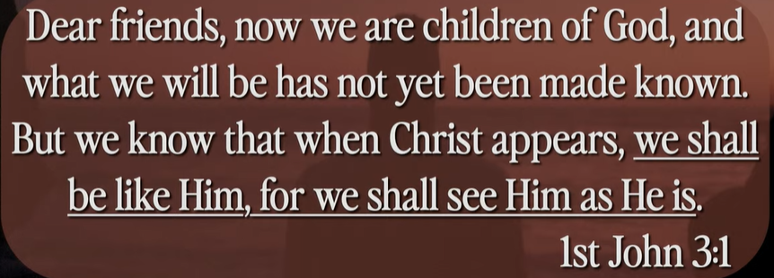

W unify first, then Christ come, we will with him and see him soon.

**IV. JESUS PRAYS THAT WE WOULD BE FULL OF LOVE - verses 25-26**

Bible Excerption:

**25**“Righteous Father, though the world does not know you, I know you, and they know that you have sent me. **26**I have made you[[a](https://www.biblegateway.com/passage/?search=John%2017%3A20-26&version=NIV#fen-NIV-26786a)] known to them, and will continue to make you known in order that the love you have for me may be in them and that I myself may be in them.”

Explanation



Jesus, “We would be full of love.” The is the glue. Unity, super natural.

Summary of today topic, “Jesus Prays for Church”

1. Jesus prays Father to be with him. Jesus introduce god to us. Jesus wants to be unified with church and God. “God, Son, Spirit” and church are whole team. We work together.

2. Jesus want us unify together with God. Unity is to glue together, not liberty but sharity.

3. Jesus prays that we would be with God. We will see God soon.