07/23/2023, 6pm, Saturday, 8:30am, 10:30am, Sunday Worship

<https://www.youtube.com/watch?v=6WTCxYSl2EA>

Class Note:

<https://static1.squarespace.com/static/5e4c80df9c80885b56806c76/t/64bc721e4d85743765289265/1690071582854/Daniel+Notes072323.pdf>



Bible Excerption:

# **John 18:1-9**

# **New International Version**

### Jesus Arrested

**18**When he had finished praying, Jesus left with his disciples and crossed the Kidron Valley. On the other side there was a garden, and he and his disciples went into it.

**2**Now Judas, who betrayed him, knew the place, because Jesus had often met there with his disciples.

**3**So Judas came to the garden, guiding a detachment of soldiers and some officials from the chief priests and the Pharisees. They were carrying torches, lanterns, and weapons.

**4**Jesus, knowing all that was going to happen to him, went out and asked them, “Who is it you want?”

**5**“Jesus of Nazareth,” they replied. “I am he,” Jesus said. (And Judas the traitor was standing there with them.)

**6**When Jesus said, “I am he,” they drew back and fell to the ground.

**7**Again he asked them, “Who is it you want?” “Jesus of Nazareth,” they said.

**8**Jesus answered, “I told you that I am he. If you are looking for me, then let these men go.”

**9**This happened so that the words he had spoken would be fulfilled: “I have not lost one of those you gave me.”

Explanation:

We are here to present to the Lord.



We had people come over this weekend from all over of the America to join the baptize.

**I. JESUS GETS BETRAYED - verses 2-3**

Bible Excerption:

**2**Now Judas, who betrayed him, knew the place, because Jesus had often met there with his disciples. **3**So Judas came to the garden, guiding a detachment of soldiers and some officials from the chief priests and the Pharisees. They were carrying torches, lanterns, and weapons.

Explanation:

Jesus is betrayed by his disciple Judas who is betrayed because of the 30 pieces of silver. Jesus often have meeting with disciples in the garden. Judas guides 200-600 soldiers with torches, lanterns, and weapons to capture Jesus.

Detachment (分离)

Pharisees (法利赛人):a [member](https://dictionary.cambridge.org/dictionary/english-chinese-simplified/member) of an [ancient](https://dictionary.cambridge.org/dictionary/english-chinese-simplified/ancient) [group](https://dictionary.cambridge.org/dictionary/english-chinese-simplified/group) of Jews, written about in the [Bible](https://dictionary.cambridge.org/dictionary/english-chinese-simplified/bible), who [believed](https://dictionary.cambridge.org/dictionary/english-chinese-simplified/believe) in [obeying](https://dictionary.cambridge.org/dictionary/english-chinese-simplified/obey) [religious](https://dictionary.cambridge.org/dictionary/english-chinese-simplified/religious) [laws](https://dictionary.cambridge.org/dictionary/english-chinese-simplified/law) very [carefully](https://dictionary.cambridge.org/dictionary/english-chinese-simplified/carefully) and [separated](https://dictionary.cambridge.org/dictionary/english-chinese-simplified/separate) themselves from the [ordinary](https://dictionary.cambridge.org/dictionary/english-chinese-simplified/ordinary) [people](https://dictionary.cambridge.org/dictionary/english-chinese-simplified/people).

**II. JESUS REVEALS HIS IDENTITY - verses 4b-6**

Bible Excerption:

**4**Jesus, knowing all that was going to happen to him, went out and asked them, “Who is it you want?”

**5**“Jesus of Nazareth,” they replied.

“I am he,” Jesus said. (And Judas the traitor was standing there with them.) **6**When Jesus said, “I am he,” they drew back and fell to the ground.

Explanation:



Jesus steps forward and show his identity, said “I am he, Jesus Nazareth.”

**• Come let us bow down in worship, let us kneel before the LORD our Maker; for He is our God, and we are the people of His pasture, the flock under His care. - Psalm 95:6-7**

Bible Excerption:

# **Psalm 95:6-7**

# **New International Version**

**6**Come, let us bow down in worship, let us kneel before the Lord our Maker;  
**7**for he is our God and we are the people of his pasture, the flock under his care.

Today, if only you would hear his voice,

Explanation:

**III. JESUS PROTECTS HIS OWN - verses 7-9**

Bible Excerption:

**7**Again he asked them, “Who is it you want?” “Jesus of Nazareth,” they said.

**8**Jesus answered, “I told you that I am he. If you are looking for me, then let these men go.” **9**This happened so that the words he had spoken would be fulfilled: “I have not lost one of those you gave me.”

Explanation:



Jesus protects other people. “Take me and forgive them.”

**• Surely, He took up our pain and bore our suffering, yet we considered Him punished by God, stricken by Him, and afflicted. But He was pierced for our transgressions, He was crushed for our iniquities; the punishment that brought us peace was on Him, and by His wounds we are healed. - Isaiah 53:4-5**

Bible Excerption:

# **Isaiah 53:4-5**

# **New International Version**

**4**Surely, he took up our pain and bore our suffering, yet we considered him punished by God, stricken by him, and afflicted.  
**5**But he was pierced for our transgressions, he was crushed for our iniquities;  
the punishment that brought us peace was on him, and by his wounds we are healed.

Explanation:

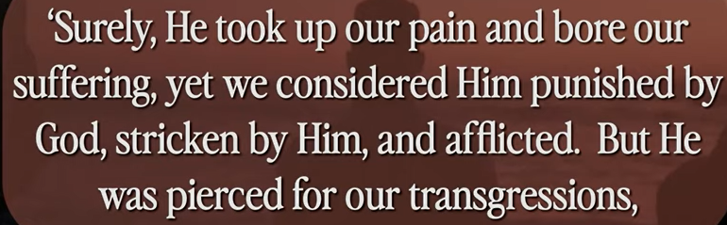

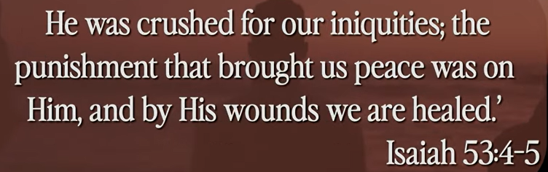

Transgression (越界)

Jesus takes all penalty and protect for us.

Summary of today’s topic, “The True Cost of Freedom”

1. Jesus is betrayed by his disciple Judas who is betrayed because of the 30 pieces of silver. Jesus often have meeting with disciples in the garden. Judas guides 200-600 soldiers with torches, lanterns, and weapons to capture Jesus.

2. Jesus steps forward and show his identity, said “I am he, Jesus Nazareth.”

3. Jesus protects other people. “Take me and forgive them.” Jesus takes all penalty and protect for us. He become the lamb for us.