12/25/2022, 8:30am, 10:30am: Sunday Worship
Online worship: https://maranathachapel.online.church/
Class Note: N/A




Song: The voice of God, His every breath.
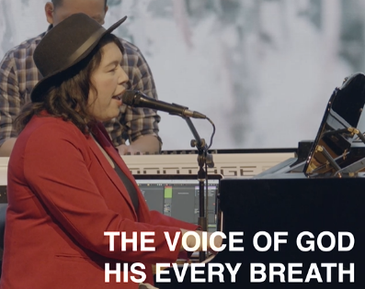
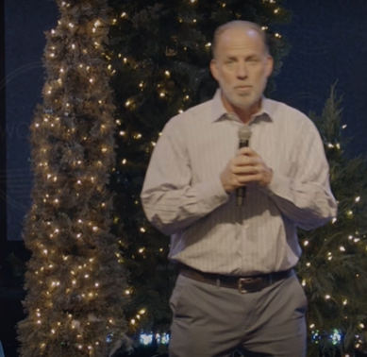
Welcome. This is Christmas day on Sunday. This is a crazy year.

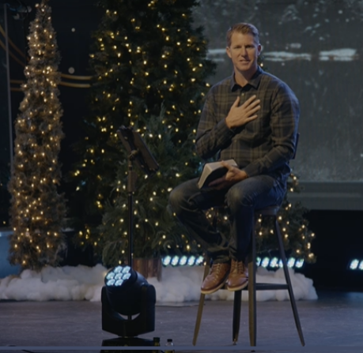
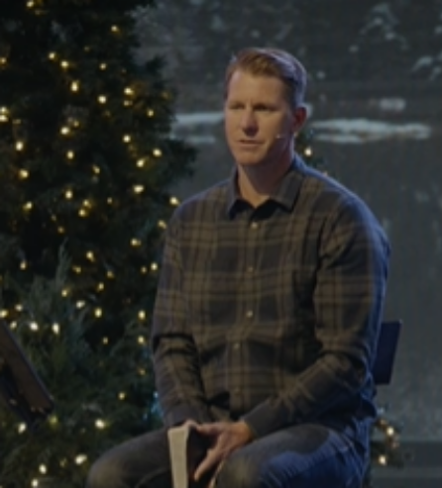
Today is Christmas day. Special day. We will look Luke, Chapter 2.
Father, you open your heart.

Luke 2: 2
New International Version
The Birth of Jesus
2 In those days Caesar Augustus issued a decree that a census should be taken of the entire Roman world. ² (This was the first census that took place while^{[a]} Quirinius was governor of Syria.) ³ And everyone went to their own town to register.

Explanation:
Jesus is born is a historical event. Once upon a time.
He was born 2000 years ago. He is impact to the history. Jesus is incredible in the human history.
He is in political event. He was worship as a God. He is the savior of the Rome.
Mary Joseph was married in Nazareth.
Jesus is departure from Haven and arrive to earth.
He is a man and millions of people worship him as a king.
He the savior of Rome.

Luke 2: 4
New International Version

⁴ So Joseph also went up from the town of Nazareth in Galilee to Judea, to Bethlehem the town of David, because he belonged to the house and line of David. ⁵ He went there to register with Mary, who was pledged to be married to him and was expecting a child. ⁶ While they were there, the time came for the baby to be born, ⁷ and she gave birth to her firstborn, a son. She wrapped him in cloths and placed him in a manger, because there was no guest room available for them.

Explanation:
Joseph is married to Mary. She is already pregnant. She said “I am pregnant”.

Luke 2: 8
New International Version

⁸ And there were shepherds living out in the fields nearby, keeping watch over their flocks at night. ⁹ An angel of the Lord appeared to them, and the glory of the Lord shone around them, and they were terrified. ¹⁰ But the angel said to them, “Do not be afraid. I bring you good news that will cause great joy for all the people. ¹¹ Today in the town of David a Savior has been born to you; he is the Messiah, the Lord. ¹² This will be a sign to you: You will find a baby wrapped in cloths and lying in a manger.”

Explanation:
There are shepherds.
The angle come to Joseph, “do not worry to marry with Mary.”

Luke 2: 13
New International Version

¹³ Suddenly a great company of the heavenly host appeared with the angel, praising God and saying,
¹⁴ “Glory to God in the highest heaven,
and on earth peace to those on whom his favor rests.”
¹⁵ When the angels had left them and gone into heaven, the shepherds said to one another, “Let’s go to Bethlehem and see this thing that has happened, which the Lord has told us about.”
¹⁶ So they hurried off and found Mary and Joseph, and the baby, who was lying in the manger. ¹⁷ When they had seen him, they spread the word concerning what had been told them about this child, ¹⁸ and all who heard it were amazed at what the shepherds said to them. ¹⁹ But Mary treasured up all these things and pondered them in her heart. ²⁰ The shepherds returned, glorifying and praising God for all the things they had heard and seen, which were just as they had been told.
²¹ On the eighth day, when it was time to circumcise the child, he was named Jesus, the name the angel had given him before he was conceived.
Explanation:
A great company from heaven with the angle, praising God and said, “Glory to God in the highest heaven.” When angles go back the heaven, the shepherds said, “Let’s go to Bethlehem and see what happened.”
The eighth day, the child was given the name “Jesus” by the angel.

Explanation:
There are three things:
1. Jesus was announced by the angles.
2. He left from the heaven
3. Jesus is born into the human being and fight for eveil.

Luke 2: 22
New International Version
Jesus Presented in the Temple
²² When the time came for the purification rites required by the Law of Moses, Joseph and Mary took him to Jerusalem to present him to the Lord ²³ (as it is written in the Law of the Lord, “Every firstborn male is to be consecrated to the Lord”^{[b]}), ²⁴ and to offer a sacrifice in keeping with what is said in the Law of the Lord: “a pair of doves or two young pigeons.”^{[c]}
²⁵ Now there was a man in Jerusalem called Simeon, who was righteous and devout. He was waiting for the consolation of Israel, and the Holy Spirit was on him. ²⁶ It had been revealed to him by the Holy Spirit that he would not die before he had seen the Lord’s Messiah. ²⁷ Moved by the Spirit, he went into the temple courts. When the parents brought in the child Jesus to do for him what the custom of the Law required, ²⁸ Simeon took him in his arms and praised God, saying:
“Sovereign Lord, as you have promised,
you may now dismiss^{[d]} your servant in peace.
³⁰ For my eyes have seen your salvation,
³¹ which you have prepared in the sight of all nations:
³² a light for revelation to the Gentiles,
and the glory of your people Israel.”

Explanation:
Joseph and Mary bring Jesus to Jerusalem and present to God in temple.
Every first-born male baby is consecrated (dedicated donate to) to the Lord.
Pray:
Jesus was born to die. He came from heaven to triumph the evil.
He is savior.
Summary:
Jesus was born at Nazareth (拿撒勒) near Bethlehem (伯利恒) on Christmas (12/25), 2000 years ago.
There are three things in Luke, chapter 2.
1. Jesus was announced the birth by the angel.
2. Jesus was from heaven to earth.
3. Jesus was born into human being and will fight for the evil.

