08/02/2025, Legacy (last week) Worship

https://www.youtube.com/live/4iJ8OxUadpY?si=mjtNNdKP6gdQAMyk

“Lost and Stuck? / Foreign Faith,” Phil EuBank, Lead Pastor



Introduction:

Mark Swarner, Campus Pastor

13:29/1:14:59



13:50

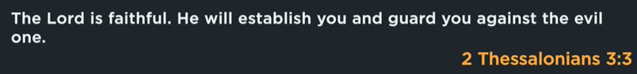

14:20

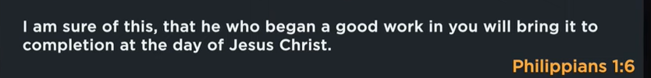

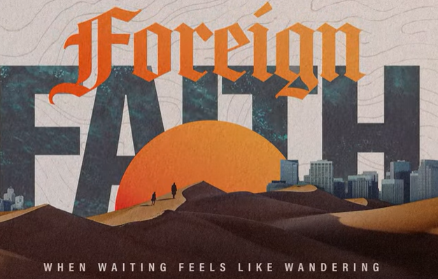

25:00

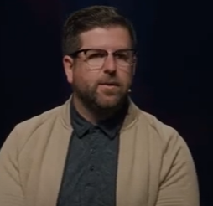

Phil EuBank, Lead Pastor

We move from Summer to the Fall. We need a rest.

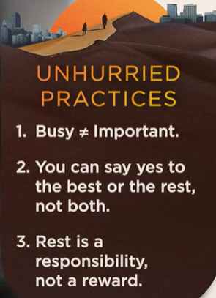

29:24

I come from Colorado, to Seattle, and settled down in Silicon Valley. There are a lot of culture change. We talk Isarael culture different.



When you feel stuck, God is just getting started.

Let’s rewind to several hundred years ago.



Genesis 37-50: Arrival

Joseph family move out of Egypt. There are culture problems.



Exodus 1:6-15: Shift

The Isarael people cry out for help when move out of Egypt.



Exodus 2:23-25: Outcry

God shows up and delivers guide.



After 430 years in Egypt, God’s people walked out Egypt.

Exodus 2:23-25

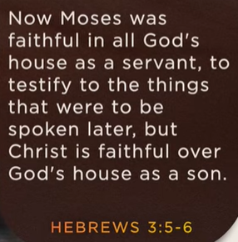

Hebrews 3:5-6



Exodus 14:3 (Dead End)

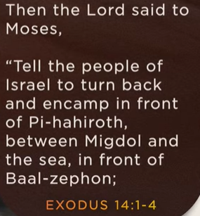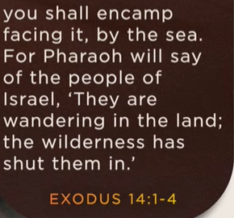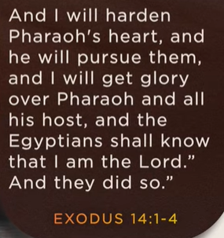

When Israel people in the dessert and get lost, God guides them to the right path.

48:00



When you feel stuck, Gid is just getting started.

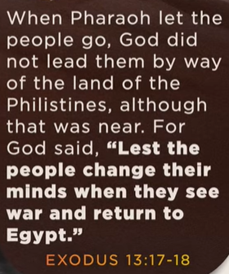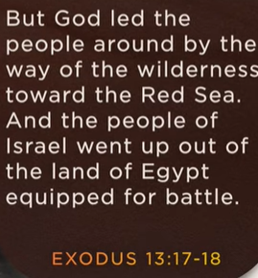



God free the slavery of Isarael people from Egypt.

God knew they’d trade freedom for familiarity.

The statement "God knew they'd trade freedom for familiarity" implies that God, with foreknowledge, recognized a human tendency to gravitate towards the familiar and known, even when the alternative (freedom) presented a better, albeit (虽然) less comfortable or certain, path.

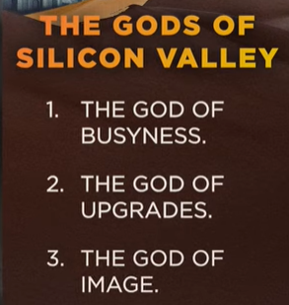

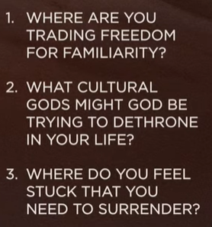

Three questions

1. Where are you trading freedom for familiarity?

2. What cultural God may break into your life?

3. Where do you feel stuck and need to surrender?

08/02/2025, Legacy (last week) Worship

https://www.youtube.com/live/4iJ8OxUadpY?si=mjtNNdKP6gdQAMyk

“Lost and Stuck? / Foreign Faith,” Phil EuBank, Lead Pastor

Summary:

Today, we talked about “Lost and Stuck” in the “Foreign Faith” Series. We are about the process of questioning and moving away from traditional religious beliefs to build a new/meaningful spirituality with individuals in the modern world.

1. Genesis 37-50 (Arrival): God helps Joseph out from slavery, jail, save his family, and nations.

2. Exodus 1:6-14 (Shift): the Israelites quickly move in Egypt, hard for Egyptian to control.

3. Exodus 2:23 (Outcry): God heard Israelites cry in Egypt, think to move them out.

4. Exodus 2:24-25 (Delivery): After Israelites 430 years in Egypt, God help them out of Egypt.

5. Hebrews 3:5-6 (Moses): Moses help Israelites out of Egypt.

6. Exodus 14:3 (Dead End): God help Isaralites out of Red Sea, dessert, and wilderness.

7. When you feel stuck, Gid is just getting started.

8. God knows human humans do not feel comfortable to move to search for freedom.

9. In silicon valley, we have situation:

9.1 Do we want freedom instead of familiarity.

9.2 Where God may break into your life?

9.3 Do you feel stuck and need to surrender?