08/09/2025, Legacy (last week) Worship

https://www.youtube.com/live/Gh6T7jrJDBg?si=2dAOR8zl4-6wAEb5

“When We Lead Ourselves / Foreign Faith,” Phil EuBank, Lead Pastor



Introduction: 9:32/1:15:56

Mark Swarner, Campus Pastor



Phil EuBank, Lead Pastor

We welcome Matt Summers for today topic “When we lead ourselves” in the seirs of “Foreign Faith”.

 

Matt Summers. Pastor of Spiritual Formation

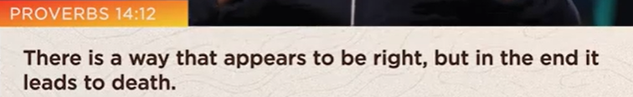

Proverbs 14:12

There is a way that appears to be right, but in the end, it leads to death.

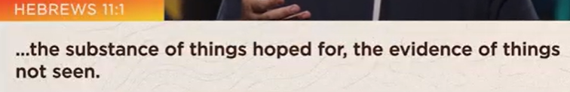

Hebrews 11:1

… The substance of things hoped for, the evidence of things not seen.



When we forget who we are, we forget whose we are.



If we don’t make peace with out past, it will define our present.

Our present is defined by the past.

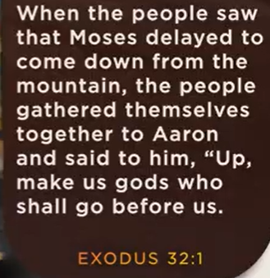 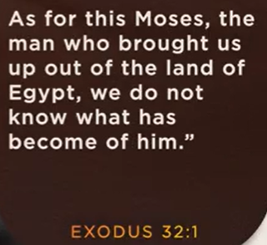

Exodus 32:1

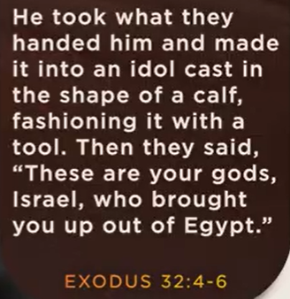

Exodus 32:4-6

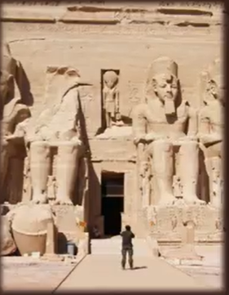



In the absence of an identity, they turned to idolatry.

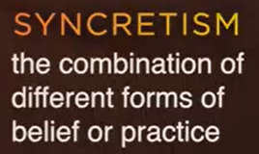

Syncretism: The combination of different forms of belief or practice



30:18



30:35/1:14:56

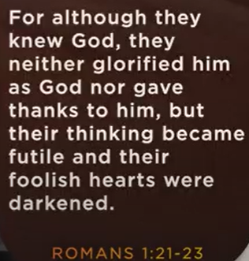

Romans 1:21-23

32:27/1:14:56

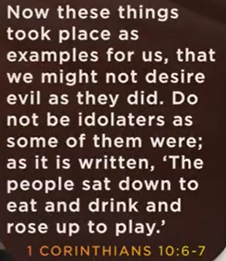

1 Corinthians 10:6-7

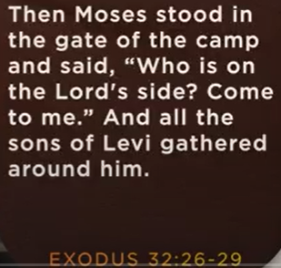 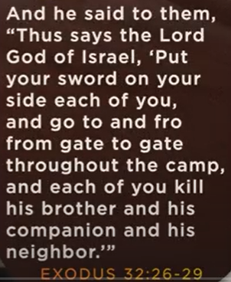 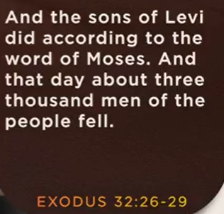

Exodus 32:26-29



Idolatry alters our identity



08/09/2025, Legacy (last week) Worship

https://www.youtube.com/live/Gh6T7jrJDBg?si=2dAOR8zl4-6wAEb5

“When We Lead Ourselves / Foreign Faith,” Phil EuBank, Lead Pastor

Summary:

We should always trust and follow God's lead when God is distant.

1. Proverbs 14:12 “There is a way that appears to be right, but in the end, it leads to death.”

Trust God's guidance leads to success.

2. Hebrews 11:1 defines “Faith as the assurance of things hoped for and the conviction of things not seen.”

Faith is not based on visible but based on God has promised.

3. Exodus 32:1: When Moses is delayed on Mount Sinai, the Israelites were impatient.

4. Exodus 32:4-6: The Israelites were impatient and worship of golden calf when Moses getting Ten Commandments on Mount Sinai. The Isaralites become Syncretism which combine of different religious and culture.

6. Romans 1:21-23: Human reject God resulting intellectual darkness.

7. 1 Corinthians 10:6-7:  Idolatry (偶像崇拜) are sinful practices.

8. Exodus 32:26-29: The Israelites the worship of the golden calf result 3,000 deaths.

9. Conclusion:

a. Idols are insecure

b. Follow God’s leadership

c. Develop patience, trust, and faith.