08/23/2025, Legacy (last week) Worship

https://www.youtube.com/live/ZuWk_99RTsQ?si=kyPcO0iPPMH364VU

“Letting God Take the Lead / Foreign Faith,” Phil EuBank, Lead Pastor

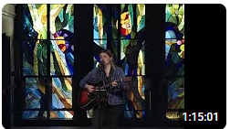

Introduction: 9:32/1:15:00

Mark Swarner, Campus Pastor

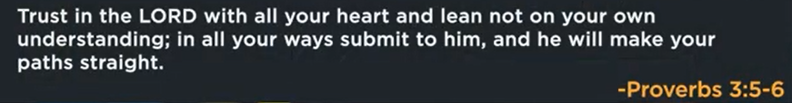

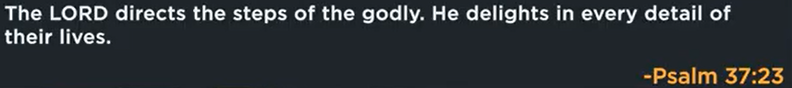



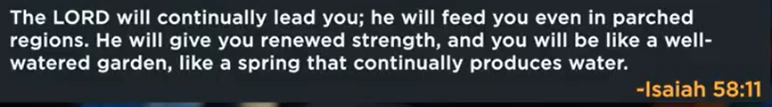



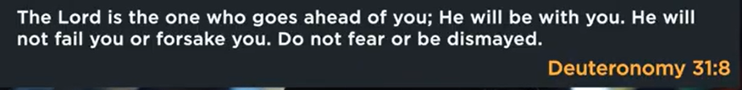

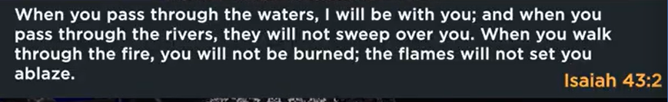

19:30/1:15:00

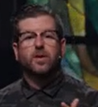

Israelites spent 40 years to get the promise from God.



The long road with God beats any shortcut without Him.

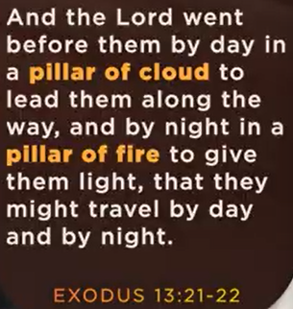 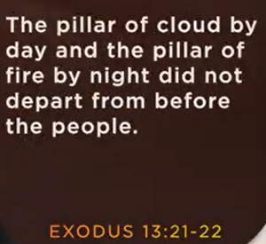

Exodus 13:21-22

**21**By day the Lord went ahead of them in a pillar of cloud to guide them on their way and by night in a pillar of fire to give them light, so that they could travel by day or night. **22**Neither the pillar of cloud by day nor the pillar of fire by night left its place in front of the people.

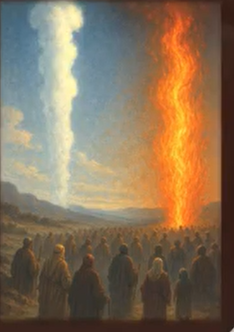

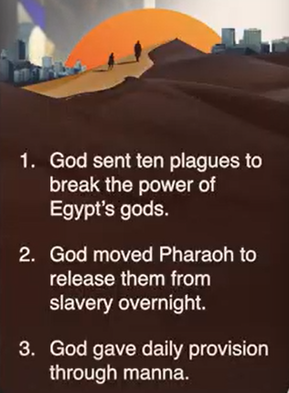

1. God sent ten plagues to break the power of Egypt’s God.

2. God moves Pharaoh to release them from slavery overnight

3. God gave daily provision through manna.





What if we stopped asking God “what’s next” and started asking Him “what’s left”.



The Long Road with God Protects us.

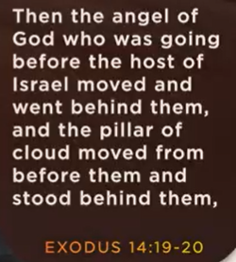

Exodus 14:19-20

**19**Then the angel of God, who had been traveling in front of Israel’s army, withdrew and went behind them. The pillar of cloud also moved from in front and stood behind them, **20**coming between the armies of Egypt and Israel. Throughout the night the cloud brought darkness to the one side and light to the other side; so neither went near the other all night long.



Every detour with God is designed to keep you from destinations you will thank Him for avoiding in eternity.



The Long Road with God Directs us.

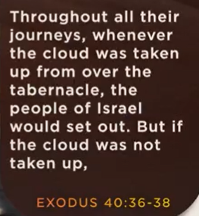 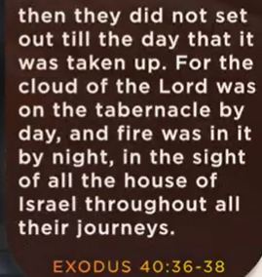

Exodus 40:36-38

**36**In all the travels of the Israelites, whenever the cloud lifted from above the tabernacle, they would set out; **37**but if the cloud did not lift, they did not set out—until the day it lifted. **38**So the cloud of the Lord was over the tabernacle by day, and fire was in the cloud by night, in the sight of all the Israelites during all their travels.

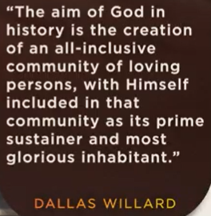

Dallas Willard

The aim of God in history is the creation of an all-inclusive community of loving persons, with Himself included in that community as its prime sustainer and most glorious inhabitant.





AI will give us the illusion of illumination, masking our deeper need for delayed gratification.

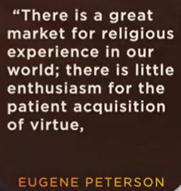 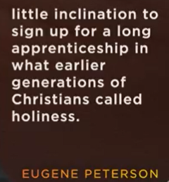 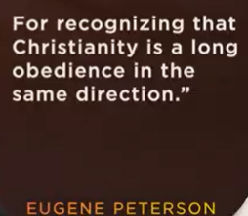

Eugene Peterson

“There is a great market for religious experience in our world; there is little enthusiasm for patient acquisition o virtue, little inclination to sign up for a ling apprenticeship in what earlier generations of Christians called holiness. For recognizing that Christianity is a long obedience in the same direction.”

08/23/2025, Legacy (last week) Worship

https://www.youtube.com/live/ZuWk_99RTsQ?si=kyPcO0iPPMH364VU

“Letting God Take the Lead / Foreign Faith,” Phil EuBank, Lead Pastor

Summary:

1. “The long road with God beats any shortcut without Him”: Patience, obedience, and endurance follow God path, leads to more meaningful, secure, and complete outcome.

2. Exodus 13:21-22: God guide and helps his people to leave Egypt.

a. God sent ten plagues to break the power of Egypt’s God.

b. God moves Pharaoh to release them from slavery overnight

c. God gave daily provision through manna.

3. Stop asking God “what’s next” and asking God “what’s left”:  We ask God give us instead of asking future.

4. The Long Road with God Protects us: God uses a longer path to protect us.

5. Exodus 14:19-20: God protects His people with miraculous escape.

6. Every detour with God is for destinations: Life has obstacles. God redirects to a better path.

7. The Long Road with God Directs us: God leads us difficult path to develop strong faith.

8. Exodus 40:36-38: God shows His people in direction.

9. AI give us quick answer. God give us delay and deeper lead.

10. Trust God and let the Him lead us to longer and better future.