08/23/2025, Legacy (last week)

https://www.youtube.com/live/dhiWOnYBtsY?si=vOUl-YSDsqjTT0jh

“Calling is Greater Than Comfort / The Art of Showing Up,” Phil EuBank, Lead Pastor



Introduction: 9:32/1:14:56

Mark Swarner, Campus Pastor

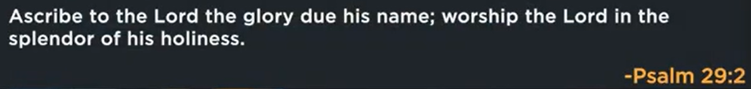

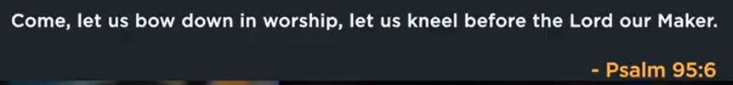

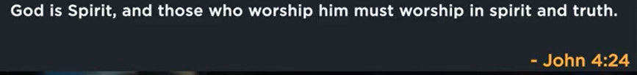

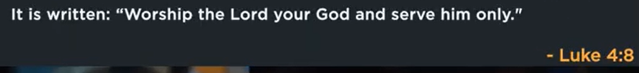

21:31/1:14:56





We will not grow up until we show up.



Calling > comfort

Christian should step out the comfort zones, show up action with presence, courage, compassion to serve others, and fulfill their spiritual calling in unfamiliar/uncertain situations.



No one who puts his hand to plow and look back is fit for the kingdom of God.



We are called to One another.

We have a responsibility to connect with, serve, and support each other, often implying a call to action for love, service, and community. This phrase suggests a moral or spiritual imperative to engage with other people and act for their benefit, rather than focusing solely on oneself.

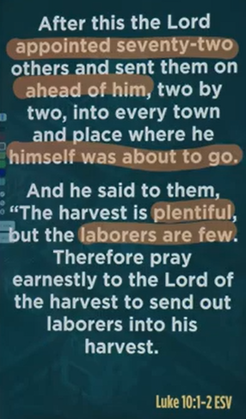

Luke 10:1-2 ESV

After this, the Lord appointed seventy-two others and sent them on ahead of him, two by two, into every town and place where he himself was about to go.

And he said to them, “The harvest is plentiful but the laborers are few. Therefore, pray earnestly to the Lord of the harvest to send out laborers onto his harvest.

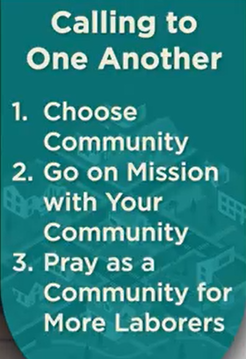

Calling to One another: 1. Choose community, 2. Go on Mission with your community, 3. Pray as a community for more laborers.

Calling to One another: There are three steps outlined reinforce the Christian faith:

1. Choose community: Your faith is strengthened by your relationship with other believers, who can support you, hold you accountable, and help you grow. This includes praying with and for one another.

2. Go on mission with your community: A shared mission focuses the community outward, allowing the group to be a living example of God's love and work together to share the gospel. Community prevents mission from becoming a lonely, exhausting pursuit.

3. Pray as a community for more laborers: By praying together, the community participates in Jesus's call to ask the "Lord of the harvest" to send out more workers into the world. This collective prayer for expansion and growth solidifies the community's mission and purpose.



Isolation and loneliness are easy; community takes work.



We won’t grow up until we show up.



We are called to bless others

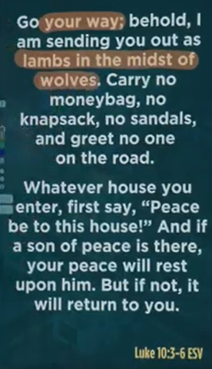

Luke 10:3-6 ESV

Go your way, behold, I am sending you out as lambs in the midst of wolves. Carry no moneybag, no knapsack, no sandals, and greet on one on the road.

Whatever house you enter, first say, “Peace be to this house!” and if a son of peace is there, your peace will rest upon him, but

Luke 10:3-6 is a set of instructions from Jesus to his 72 disciples for evangelism, emphasizing dependence on God by traveling light, being focused, and leaving a blessing of peace where it is welcomed. Jesus warns that they are like "[lambs among wolves](https://www.google.com/search?sca_esv=4fc03c7be16c6b8d&rlz=1C1KDEC_enUS826US826&cs=0&sxsrf=AE3TifNhubJUbn0h9dOFD4iy4gw0fxNw2A%3A1756585514678&q=lambs+among+wolves&sa=X&ved=2ahUKEwjXnNP8rrOPAxVsFzQIHSsyFEEQxccNegQIAxAB&mstk=AUtExfAGmE89TNUZ3knTkABlPMxru87CH0SLyjwDphfYmA70qFz7FoqRpvifiNZ_s1_q-DySCVHTRiYBmpwGdH_IKWOGO86x6uZKMlK_zNTEgsPxuSXGzAWlyX-MRTokLIG26K8gL8yzhZJUoSmfph9xtg19EapPcPk2XDk8qoSkNExCwyVVzRln6RESX_rt4CLF4vNtEEVbLppJdsYTPv7fwjP6UzUhSsb0P9cjvEiYDBwjBeKx6RpE4EDjO_retbVDHXmIQELp0auOyLr21CBBOp6E&csui=3)," highlighting the need for faith and trust in God's provision, rather than worldly resources, and that their message of peace should be proclaimed to all.

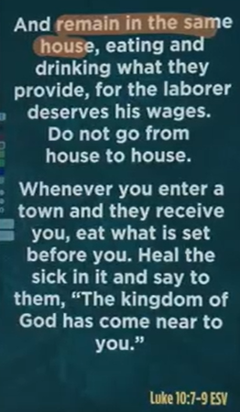

Luke 10:7-9 ESV

And remain in the same house, eating and drinking what they provide, for the laborer deserves his wages. Do not go from house o=to house.

The main point of Luke 10:7-9 is to provide instructions for Jesus' disciples on how to receive hospitality and minister the Kingdom of God, emphasizing focus on the mission rather than comfort, accepting provision from those who welcome them, and healing the sick as a sign that God's Kingdom has drawn near. Disciples are to remain with the first host, demonstrating trust in God's provision, and convey the message that the Kingdom is present through their actions of healing and proclamation.



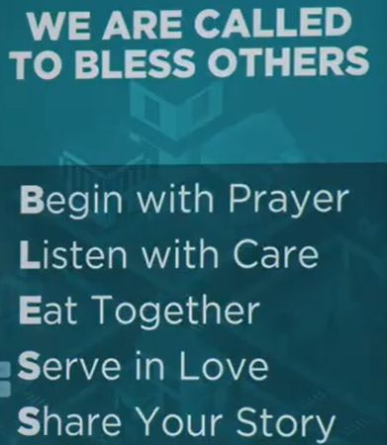

David Augsburger: Being heard is so close to being loved that for the average person they are almost indistinguishable.

We are called to bless others:

a. Begin with prayer, b. Listen with care, c. Eat together, d. Server in Love, e. Share your story.

**Attentive listening is a profound and fundamental way to express love and care**. The actions listed (praying, listening, eating, serving, sharing) are practical steps for building deep, meaningful connections with people by making them feel seen and heard.

The core ideas explained

* **"Being heard is so close to being loved..."**: For many people, the feeling of being genuinely heard and understood is the closest they will come to experiencing pure love. It signifies that their story and feelings are important enough for someone else to stop and pay attention.
* **Listening as an act of love**: True listening is a rare and powerful gift. In a distracted world, giving someone your full, undivided attention communicates that you respect and value them. This is why listening is positioned as a central action for "blessing others".
* **Love in action**: The five items on the list provide concrete examples of how to put this philosophy into practice. They are not just abstract ideas, but actionable behaviors for deepening relationships:
  + **Listen with care:** This is the most direct application of the quote and is central to the entire message.
  + **Praying and sharing stories:** These actions create intimacy and vulnerability, which are only possible in a space of trust where one feels heard.
  + **Eating and serving:** These are acts of shared experience and selfless care that reinforce feelings of connection and importance.



 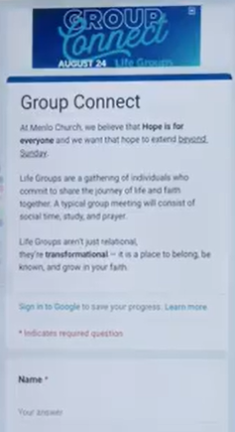



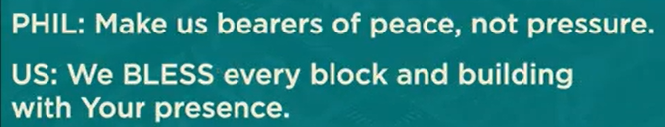

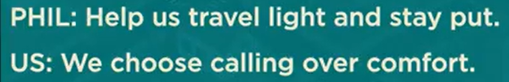



Some of us maybe nervous. We hang in balance.

08/23/2025, Legacy (last week)

https://www.youtube.com/live/dhiWOnYBtsY?si=vOUl-YSDsqjTT0jh

“Calling is Greater Than Comfort / The Art of Showing Up,” Phil EuBank, Lead Pastor

Summary:

1. People will not grow up until we show up: Christian should step out the comfort zones, show up action with courage/compassion to serve others.

2. No one puts his hand to plow and look back for the kingdom of God: Christians have responsibility to serve others.

3. Luke 10:1-2: The gospel is a collection of spiritual harvest without laborers.

4. Three steps to improve faith: a. Choose community, b. Go on mission with your community, c. Pray as a community for more laborers

5. Luke 10:3-6: Jesus blessed the peace from God.

6. Luke 10:7-9: Christian serve in the same church without moving around.

7. The action list {B, L, E, S, S}:

B: Begin with prayer,

L: Listen with care,

E: Eat together,

S: Server in Love,

S: Share your story.