09/06/2025, Legacy (last week)

https://www.youtube.com/live/r05ITp1rlak?si=GJ6_v1B6SsKPzqtx

“Interruptible / The Art of Showing Up,” Mark Swarner, Campus Pastor



Phil EuBank, Lead Pastor

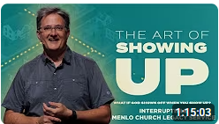

Introduction:

9:56/1:15:02

 

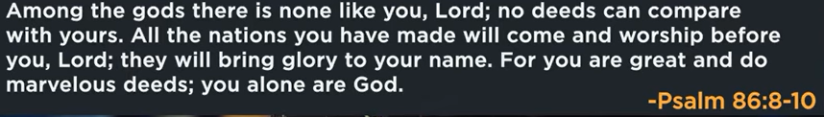

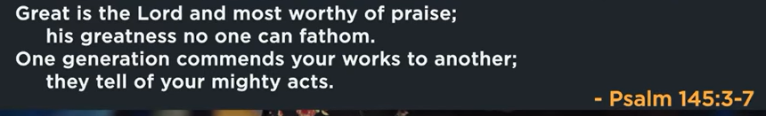

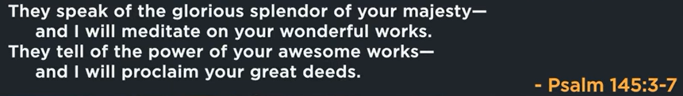

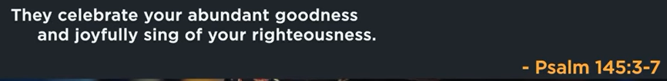

20:35/1:15:02

 

Last week, we talk about the priority of calling us comfortable.

This week, we talk interruptible.



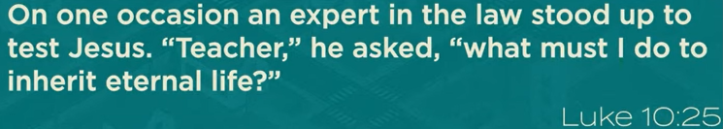

Luke 10:25

On one occasion, an expert in the law stood up to test Jesua, “Teacher,” he asked “ What must I do inherit eternal life?”

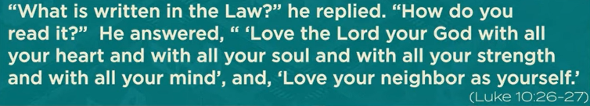

Luke 10:26-27

“What is written in the Law?” he replied. “How do you read it?” he answered, “Love the Lord your God with all your heart and with your soul and with all your strength and with all your mind and Love your neighbor as yourself.”

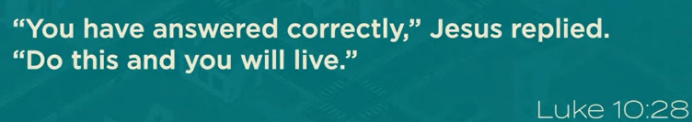

Luke 10:28

“You have answered correctly,” Jesus replied

“Do this and you will live.”



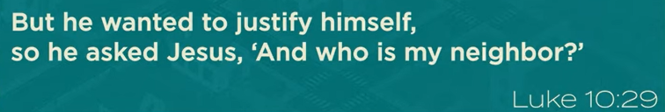

Luke 10:29

But he wanted to justify himself, so he asked Jesus, “and who is my neighbor?”

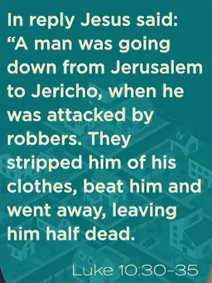 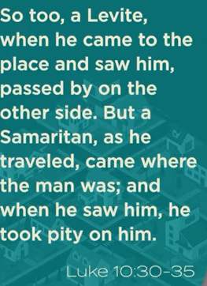 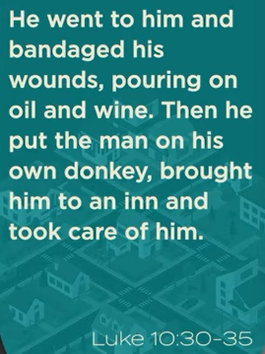

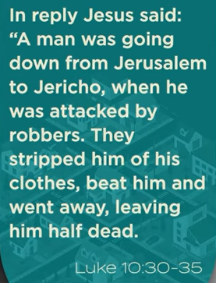 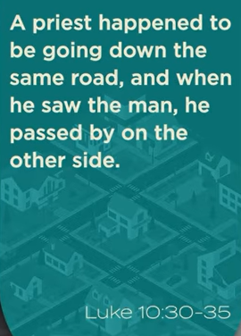 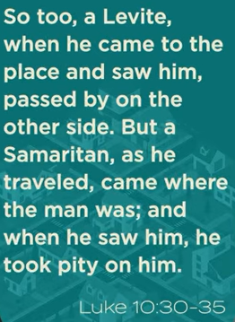

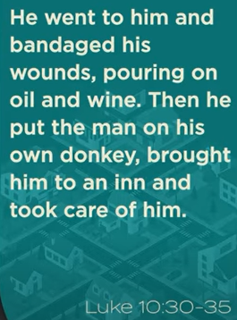 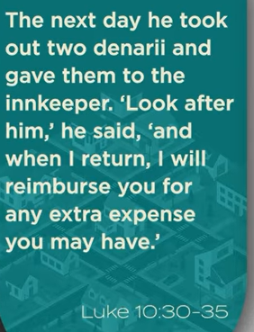 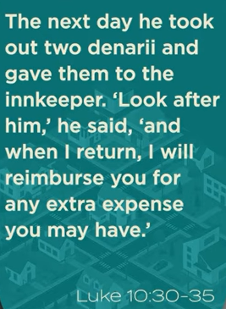



Run from Jerusalem to entire width of west bank.

Luke 10:30-35

You pass to the other side.

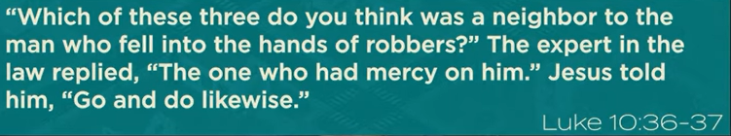

Luke 10:36-37

There is no answer for the neighbor.

What kind of neighbors are those who obey the law.

The Good Smartian is a story about Grace and compassion.



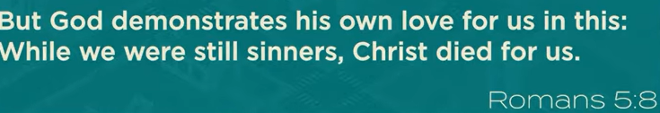

Romans 5:8



09/06/2025, Legacy (last week)

https://www.youtube.com/live/r05ITp1rlak?si=GJ6_v1B6SsKPzqtx

“Interruptible / The Art of Showing Up,” Mark Swarner, Campus Pastor

Summary: