09/13/2025, Legacy (last week)

https://www.youtube.com/live/XORk3H_FbtA?si=o3-nSfphQe6bNkXa

“Making Room at the Table / The Art of Showing Up,” Phil EuBank, Lead Pastor

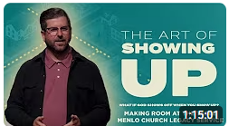

Phil EuBank, Lead Pastor

Introduction:

8:20/1:15:00

 

14:10/1:15:00

 

We have Alpha in Los Altos community center to answer your questions in the bay area.





Hospitality (款待) is the new evangelism (传福音).

Hospitality is the social party.

Hospitality (款待) is the new evangelism (传福音): Hospitality means “Care for strangers”. Hospitality is a powerful way to share the gospel message and attract others to Christianity. This approach shifts the focus from solely verbal proclamation to demonstrating Christ's love through actions like providing a safe space and showing empathy, thereby creating an environment where people can experience the transformative power of God's love firsthand.



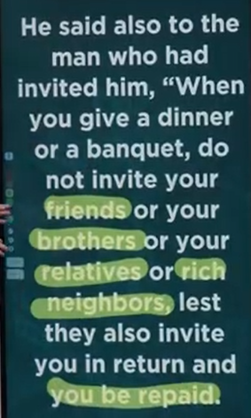 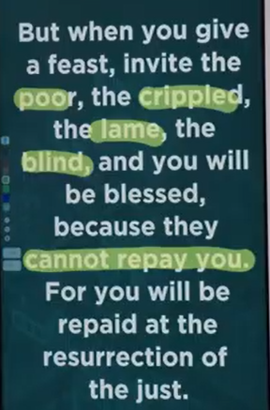

The hospitality come from two Greek words below: Love and Stranger.

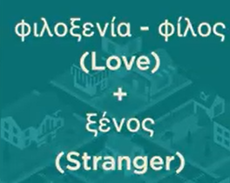

In the party, we have question “Who invite you?”



The excuses that blind:

"The excuses that blind" refers to the core concept in Tony Evans' book *No More Excuses*, which asserts that men should cease employing excuses, including those related to societal pressures, to rationalize their lack of spiritual action and failure to meet divine expectations. The book advocates for men to reject a victim mentality, embrace personal responsibility based on biblical standards, and overcome excuses to fulfill their intended roles. You can read *No More Excuses* by visiting [amas.hk](https://www.amas.hk/pdf/lishishenxue/tushu/No%20More%20Excuses%20Be%20the%20Man%20God%20Made%20You%20to%20Be%20(Tony%20Evans)%20(z-lib.org).pdf).

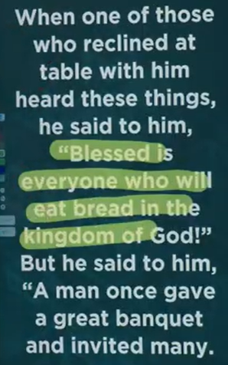 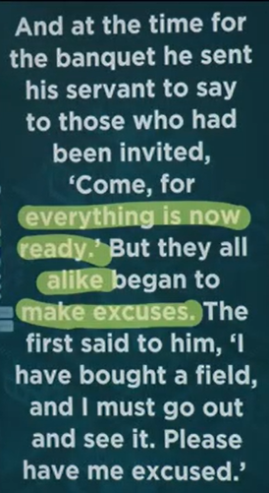

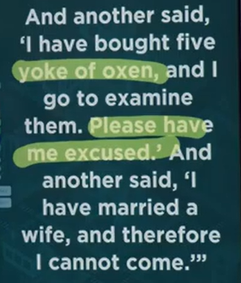 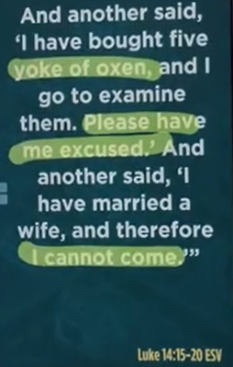

Luke 14:15-20 ESV

**The Parable of the Great Banquet**

**15**When one of those at the table with him heard this, he said to Jesus, “Blessed is the one who will eat at the feast in the kingdom of God.”

**16**Jesus replied: “A certain man was preparing a great banquet and invited many guests. **17**At the time of the banquet he sent his servant to tell those who had been invited, ‘Come, for everything is now ready.’

**18**“But they all alike began to make excuses. The first said, ‘I have just bought a field, and I must go and see it. Please excuse me.’

**19**“Another said, ‘I have just bought five yoke of oxen, and I’m on my way to try them out. Please excuse me.’

**20**“Still another said, ‘I just got married, so I can’t come.

The main point of Luke 14:15-20, also known as the [Parable of the Great Banquet](https://www.google.com/search?sca_esv=81a354ae161062d0&rlz=1C1KDEC_enUS826US826&cs=0&sxsrf=AE3TifMkNmy_5GTPD3GDMcnGGQEa1jpX6w%3A1757802576848&q=Parable+of+the+Great+Banquet&sa=X&ved=2ahUKEwiL9Knx5NaPAxVdHjQIHWwaLGgQxccNegQIAhAB&mstk=AUtExfCjjE7lYgLLrgEChhyEKaXTSNTD4tZLYX4zQS-I2RMAxcz_V-t2b5ua5gmdIJpkAKp0LuJRX53-Ocon9Uh_h5s1Ke6UJzNl009gRancAb5NgSzLwIBgpjwHiF5WxMyZiAK-eloWUyh6W_v2dbQebzSGyoxQU-zsAqiFr_4vyVDMw0C4E8nsKDeAwAxewfRCJgY7llS_6DB-gc-x9NES45v73MEj5wFa-QENn3V32cW_7sucX-UlT9O_diV9PMMuyMNcjFVs-GmmxmKFjdniC721&csui=3), is to illustrate that God graciously invites everyone to His kingdom and feast, but many will reject this invitation due to worldly distractions and excuses, leading God to invite those from the margins of society instead. The parable highlights the urgency and importance of accepting God's invitation to salvation, warning against becoming too preoccupied with material possessions and worldly affairs to respond to this greater opportunity for eternal life.



The invitation that multiplies

An invitation when accepted, requires the recipient to extend the same invitation to others.

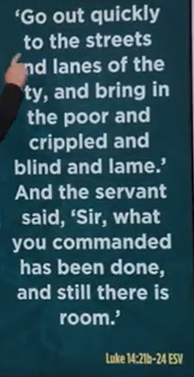 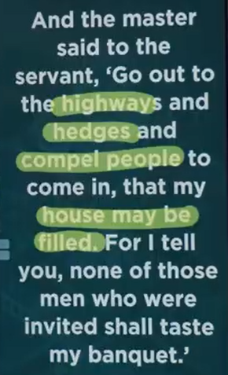

Luke 14:21-24

**21**“The servant came back and reported this to his master. Then the owner of the house became angry and ordered his servant, ‘Go out quickly into the streets and alleys of the town and bring in the poor, the crippled, the blind and the lame.’

**22**“‘Sir,’ the servant said, ‘what you ordered has been done, but there is still room.’

**23**“Then the master told his servant, ‘Go out to the roads and country lanes and compel them to come in, so that my house will be full. **24**I tell you, not one of those who were invited will get a taste of my banquet.’”

The main point of Luke 14:21-24 is that God's kingdom, like a grand banquet, is open to all who will respond to the invitation, especially the poor and marginalized, because the wealthy and powerful initially reject it by making excuses. This parable illustrates God's boundless grace, the tragedy of rejecting His call, and His ultimate plan to fill His kingdom with those, like the [Gentiles](https://www.google.com/search?sca_esv=81a354ae161062d0&rlz=1C1KDEC_enUS826US826&cs=0&sxsrf=AE3TifMBn-U9UYPpkeLGm2Q2QgBpDaXZSA%3A1757803077109&q=Gentiles&sa=X&ved=2ahUKEwiv8tff5taPAxWwATQIHa75Gg8QxccNegQIBBAB&mstk=AUtExfAuCGywwDFC5k1WIjR_GKgwx41qyBdlfYkENQNLXCXOfN6fesp1FsQ-CBiH8cOPTAWACJ3IQwITKfgjdC1-XJEeHKS28zfHieZdGm7kS2SA0tnDlMv-qgJo56sDQQf7QVUkMBy9Poe4wF_MGqS0k2Hxr0D00Q8ysxU3aubxgh1dCL-HhgUnbjpmQJXOybL2A8H6l1Tj_4GwcSvc0m2sNdgdMfqsHyq6ohL9EBJPqOxqKA6aegadeCufGNGG0fmCIVsCI9mCUwQ5z0JB6bKaKQtA&csui=3), who were previously excluded by society but gratefully accept His offer of salvation.

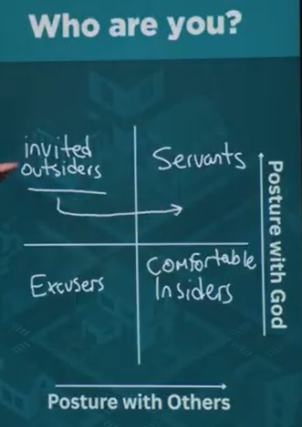

Posture (姿势)

The main point of the framework "invited outsiders, servants, excusers, comfortable insiders" is to examine the different postures people take in their relationship with God and others, and to challenge "comfortable insiders" to adopt the welcoming posture of a servant. This concept is often used in a Christian or church context to illustrate how people relate to their faith and community.

The framework breaks down these postures into four main types:

* Invited outsiders: These are the people on the fringes of the community. They have been invited into the family of God, but they are not yet fully integrated. Their perspective can challenge the assumptions of those on the inside.
* Servants: A servant's posture is one of humility and selfless service, modeled after Jesus. This is the ideal posture for believers, who should serve others because God has served and welcomed them.
* Excusers: This group makes excuses and offers reasons for not fully participating or engaging with God and the community. They want to remain on the sidelines.
* Comfortable insiders: This group represents the opposite of a servant. They are in the center of the community and feel a sense of entitlement or comfort that prevents them from serving others. Their comfort can lead to unintentional barriers for newcomers.

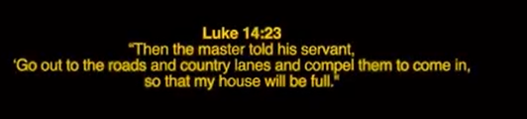

Luke 14:23

**23**“Then the master told his servant, ‘Go out to the roads and country lanes and compel them to come in, so that my house will be full.

The main point of Luke 14:23 is God's enthusiastic and inclusive invitation to salvation for all people, particularly the marginalized, through urgent evangelism and compelling persuasion. As part of the parable of the Great Banquet, this verse emphasizes that God's house (the kingdom) must be full, prompting the urgent and earnest effort of servants to invite the poor, crippled, blind, and lame—and even strangers from the highways and country lanes—to partake in the spiritual feast of salvation.

Key Elements of Luke 14:23:

* Inclusivity of the Kingdom:

The parable debunks the idea that the Messianic kingdom (God's kingdom) would only be for the elite or favored.

* Urgent Invitation:

The master's instruction to "compel" the guests highlights God's passionate desire that His house be full.

* Focus on the Marginalized:

By inviting the poor, crippled, blind, and lame, God shows His grace and desire to include those often overlooked by society.

* Broadened Reach:

The call to go out to the "highways and hedges" signifies God's willingness to extend salvation to the Gentiles (non-Jews), after the initial invitations were refused by those of Israel.

* Compelling Persuasion, Not Coercion:

The word "compel" here means to urge strongly, to persuade with great earnestness and enthusiasm, not to force or use physical coercion.

* Divine Longing for Community:

The parable reflects God's desire for relationship and community with His creation, aiming to fill His spiritual banquet with a diverse and populous kingdom.

09/13/2025, Legacy (last week)

https://www.youtube.com/live/XORk3H_FbtA?si=o3-nSfphQe6bNkXa

“Making Room at the Table / The Art of Showing Up,” Phil EuBank, Lead Pastor

Summary:

Making Room at the Table: God save people with table and meals in God Kingdom.

1. Hospitality (款待) is the new evangelism (传福音): Hospitality (Care for strangers) is a way to share the gospel message in church.

2. The excuses that blind: People should stop excuses for no action in outsider invitation.

3. Luke 14:15-20 (Parable (寓言) of Great Banquet): God invites everyone to His kingdom and feast but many reject this invitation with excuses.

4. The invitation that multiplies: An invitation which is accepted requires to extend the same invitation to others.

5. Luke 14:21-24: God's kingdom is open to all who respond to the invitation.

6. Four types of posture:

a) Invited outsiders: People outside the church.

b) Servants: People serve the church.

c) Excusers: People not join the church, remain on the sidelines.

d) Comfortable insiders: This group inside the church but outside the servant.

7. Luke 14:23: God save all people including crippled (残废的), blind, and lame (瘸).