09/20/2025, Legacy (last week)

https://www.youtube.com/live/_vmB_GmZXTI?si=w7KTWZ6Vl7UoNSUE

“Stay A While / The Art of Showing Up,” Phil EuBank, Lead Pastor



Phil EuBank, Lead Pastor

Introduction:

10:00/1:14:57

 

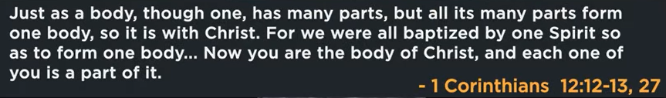

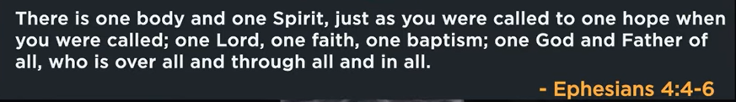

24:50/1:14:57

 

Welcome for showing up. We have learned last month for how important of the show up.

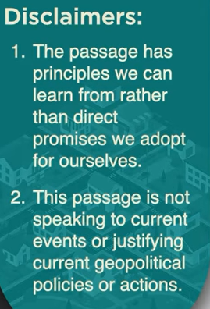

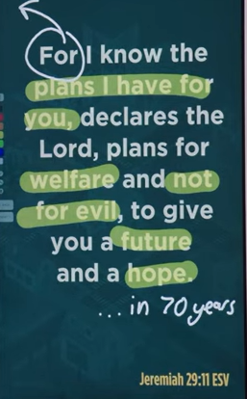

Jeremiah 29:11

Even for Isarael, it takes for 70 years.



We don’t just invite someone. We have to invest somewhere.



In exile, there is no coincidence.

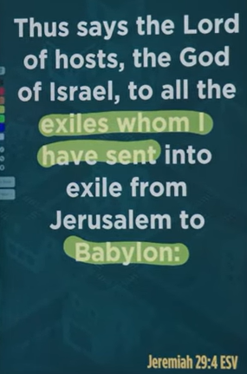

Jeremiah 29:4

God says, “I sent you.” There is chaos outside.

The jobs, the neighbors, the classes, etc. There are no coincidence.



We are in a holding pattern until we are cleared for landing.

We are like in the exile.

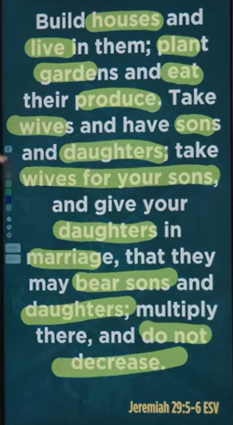

God gives us a list in the Isarael exiles.

Don’t deter, don’t pause, start plating now. Keep restarting and uprooting.

The call is not to escape Babylon to Idaho or Texas. This is not a financial statement s tis a cultural in Silicon valley.

This is the life that placed you in. There is no coincidence.



In 49ers, there are players on the field, fully vested. and there are reserved players.

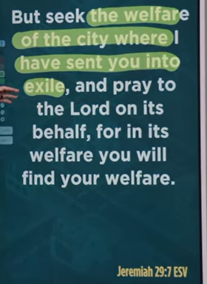

Jeremiah 29:7

You are side lined. You are not here to watch. We are ready to play.

We get full life here and an eternal life waiting.

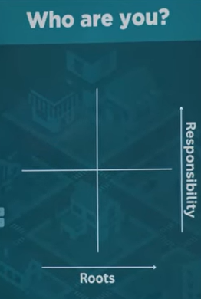 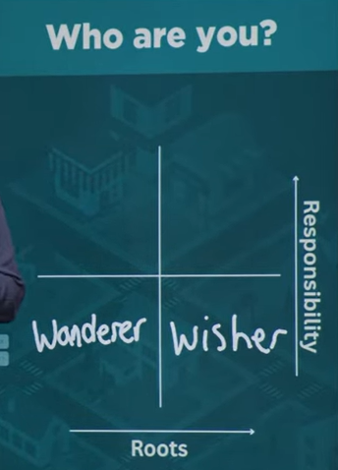

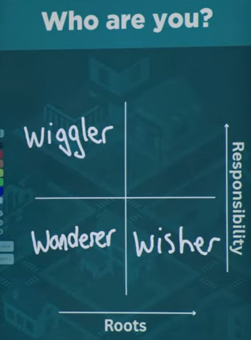 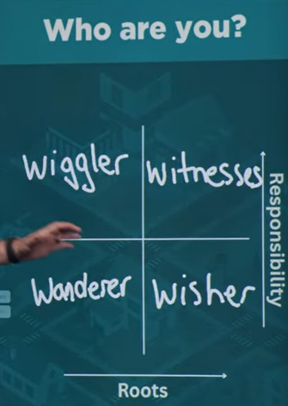

We diagnose ourselves. Wiggler: 摇摆者

Witnesses are deeper roots and big responsibility.

You cannot plant garden and build a house unless you know the future.

09/20/2025, Legacy (last week)

https://www.youtube.com/live/_vmB_GmZXTI?si=w7KTWZ6Vl7UoNSUE

“Stay A While / The Art of Showing Up,” Phil EuBank, Lead Pastor

Summary: