10/04/2025, Legacy (last week)

https://www.youtube.com/live/ChZtbM3vW2I?si=Mt7kSiQizmDUi6cK

“Thomas wasn’t Wrong | Benefit of the Doubt,” Phil EuBank, Lead Pastor



The "Doubting Thomas" means that doubt can be a natural element of faith that leads to a deeper belief. The doubt not as a lack of faith, but as a path to spiritual growth and a stronger connection with God.

Who is doubting Thomas?

Thomas is one of Jesus's twelve disciples. Thomas doesn’t believe Jesus's resurrection until he sees Jesus’s crucifixion.

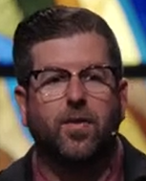 

Phil EuBank, Lead Pastor

Introduction:

10:00/1:14:57

 

We have guest preacher, Scott Palmbush.

20:00/1:14:57

 

Scott Palmbush, Guest preacher

We talk about the doubt today. We have doubt in faith. Doubt is the path to the deeper faith.

It called benefit of the doubt.

 

 



We have doubt in trying food, printer jam, go home without kid at home, wait for car repair, football game miss field goal, etc.



Our doubts are not a problem but a port

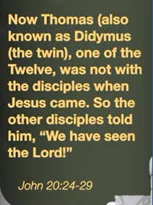 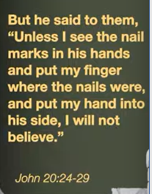 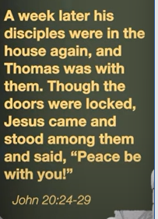

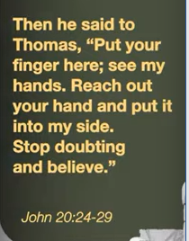 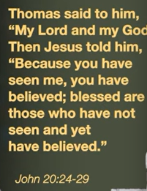

John 20:24-29: Jesus offers grace and patience to the doubter Thomas, affirming that faith is not just about seeing but about believing in the risen Christ, providing comfort to those who cannot see Him directly and encouraging belief based on the testimony of others. The passage highlights the contrast between Thomas's demand for physical proof and Jesus's subsequent affirmation that "Blessed are those who have not seen and yet have come to believe".

1. Thomas’s Doubt: When Thomas missed Jesus's first appearance to the other disciples, he doubted the resurrection and insisted on physical proof, specifically wanting to touch Jesus's wounds.

2. Jess’s Response: A week later, Jesus reappears to the disciples, directly addresses Thomas's doubt, and invites him to see and touch his wounds.

3. Thomas’s Confession: This interaction leads to Thomas's humble confession: "My Lord and my God!".

4. Jesus’s Blessing:

Jesus's final words to Thomas are, "Because you have seen me, you have believed; blessed are those who have not seen and yet have come to believe".

Why This Passage is Significant

* Human Frailty:

It acknowledges that doubt is a human experience, and provides an example of how faith can be strengthened.

* A Challenge to See Beyond Proof:

It moves beyond the idea of "seeing is believing" and establishes that faith can and should exist without direct physical evidence.

* A Message of Comfort and Encouragement:

The passage offers assurance to all who believe in Jesus without having seen Him, validating their faith.

There are a lot of examples of doubt in bible.

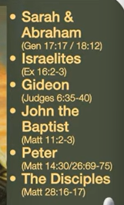

Examples of doubt in Bible:

a. Gen 17:17/18:12 (Sarah and Abraham): God promises Abraham and Sarah to have a son, who will be the heir to a great nation, despite their extreme old age and Sarah's barrenness. This is illustrated by Sarah's laughter of disbelief in Genesis 18:12 and Abraham's similar reaction in Genesis 17:17, which highlights the seemingly impossible nature of the promise but ultimately showcases the fulfillment of God's powerful plan.

b. Ex 16:2-3 (Israelites): The Israelites complain Moses and Aaron in the desert, expressing a wish to have died in Egypt with plenty of food rather than starve to death in the wilderness. The main themes are the Israelites' distrust in God's ability to provide and their forgetfulness of His previous acts of deliverance from slavery.

c. Judges 6:35-40 (Gideon): Judges 6:35-40 is Gideon's two-part fleece test, a human demonstration of doubt and a need for tangible confirmation of God's promise to save Israel from the Midianites, even though God had already confirmed his call to lead them. Despite his initial lack of confidence, God patiently grants the signs, with dew falling on the fleece but not the ground, and then on the ground but not the fleece, ultimately giving Gideon the courage he needed to fight.

d. Matt 11:2-3 (John the Baptist): Describes John the Baptist asking Jesus if He is the Messiah from prison, sending his disciples to inquire if Jesus is "the one who is to come" or if they should look for another. This passage highlights John's honest struggle with doubt amidst hardship and confusion, the challenge to his expectations of the Messiah, and Jesus' response that the works of the Messiah, like healing the sick and proclaiming the good news to the poor, are evidence of His identity.

e. Matt 14:30/26:69-76 (Peter): The contrast between Peter's moments of courageous faith and his profound human weakness. His journey illustrates that true faith is not a path of instant perfection, but a process of relying on Jesus even after a failure.

f. Matt 28:16-17 (The Disciples): the eleven disciples gathered in Galilee as instructed and, upon seeing the risen Jesus, some worshiped Him while others doubted. This encounter highlights the disciples' obedient response to Jesus' command, even amidst their lingering uncertainty about His resurrection.

Do we have question in doubt?

Thomas is with them and walked away.

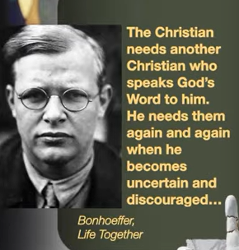

Bonhoeffer, Life Together: The Christian needs another Christian who speaks God’s word to him. He needs them again and again when he becomes uncertain and discouraged…

That is Lord’s job to answer Thomas. One week later, God talks to Thomas. Thomas spent one week feeling jealous of the other disciples. Thomas, the doubter, make the most profound declaration of Faith in Bible.

According to Dietrich Bonhoeffer's "Life Together," Christians require the spoken word of God from other believers because individual faith can be uncertain, whereas the external word from another Christian is more reliable and powerful, making Christian fellowship essential. This community provides mutual encouragement, strengthens faith, counters individualism by emphasizing that salvation is external and received through the group, and should be approached with thankfulness rather than idealistic expectations.

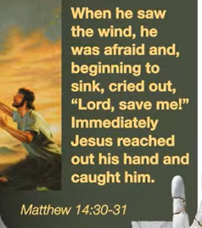 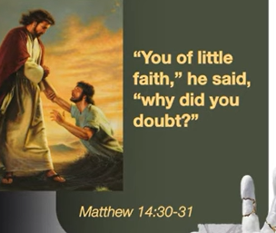

Matthew 14:30-31

The main point of Matthew 14:30-31 is that fear and doubt cause faith to falter, making us sink under our circumstances, but focusing on Jesus and crying out to Him restores faith and secures His immediate help. Peter's experience shows that distractions—like seeing the strong wind—can cause faith to fail, but Jesus's swift rescue demonstrates His unwavering love and power to save us when we focus on Him.



God is not distant in your doubters.

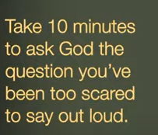

God is not distant in your doubters.

Take 10 minutes to ask God question. You have been too scared to our loud.

The main point of the statement is that God is not threatened by or distant from a believer's doubts; rather, expressing your honest questions and fears is a valid and important way to connect with him. The call to "take 10 minutes to ask God" is an invitation to engage in open, direct, and vulnerable communication, instead of letting fear keep your doubts silent and isolated. God is not threated by doubt and encourages individuals to express their fears and questions through prayer.

10/04/2025, Legacy (last week)

https://www.youtube.com/live/ChZtbM3vW2I?si=Mt7kSiQizmDUi6cK

“Thomas wasn’t Wrong | Benefit of the Doubt,” Phil EuBank, Lead Pastor

Summary:

Who is doubting Thomas?

Thomas is one of Jesus's twelve disciples. Thomas doesn’t believe Jesus's resurrection until he sees and touch the wounds of Jesus’s crucifixion. The doubt is an element of faith that leads to a deeper belief. The doubt not lack of faith, but as a path to spiritual growth and a stronger connection with God.

1. "Our doubts are not a problem but a portal": Doubt is an opportunity for growth and deeper understanding, not a roadblock or a sign of failure.

2. John 20:24-29: Jesus’s resurrection and shows Thomas the wounds in crucifixion.

3. Doubt Examples in Bible:

a. Gen 17:17/18:12: God keeps promise to give sons when Abraham at 86 and 100 years old.

b. Ex 16:2-3: The Israelites complain Moses in the dissert and wants to go back to Egypt.

c. Judges 6:35-40: Gideon have doubt to lead Israelites and wants to have proof from God.

d. Matt 11:2-3: John struggles with doubt. Jesus shows the Messiah proof.

e. Matt 14:30/26:69-76: Peter has courageous faith and human weakness.

f. Matt 28:16-17: The 11 disciples gathered in Galilee and see the risen Jesus.

4. Bonhoeffer, “Life Together: The Christians need another Christian who speaks God’s word to him”: The church group provide encouragement, strong faith to the Christian.

5. Matthew 14:30-31: Jesus give us love and power to remove doubt and give us faith.

6. “God is not distant in your doubters”: Take 10 minutes to pray and ask God question when you have doubt.