1011/2025, Legacy (last week)

https://www.youtube.com/live/oozZ1ic6gRQ?si=xHusN9BQjyLiodN-

“Believing in the Tension | Benefit of the Doubt,” Phil EuBank, Lead Pastor

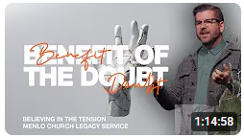

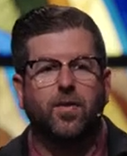 

Phil EuBank, Lead Pastor

Introduction:

10:00/1:14:57

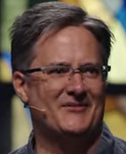 

We have guest preacher, Scott Palmbush.

14:00/1:14:57

LOL: Lots Of Love from my father-in-law for 30 years vs. Laugh Out Loud for us. People misunderstand all the time.



Today is my 1009th day in Menlo Church.





20:00/1:14:57

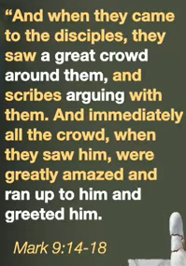  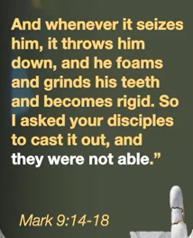

Mark 9:14-18

27:00/1:14:57



27:51/1:12

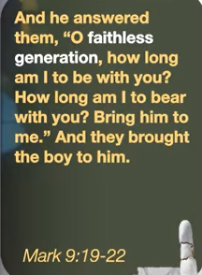 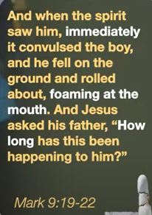 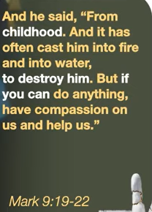

Mark 9:19-22

32:37/1:14:57



In Greek, “Krino” means “To Judge or Separate” or to characterize people.



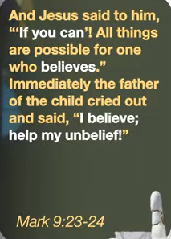

Mark 9:23-24

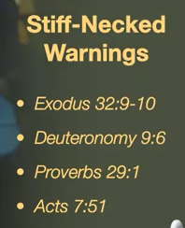

Exodus 32:9-10

Deuteronomy 9:6

Proverbs 29:1

Acts 7:51

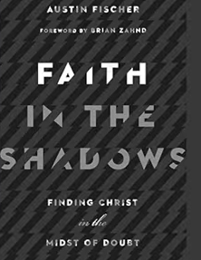

Faith in the Shadow: Finding Christ in the Midst of Doubt, Austin Fischer

Forward by Brian Zaknd

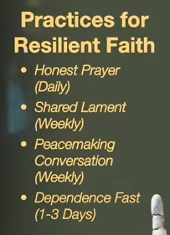

1011/2025, Legacy (last week)

https://www.youtube.com/live/oozZ1ic6gRQ?si=xHusN9BQjyLiodN-

“Believing in the Tension | Benefit of the Doubt,” Phil EuBank, Lead Pastor

Summary: