10/18/2025, Legacy (last week)

https://www.youtube.com/live/G24l3firEK0?si=V2hZSllThvZRHlsP

“Finding Steady Faith | Benefit of the Doubt,” Phil EuBank, Lead Pastor

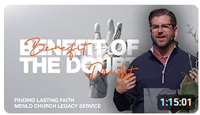

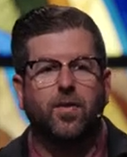 

Phil EuBank, Lead Pastor

Introduction:

10:00/1:14:57

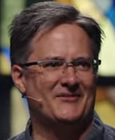 

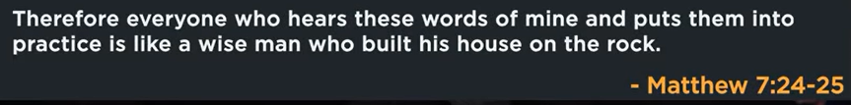

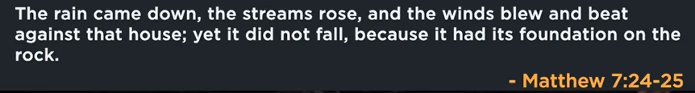

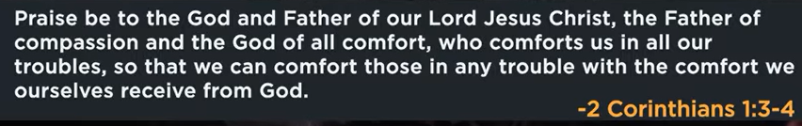

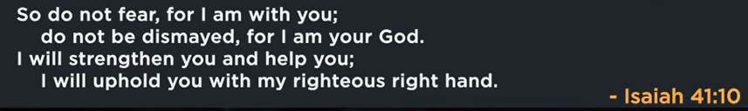

19:48/1:15:00

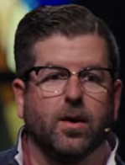

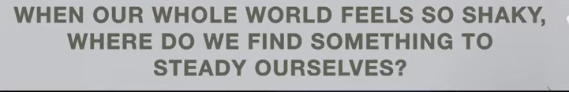

“When our whole world feels so shaky, where do we find something to steady ourselves?”

**true stability comes from internal sources, not external circumstances**. While outside events and turmoil are often uncontrollable, the path to peace and resilience lies in cultivating inner strength and groundedness.

Multiple perspectives address this question, offering different sources for cultivating internal stability:

Psychological perspective

From a mental health perspective, grounding yourself and managing your mindset are key to finding stability.

* **Mindfulness and presence:** Practices like meditation and focusing on the present moment help anchor you and reduce anxiety about the future.
* **Controlling the controllable:** When external events feel chaotic, focusing your energy on the aspects of your own life and mindset that you can control provides a sense of empowerment.
* **Self-care:** Taking care of your physical and emotional needs through routine, proper sleep, and connection with nature helps regulate your nervous system and builds resilience.

Spiritual perspective

In many spiritual traditions, stability is found in faith and the belief that something unshakeable exists beyond worldly problems.

* **Unchanging faith:** For some, this stability comes from trusting in a higher power or spiritual truths that remain constant even when external life feels chaotic.
* **Spiritual practice:** Prayer, meditation, and other spiritual rituals can reconnect an individual with their inner peace and help them surrender to uncertainty.
* **Processing and growth:** Some spiritual views suggest that challenging times are meant to shake things up, revealing what is temporary and allowing a person to align with a deeper purpose or spiritual growth.

Philosophical perspective

Philosophical traditions focus on perspective, acceptance, and an internal fortitude that is independent of what happens outside.

* **Developing an internal center:** The goal is to become "imperturbable" by detaching from a need for external validation or control. This acceptance is not passive but a proactive choice to work with reality rather than fight it.
* **Reflecting on values:** When everything else is falling away, reflecting on what truly matters helps clarify and reinforce one's personal identity and purpose.
* **Detachment and perspective:** Stoic and similar philosophies suggest that external events are neutral, and our perception determines our inner state. We find strength by realizing we have power over our minds, not external events.

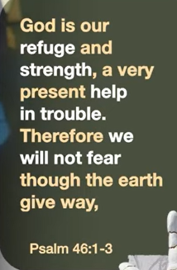 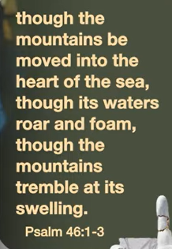

Psalm 46:1-3

The main point of Psalm 46:1-3 is that God is a secure refuge and source of strength in times of crisis, and His presence means His people have no reason to fear even in the most chaotic circumstances. The passage uses vivid imagery of the world collapsing to emphasize that God's stability is greater than any worldly turmoil. Therefore, one's security is found in God, not in the unstable conditions of the world.

* **[God as refuge and strength:](https://www.google.com/search?rlz=1C1KDEC_enUS826US826&cs=0&sca_esv=dc53ca82c92a9b30&sxsrf=AE3TifPcfzBZAZ0UL_B5ggbZ9dslgv8Z5A%3A1760825938398&q=God+as+refuge+and+strength&sa=X&ved=2ahUKEwi9n7Hk466QAxXYDjQIHWFUKHYQxccNegQIGRAD&mstk=AUtExfAbGMGg1lEBZHJsWZiMnQbqb-RSHuOpNstrlq4amyqLf0ZuITe3VHmyYpIuQPmY4Kf3dkcDSia8lXtI9Pm_er9XKT7B8_URnTH1xKbBwPEo9z_HOBGS3w456ukWj4ceLyfHsK7Twl7DLOLUZMR2v6hsREY3L4ObsGhrs5hyZ3bom8kvHuI1hKsIy-A44e0DWp4AJsoh5ZIkaGJkjEj5Aim8Rw4OPziiE8ZOtYdh8tGP-zVAoictkRpRCG3mPPZvmiZSz_lJXdUSgNA1Mw0xM_0x&csui=3)**

The verses declare that God is our "refuge and strength" and a "very present help in trouble". This means He is the one we run to for safety and the source of our power when we are weak.

* **[The promise of no fear:](https://www.google.com/search?rlz=1C1KDEC_enUS826US826&cs=0&sca_esv=dc53ca82c92a9b30&sxsrf=AE3TifPcfzBZAZ0UL_B5ggbZ9dslgv8Z5A%3A1760825938398&q=The+promise+of+no+fear&sa=X&ved=2ahUKEwi9n7Hk466QAxXYDjQIHWFUKHYQxccNegQIIxAD&mstk=AUtExfAbGMGg1lEBZHJsWZiMnQbqb-RSHuOpNstrlq4amyqLf0ZuITe3VHmyYpIuQPmY4Kf3dkcDSia8lXtI9Pm_er9XKT7B8_URnTH1xKbBwPEo9z_HOBGS3w456ukWj4ceLyfHsK7Twl7DLOLUZMR2v6hsREY3L4ObsGhrs5hyZ3bom8kvHuI1hKsIy-A44e0DWp4AJsoh5ZIkaGJkjEj5Aim8Rw4OPziiE8ZOtYdh8tGP-zVAoictkRpRCG3mPPZvmiZSz_lJXdUSgNA1Mw0xM_0x&csui=3)**

Because of this, the psalmist states, "Therefore we will not fear". Even if the entire world seems to be falling apart, we are not to be paralyzed by fear.

* **[God's presence is the anchor:](https://www.google.com/search?rlz=1C1KDEC_enUS826US826&cs=0&sca_esv=dc53ca82c92a9b30&sxsrf=AE3TifPcfzBZAZ0UL_B5ggbZ9dslgv8Z5A%3A1760825938398&q=God%27s+presence+is+the+anchor&sa=X&ved=2ahUKEwi9n7Hk466QAxXYDjQIHWFUKHYQxccNegQIIhAD&mstk=AUtExfAbGMGg1lEBZHJsWZiMnQbqb-RSHuOpNstrlq4amyqLf0ZuITe3VHmyYpIuQPmY4Kf3dkcDSia8lXtI9Pm_er9XKT7B8_URnTH1xKbBwPEo9z_HOBGS3w456ukWj4ceLyfHsK7Twl7DLOLUZMR2v6hsREY3L4ObsGhrs5hyZ3bom8kvHuI1hKsIy-A44e0DWp4AJsoh5ZIkaGJkjEj5Aim8Rw4OPziiE8ZOtYdh8tGP-zVAoictkRpRCG3mPPZvmiZSz_lJXdUSgNA1Mw0xM_0x&csui=3)**

The ultimate security comes from God's constant, unwavering presence with His people, providing an anchor during life's storms.

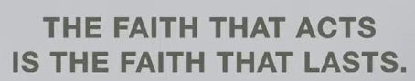

The faith that acts is the faith that lasts.

faith without action is not genuine and will not last, because true faith is an active, ongoing commitment that results in deeds of love and obedience. It's a belief system that is demonstrated through actions, not just words or feelings, and this active expression of faith is what sustains it and proves its authenticity.

What it means

* **[Faith is proven through actions](https://www.google.com/search?sca_esv=dc53ca82c92a9b30&rlz=1C1KDEC_enUS826US826&cs=0&sxsrf=AE3TifOCB5132cH87XBVLHwRxmq_2c8qyw%3A1760826164754&q=Faith+is+proven+through+actions&sa=X&ved=2ahUKEwifqP_P5K6QAxV4AzQIHULxCY8QxccNegQIHxAD&mstk=AUtExfB7Mexh7DkM-2m3-92ed0sc_qLVzJNrLJHKt7NVeaUybKfJe1DqLAx6KzCBTxCHPLEEpIsSwU8-Dd_0z6-1wdnDX6KP5BBQeVsQrdIhi-38cKBFct7Sr80IpnGz37biQUSfFuffO7mXvI5wEsmPSw15wX5k5Z4wvmiAd5p0qfkqIxTLYlCqEA-mHYfOxeYYFYnNS-wCCU-4Qb2q5yUNoCiaHJNzELIm9_3o6ScJLhSUysr3JZHHCgKiNuCpJkbEEteh3KzUNlFTMiT0E-DdjAsV&csui=3)**[:](https://www.google.com/search?sca_esv=dc53ca82c92a9b30&rlz=1C1KDEC_enUS826US826&cs=0&sxsrf=AE3TifOCB5132cH87XBVLHwRxmq_2c8qyw%3A1760826164754&q=Faith+is+proven+through+actions&sa=X&ved=2ahUKEwifqP_P5K6QAxV4AzQIHULxCY8QxccNegQIHxAD&mstk=AUtExfB7Mexh7DkM-2m3-92ed0sc_qLVzJNrLJHKt7NVeaUybKfJe1DqLAx6KzCBTxCHPLEEpIsSwU8-Dd_0z6-1wdnDX6KP5BBQeVsQrdIhi-38cKBFct7Sr80IpnGz37biQUSfFuffO7mXvI5wEsmPSw15wX5k5Z4wvmiAd5p0qfkqIxTLYlCqEA-mHYfOxeYYFYnNS-wCCU-4Qb2q5yUNoCiaHJNzELIm9_3o6ScJLhSUysr3JZHHCgKiNuCpJkbEEteh3KzUNlFTMiT0E-DdjAsV&csui=3)

The phrase is a summary of the biblical idea, especially from the book of James, that "faith without works is dead". This means that if faith doesn't lead to action, it's not real or effective.

* **[Action is the fruit of faith](https://www.google.com/search?sca_esv=dc53ca82c92a9b30&rlz=1C1KDEC_enUS826US826&cs=0&sxsrf=AE3TifOCB5132cH87XBVLHwRxmq_2c8qyw%3A1760826164754&q=Action+is+the+fruit+of+faith&sa=X&ved=2ahUKEwifqP_P5K6QAxV4AzQIHULxCY8QxccNegQIJRAD&mstk=AUtExfB7Mexh7DkM-2m3-92ed0sc_qLVzJNrLJHKt7NVeaUybKfJe1DqLAx6KzCBTxCHPLEEpIsSwU8-Dd_0z6-1wdnDX6KP5BBQeVsQrdIhi-38cKBFct7Sr80IpnGz37biQUSfFuffO7mXvI5wEsmPSw15wX5k5Z4wvmiAd5p0qfkqIxTLYlCqEA-mHYfOxeYYFYnNS-wCCU-4Qb2q5yUNoCiaHJNzELIm9_3o6ScJLhSUysr3JZHHCgKiNuCpJkbEEteh3KzUNlFTMiT0E-DdjAsV&csui=3)**[:](https://www.google.com/search?sca_esv=dc53ca82c92a9b30&rlz=1C1KDEC_enUS826US826&cs=0&sxsrf=AE3TifOCB5132cH87XBVLHwRxmq_2c8qyw%3A1760826164754&q=Action+is+the+fruit+of+faith&sa=X&ved=2ahUKEwifqP_P5K6QAxV4AzQIHULxCY8QxccNegQIJRAD&mstk=AUtExfB7Mexh7DkM-2m3-92ed0sc_qLVzJNrLJHKt7NVeaUybKfJe1DqLAx6KzCBTxCHPLEEpIsSwU8-Dd_0z6-1wdnDX6KP5BBQeVsQrdIhi-38cKBFct7Sr80IpnGz37biQUSfFuffO7mXvI5wEsmPSw15wX5k5Z4wvmiAd5p0qfkqIxTLYlCqEA-mHYfOxeYYFYnNS-wCCU-4Qb2q5yUNoCiaHJNzELIm9_3o6ScJLhSUysr3JZHHCgKiNuCpJkbEEteh3KzUNlFTMiT0E-DdjAsV&csui=3)

True faith isn't just a one-time belief; it's a lifestyle. The actions that come from faith are like the fruit of a tree—they are the natural, outward result of that belief.

* **[Faith isn't a passive feeling](https://www.google.com/search?sca_esv=dc53ca82c92a9b30&rlz=1C1KDEC_enUS826US826&cs=0&sxsrf=AE3TifOCB5132cH87XBVLHwRxmq_2c8qyw%3A1760826164754&q=Faith+isn%27t+a+passive+feeling&sa=X&ved=2ahUKEwifqP_P5K6QAxV4AzQIHULxCY8QxccNegQIJhAD&mstk=AUtExfB7Mexh7DkM-2m3-92ed0sc_qLVzJNrLJHKt7NVeaUybKfJe1DqLAx6KzCBTxCHPLEEpIsSwU8-Dd_0z6-1wdnDX6KP5BBQeVsQrdIhi-38cKBFct7Sr80IpnGz37biQUSfFuffO7mXvI5wEsmPSw15wX5k5Z4wvmiAd5p0qfkqIxTLYlCqEA-mHYfOxeYYFYnNS-wCCU-4Qb2q5yUNoCiaHJNzELIm9_3o6ScJLhSUysr3JZHHCgKiNuCpJkbEEteh3KzUNlFTMiT0E-DdjAsV&csui=3)**[:](https://www.google.com/search?sca_esv=dc53ca82c92a9b30&rlz=1C1KDEC_enUS826US826&cs=0&sxsrf=AE3TifOCB5132cH87XBVLHwRxmq_2c8qyw%3A1760826164754&q=Faith+isn%27t+a+passive+feeling&sa=X&ved=2ahUKEwifqP_P5K6QAxV4AzQIHULxCY8QxccNegQIJhAD&mstk=AUtExfB7Mexh7DkM-2m3-92ed0sc_qLVzJNrLJHKt7NVeaUybKfJe1DqLAx6KzCBTxCHPLEEpIsSwU8-Dd_0z6-1wdnDX6KP5BBQeVsQrdIhi-38cKBFct7Sr80IpnGz37biQUSfFuffO7mXvI5wEsmPSw15wX5k5Z4wvmiAd5p0qfkqIxTLYlCqEA-mHYfOxeYYFYnNS-wCCU-4Qb2q5yUNoCiaHJNzELIm9_3o6ScJLhSUysr3JZHHCgKiNuCpJkbEEteh3KzUNlFTMiT0E-DdjAsV&csui=3)

It's not enough to just believe something; genuine faith involves actively living out that belief through your choices and actions. For example, acting with love and compassion is an expression of faith that lasts.

* **[Action sustains faith](https://www.google.com/search?sca_esv=dc53ca82c92a9b30&rlz=1C1KDEC_enUS826US826&cs=0&sxsrf=AE3TifOCB5132cH87XBVLHwRxmq_2c8qyw%3A1760826164754&q=Action+sustains+faith&sa=X&ved=2ahUKEwifqP_P5K6QAxV4AzQIHULxCY8QxccNegQIGRAD&mstk=AUtExfB7Mexh7DkM-2m3-92ed0sc_qLVzJNrLJHKt7NVeaUybKfJe1DqLAx6KzCBTxCHPLEEpIsSwU8-Dd_0z6-1wdnDX6KP5BBQeVsQrdIhi-38cKBFct7Sr80IpnGz37biQUSfFuffO7mXvI5wEsmPSw15wX5k5Z4wvmiAd5p0qfkqIxTLYlCqEA-mHYfOxeYYFYnNS-wCCU-4Qb2q5yUNoCiaHJNzELIm9_3o6ScJLhSUysr3JZHHCgKiNuCpJkbEEteh3KzUNlFTMiT0E-DdjAsV&csui=3)**[:](https://www.google.com/search?sca_esv=dc53ca82c92a9b30&rlz=1C1KDEC_enUS826US826&cs=0&sxsrf=AE3TifOCB5132cH87XBVLHwRxmq_2c8qyw%3A1760826164754&q=Action+sustains+faith&sa=X&ved=2ahUKEwifqP_P5K6QAxV4AzQIHULxCY8QxccNegQIGRAD&mstk=AUtExfB7Mexh7DkM-2m3-92ed0sc_qLVzJNrLJHKt7NVeaUybKfJe1DqLAx6KzCBTxCHPLEEpIsSwU8-Dd_0z6-1wdnDX6KP5BBQeVsQrdIhi-38cKBFct7Sr80IpnGz37biQUSfFuffO7mXvI5wEsmPSw15wX5k5Z4wvmiAd5p0qfkqIxTLYlCqEA-mHYfOxeYYFYnNS-wCCU-4Qb2q5yUNoCiaHJNzELIm9_3o6ScJLhSUysr3JZHHCgKiNuCpJkbEEteh3KzUNlFTMiT0E-DdjAsV&csui=3)

Continually putting faith into practice through action is what keeps it strong and alive, especially during difficult times. This ongoing process of acting on faith helps it endure and grow.



Storm-proof your life

The main point of "Storm-proof your life" is to build a life with a strong, solid foundation so you can withstand inevitable hardships and crises. This involves making consistent, wise daily choices and building on a foundation of God's teachings, as the storms of life (like financial, health, or relationship troubles) will always come, but a life built on the right principles will endure.

* **Acknowledge storms are inevitable:**

Life will present challenges, and no one is immune. The goal isn't to avoid storms but to prepare for them.

* **Build on a strong foundation:**

The key to resilience is building on a solid foundation, which is often described as being built on "hearing AND doing" God's word, making it the ultimate authority and guide for life.

* **Daily choices are the "building blocks":**

Your daily decisions, choices, and routines are the materials you use to construct your life's foundation. A wise builder uses these consistently to create a sturdy structure.

* **Dig deep for truth:**

This involves more than just a casual glance; it means taking time to meditate on and internalize the truths of scripture until they are firmly settled in your heart.

* **Focus on God's presence and purpose:**

During crises, remember God's presence with you, His overarching purpose for your life, and His unwavering promises.

* **The foundation is a matter of choice:**

Whether your life will stand strong or fall depends on the foundation you build now, so choose to build with wisdom and make God the ultimate foundation.

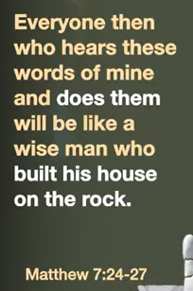 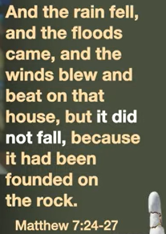

Matthew 7:24-27

The main point of Matthew 7:24-27 is that true wisdom is not just hearing Jesus' teachings, but actively putting them into practice. Those who build their lives on this foundation of obedience will withstand life's storms, while those who hear but do not obey build on a fragile foundation of sand, and their lives will collapse. This parable uses the metaphor of building a house to emphasize that faith requires action to be strong and enduring.

* **The Wise Builder:**

Listens to Jesus' words and puts them into practice, like a wise person building their house on a solid rock foundation. This house will not fall when storms come because of its strong foundation.

* **The Foolish Builder:**

Hears Jesus' words but does not obey them, like a foolish person building their house on sand. When the storms come, the house will collapse with a great crash.

* **The "storms"**

are understood to represent the difficulties and trials of life that test the strength of our foundation.

* **The "house"**

represents our lives, our spiritual and emotional well-being.



What are you building your life on?

The main point is to evaluate your life's foundation to ensure it's built on something lasting, like faith in God's teachings, rather than temporary things like money, popularity, or possessions. This involves understanding that a strong foundation is necessary to withstand life's challenges, and the question prompts a self-reflection on what provides ultimate stability and meaning.

* **Critiquing temporary foundations:**

The question challenges the idea that success, wealth, popularity, or achievements are solid bases for life, pointing out that these can "crumble" or disappear when difficulties arise.

* **Highlighting the need for a "rock":**

The central argument is that a life built on a temporary foundation will not withstand the "storms" of life. Instead, it calls for building on a more stable foundation, often identified as Jesus's teachings or God's word.

* **Encouraging intentional building:**

The question is a call to action, encouraging people to be intentional about what they prioritize and trust in. It suggests actively choosing to build a life on a firm foundation that provides security and purpose, rather than waiting for a crisis to force a re-evaluation.

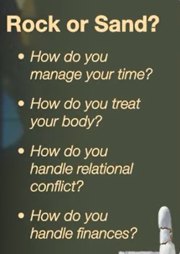

Rock or Sand?

a. How do you manage your time?

b. How do you treat your body?

c. How do you handle rational conflict?

d. How do you handle finances?

The main point of the "Rocks, Pebbles, and Sand" analogy is how to manage your time by prioritizing the most important tasks first, representing the "rocks," and then filling in the remaining space with less important tasks, "pebbles" and "sand.".

Explanation:

* **Rocks:** The largest and most important tasks, like career goals or family time.
* **Pebbles:** Smaller, important tasks that are less urgent but still need to be done.
* **Sand:** Minor tasks or distractions that can easily fill up your time if you're not careful.

Why other options are incorrect:

* **How do you treat your body?** The analogy is about time management, not self-care.
* **How do you handle rational conflict?** The analogy focuses on prioritizing tasks, not resolving conflict.
* **How do you handle finances?** The analogy is about time management, not financial planning.



Jesus calls us to step out before it is stable.

The main point of "Jesus calls us to step out before it is stable" is that true faith requires acting on God's call and trusting in him, rather than waiting for ideal, comfortable, or certain conditions. This message is often illustrated by the story of Peter walking on water, where he had to leave the safety of the boat to step out toward Jesus.

Key themes derived from this idea include:

* **Leaving your comfort zone.** The "boat" represents your comfort zone, and Jesus calls you to leave it behind to grow in faith. This often involves taking action in new or frightening situations.
* **Faith over comfort.** The desire for safety and stability can sometimes prevent people from following God's plan, which may involve risk and discomfort. The call is to prioritize obedience to God over personal comfort.
* **God is your source of stability.** You can step out into unstable circumstances because your ultimate safety and security are found in God, not in your external conditions. When Peter began to sink, Jesus was there to uphold him.
* **Movement before clarity.** Faith often requires you to take the first step without knowing the entire plan or seeing the destination. You must trust that God will guide you and reveal the path as you go.
* **Growth comes through courage.** Being challenged to leave what is familiar and comfortable is often how God strengthens your faith. This is how you discover a deeper, more empowered relationship with him.

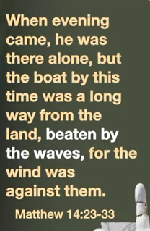 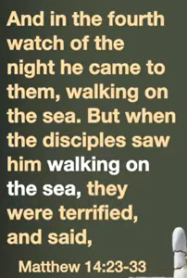 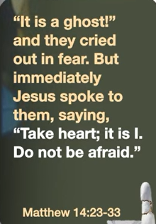 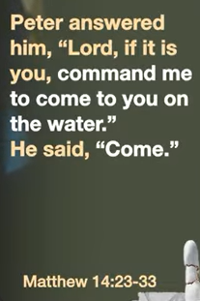

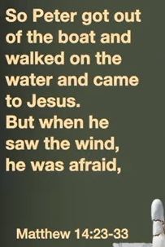 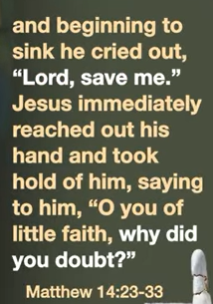 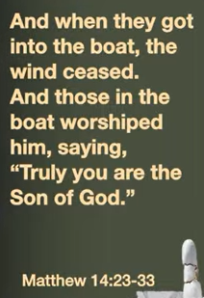

Matthew 14:23-33

The main point of Matthew 14:23-33 is to illustrate the importance of faith in Jesus Christ, especially during life's storms. The passage teaches that while it is easy to become overwhelmed by circumstances, fixing your focus on Jesus empowers you to face challenges, and He is present to save you when your faith falters.

* **Jesus's divine power:**

The story shows Jesus's authority over the natural world, walking on water to demonstrate his power over any storm, fear, or disorder.

* **The call to faith:**

Jesus calls out to his disciples, telling them to "Take courage! It is I. Don't be afraid". This is a call to both trust him and to step out in faith, even when circumstances are frightening.

* **The consequences of wavering faith:**

Peter's experience shows that when his focus shifted from Jesus to the storm, he began to sink, highlighting how doubt can lead to failure.

* **The power of calling on Jesus:**

When Peter cried out, "Lord, save me!" Jesus immediately saved him, demonstrating that even when faith wavers, calling on Jesus brings salvation.

* **The ultimate outcome:**

The passage concludes with the disciples worshiping Jesus, recognizing his divine nature ("Truly you are the Son of God"), which is the result of a strengthened faith after the ordeal.









a. Still in the boat, b. on the water, c. Sinking but reaching, d. Worshiping back in the boat

The four points describe the journey of faith based on the biblical story of Peter walking on water with Jesus (Matthew 14:22–33). The main theme is the shift from human reliance to absolute trust in divine power.

1. Still in the boat

* **The boat represents safety and human comfort.** For the disciples in the storm-tossed boat, it is their safe haven and familiar routine. In a spiritual sense, this represents our initial comfort zone, where we rely on our own abilities, resources, and experiences rather than stepping out in faith.
* **Faith is untested.** While the disciples believe in Jesus, their belief has not been tested by the storm or by doing the impossible. As one sermon puts it, "living without faith only works well when the seas of life are calm".

2. On the water

* **Leaving your comfort zone.** When Peter steps out of the boat, he leaves behind the known and safe for a journey of extreme faith. This is the action of trusting Jesus's command to "Come".
* **Faith enables the impossible.** For a brief, miraculous moment, Peter walks on water. This shows that when we keep our focus squarely on Jesus and act in obedience, we can achieve things that defy human limitations and expectations. Faith is what enables this supernatural experience, not Peter's own abilities.

3. Sinking but reaching

* **Doubt and fear lead to failure.** The moment Peter takes his eyes off Jesus and focuses on the raging storm, he becomes afraid and begins to sink. This illustrates how a shift from faith to fear can cause us to fail or falter, even after experiencing a moment of great faith.
* **The cry for rescue.** When Peter sinks, he cries out, "Lord, save me!". This is a crucial moment, demonstrating that when we fail, our immediate reaction should be to call out to Jesus for rescue, not to rely on ourselves to get back up. It shows that Jesus is the savior, and we need him to pull us out of our despair.

4. Worshiping back in the boat

* **Jesus rescues and restores.** Jesus immediately reaches out his hand, grabs Peter, and saves him. The two then return to the boat. This action proves that Jesus is always there to restore us and save us, even when our faith falters.
* **True worship and revelation.** Once Jesus and Peter are back in the boat and the storm is calmed, the other disciples worship Jesus, exclaiming, "Truly you are the Son of God". The experience of both the storm and the rescue reveals Jesus's identity and divine power to everyone in the boat, leading to genuine worship. The point is not our ability to walk on water, but God's power and presence in the storms of our life.

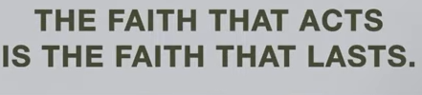

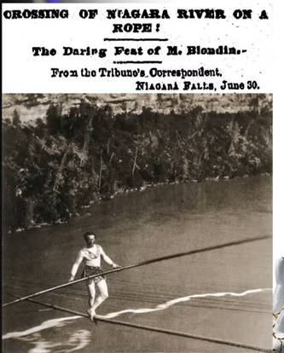

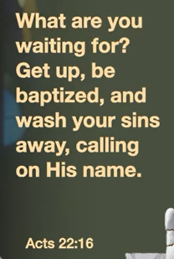

Acts 20:16

The main point of Acts 20:16 is Paul's determination to prioritize his journey to Jerusalem for the festival of Pentecost, rather than stopping in Ephesus, to avoid being delayed. His urgency highlights his focused commitment to his mission and his desire to be present at this significant event, as explained in [BibleHub.com](https://biblehub.com/commentaries/acts/20-16.htm) and [Bible Study Tools](https://www.biblestudytools.com/acts/20-16.html). He was hurrying to reach the city and ultimately to make his way back to Jerusalem after his third missionary journey.

* **Avoiding Delay:**

Paul decided to sail past Ephesus to avoid being detained by the large church there. He knew that if he stopped, his departure would be prolonged, making it difficult to reach Jerusalem by Pentecost.

* **Urgency and Focus:**

His haste underscores his focused sense of mission. He prioritized being in Jerusalem for the feast of Pentecost, a celebration with both Jewish and Christian significance, as detailed in [Christianity.com](https://www.christianity.com/bible/kjv/acts/20-16-24).

* **Prioritizing Mission:**

This decision demonstrates a strategic prioritization of his time and resources to fulfill his task, as seen in [BibleHub.com](https://biblehub.com/acts/20-16.htm). He instead arranged for the elders to meet him later in Miletus.

10/18/2025, Legacy (last week)

https://www.youtube.com/live/G24l3firEK0?si=V2hZSllThvZRHlsP

“Finding Steady Faith | Benefit of the Doubt,” Phil EuBank, Lead Pastor

Summary:

1. “When our whole world feels so shaky, where do we find something to steady ourselves?”: True stable comes from internal mind, not external world.

2. Psalm 46:1-3: In God, we have no reason to fear in the chaotic circumstances.

3. “The faith that acts is the faith that lasts”: faith with action will last long.

4. “Storm-proof your life”: Build a life with a strong foundation to prevent hardships/crises.

5. Matthew 7:24-27: True wisdom is not just Jesus' teachings but put them into practice.

6. “What are you building your life on?”: Build on faith in God instead of money or possession.

7. “Rock or Sand? a. How do you manage your time? b. How do you treat your body? c. How do you handle rational conflict? d. How do you handle finances?”: Manage your time by the most important tasks (rocks) and then fill in the less important tasks (sand).

8. "Jesus calls us to step out before it is stable": True faith needs act, not wait stable conditions.

9. Matthew 14:23-33: Have faith in Jesus Christ, especially during life's storms.

10. Matthew 14:22-33: 4 points from Peter walking on water with Jesus: a. Still in the boat, b. on the water, c. Sinking but reaching, d. Worshiping back in the boat.

11. Acts 20:16: Paul prioritize his faith: a. Avoid Delay, b. Focus, c. Mission.