10/25/2025, Legacy (last week)

https://www.youtube.com/live/aBRXPFl9eoM?si=L3pvWAHfyiuFaqmu

“Sleeping Through the Storm | Numb and Numb-er,” Phil EuBank, Lead Pastor

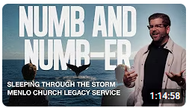

10:00/1:14:57

 

Introduction:

13:00/1:14:57

 

Introduction:

17:00/1:14:57

 

Phil EuBank, Lead Pastor

Today we start a new series “Numb and Numb-er” based on a classic story Jonah.

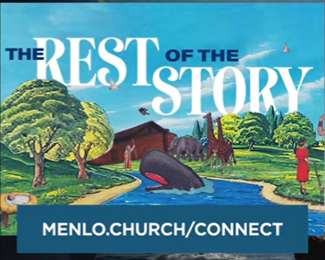 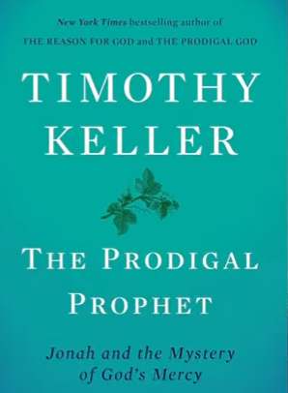

We have Numb when you go to dentist for gum surgery.

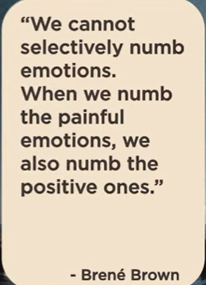

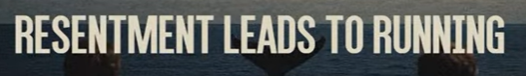

Resentment leads to running

We meet Jonah today.

Jonah resentment (怨恨) for Nineveh.

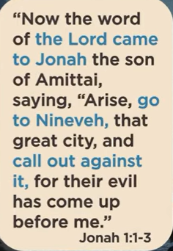 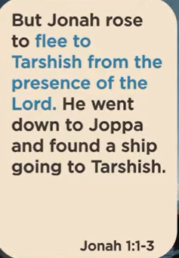



Running leads to retreating

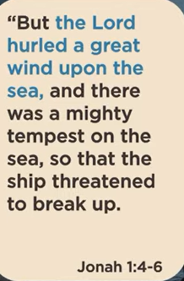 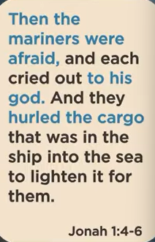 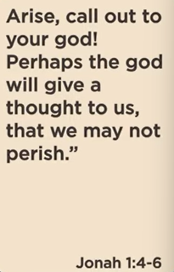

Jonah keeps setting down to Joppa, down to the bottom of the deck.

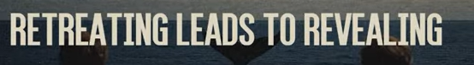

Retreating leads to revealing

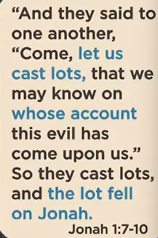 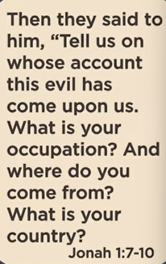 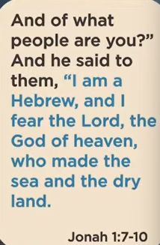 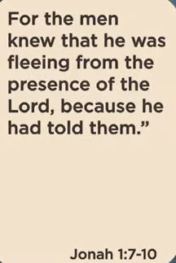



Revealing leas to releasing

Jonah is numb for the pain.

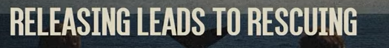

Releasing leads to rescuing

At the end, Jonah is no longer run. God saves him.

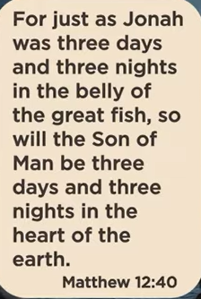

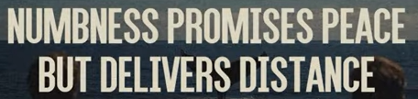

Numbness promises peace but delivers distance.

Numbness brings in peace but leads to distance.



Where am I holding back right now?

We pray together.

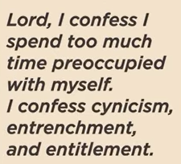 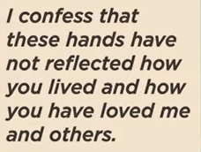 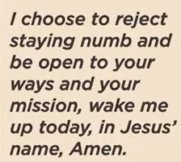

10/25/2025, Legacy (last week)

https://www.youtube.com/live/aBRXPFl9eoM?si=L3pvWAHfyiuFaqmu

“Sleeping Through the Storm | Numb and Numb-er,” Phil EuBank, Lead Pastor

Summary: