11/01/2025, Legacy (last week)

https://www.youtube.com/live/PauCi8A_3rU?si=U64GedLrx_yoKMLZ

“In the Belly of the Beast | Numb and Number,” Jevon Washington, Pastor of Ministries



Introduction:

10:00/1:15:02

 

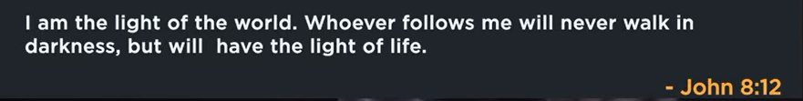

 

Phil EuBank, Lead Pastor

Topics Introduction:

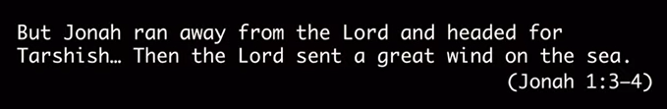

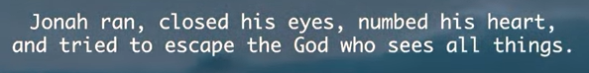

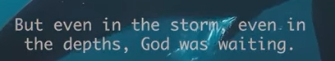



17:00/1:14:57

 

Jevon Washington, Pastor of Ministries

Find Menlo Church for your home, belong Menlo Church before you believe.

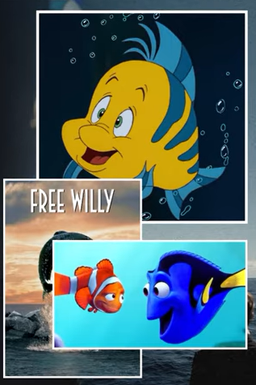

Famous fish:

1. Flounder, a tropical fish, is Ariel best friend in little Mermaid

2. Free Willy, Michael Jackson soundtrack (song narrow track along the movie), “Will You Be There”

3. Finding Nemo and Dorey, the forgettable fish.

Today, we are in chapter 2 of Jonah. This is outlandish (古怪的).

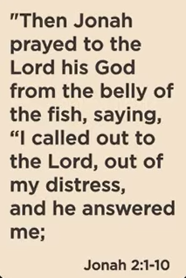 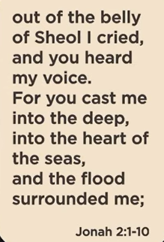 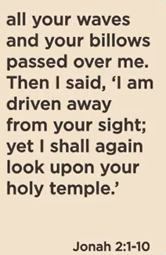

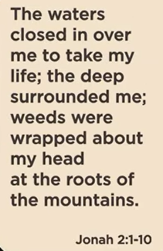 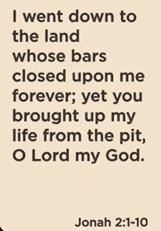 

 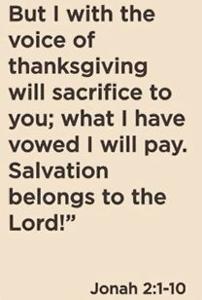 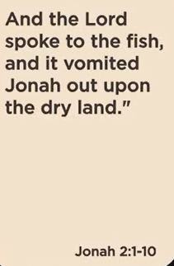

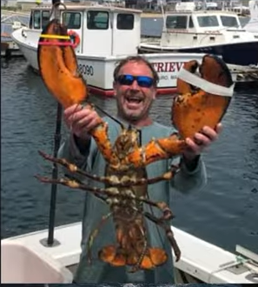 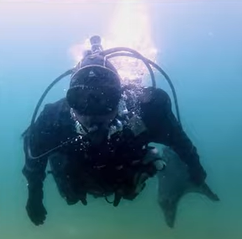

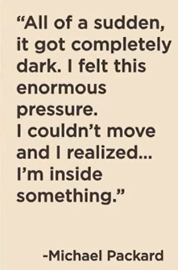 

Michael Packard is the only one eaten by whale in Cape Cod.

https://www.capecodtimes.com/story/news/2021/06/11/humpback-whale-catches-michael-packard-lobster-driver-mouth-proviencetown-cape-cod/7653838002/





Narnia

The main point of the movie *Narnia* is the struggle between good and evil, specifically showing how four children help a lion named Aslan defeat the evil White Witch and save the magical land of Narnia from an eternal winter. A deeper, allegorical point is the story of redemption and sacrifice, with Aslan's sacrifice mirroring the story of Jesus Christ and the children learning courage and self-respect through their journey.

  

  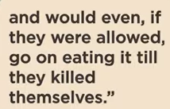

Five poison in Jonah: Eye, heart, mind, limb (四肢), ear.

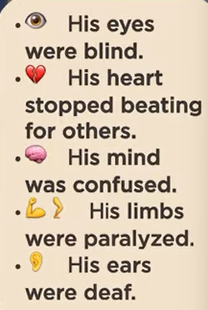

In this belly of grave of three days. Ultimately, Jonah surround to God.

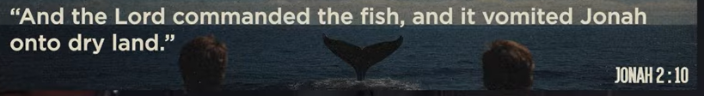

God shows Jonah may not pretty but for the lives of people.

God comes down and wants to give birth for Jonah.

Jonah cannot climb out of fish by himself.

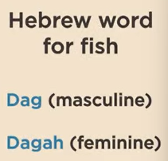

In Hebrew word,

Dag: man (Large, male fish). Very large fish. Jonah is swallowed and dangerous but did not pray,

Dagah: woman (Small and a lot of fish). Johan is bit by a lot of fish but safe. Jonah started to pray.

Jonah finally follows God command to go to Nineveh to preach people.

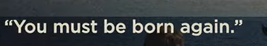

Jesus stays in grave for three days. New birth from God.

Jonah is come out of fish belly and still alive. We only have chaos in life. We stop running and



Stop running out from God.

Start returning to God.

11/01/2025, Legacy (last week)

https://www.youtube.com/live/PauCi8A_3rU?si=U64GedLrx_yoKMLZ

“In the Belly of the Beast | Numb and Number,” Jevon Washington, Pastor of Ministries

Summary: