10/24/2026, Menlo Church Worship (Summary of last week, 10/18/2026)
https://youtu.be/tdJDvdp1CDA?si=7t04h4suk8bj6mDS
https://github.com/peterhchen/1000_Family/tree/main/Church/2026
Who Are You, Really? | Beyond the Ballot | Menlo Church, Phil EuBank, Lead Pastor

0:00/34:33
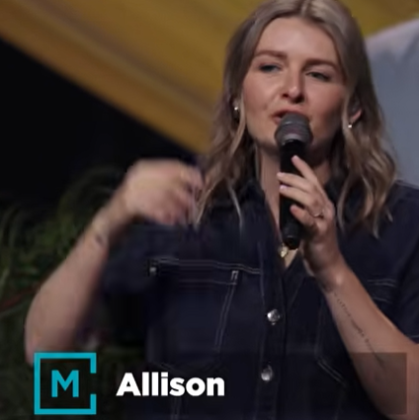
Allison Joy Li

Introduction:
0:00/34:33
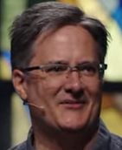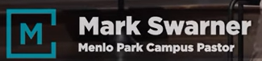
Mark Swarner, Campus Pastor

0:00/34:33
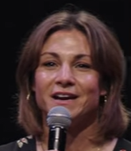

0:06/34:33
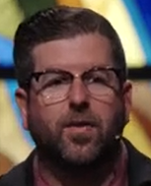
Phil EuBank, Lead Pastor

0:44/34:33
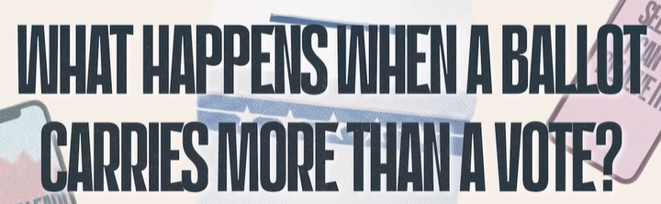
What happens when a Ballot carries more than a vote?

0:51/34:33

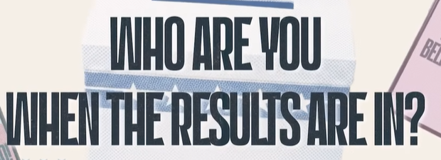
Who are you when the results are in?

0:58/34:33
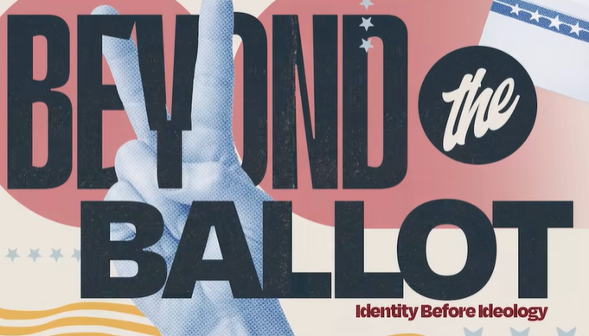
Beyond the Ballot, Identify before Ideology

1:07/34:33
Phil EuBank, Lead Pastor

2:35/34:33

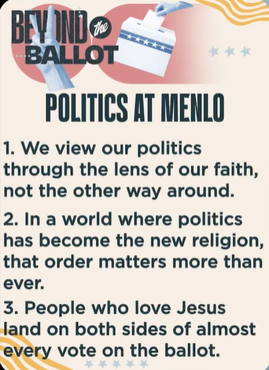
BEYOND the BALLOT: POLITICS AT MENLO
- We view our politics through the lens of our faith, not the other way around.
- In a world where politics has become the new religion, that order matters more than ever.
- People who love Jesus land on both sides of almost every vote on the ballot

這三點就是你 Main Idea 的官方版——第一點「我們透過信仰看政治，而不是反過來」正是你的 "Identity before Ideology"，教會自己寫出來了。
第二點把政治比作新宗教，第三點承認愛耶穌的人選票兩邊都有——這個系列的調子很清楚：不選邊，只排順序。

Main Idea:
1. We look politics through faith. Not faith through politics.
2. Politics is like a new religion now. The faith comes first.
3. Church People vote for both parties.

5:45/34:33
Pray:
We follow God faith and vote for both parties.

12:21/34:33

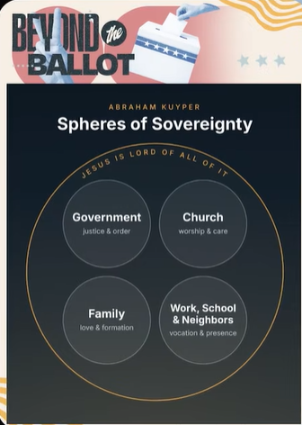
BEYOND the BALLOT: ABRAHAM KUYPER
Spheres of Sovereignty: JESUS IS LORD OF ALL OF IT
1. Government: justice & order
2. Church: worship & care
3. Family: love & formation
4. Work, School & Neighbors: vocation & presence

Main idea:
1. Jesus is Lord over all of life.
2. Life has different spheres: government, church, family, work.
3. Government is only one of the spheres. It does not rule the other spheres.

************
************
10/24/2026, Menlo Church Worship (Summary of last week, 10/18/2026)
https://youtu.be/tdJDvdp1CDA?si=7t04h4suk8bj6mDS
https://github.com/peterhchen/1000_Family/tree/main/Church/2026
Who Are You, Really? | Beyond the Ballot | Menlo Church, Phil EuBank, Lead Pastor

