12/27/2025, Legacy (last week)
https://www.youtube.com/live/9fu_vdVRpMM?si=U8usNoNdp-G7olN9
“Come All Ye Lonely | Come All Ye Faithless,” Phil EuBank, Lead Pastor

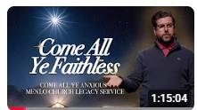

“Ye” = “y’all.” The phrase
1. " Come All Ye Lonely" means “Come here. All of you who are Lonely".
2. "Come All Ye Faithless" means “Come here. All of you who are without faith".




Phil EuBank, Lead Pastor

Introduction:
18:00/1:14:58


Speech:
22:00/1:14:58

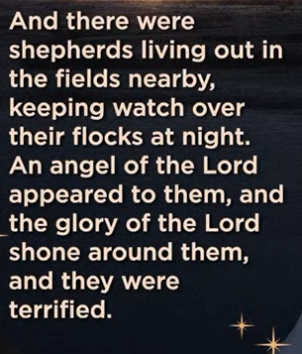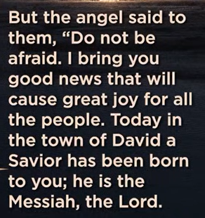

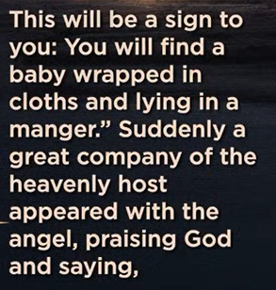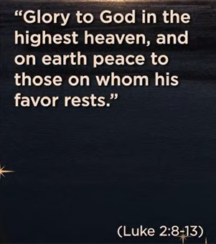

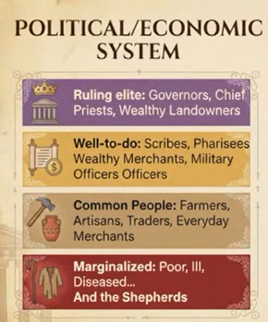

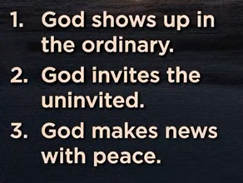
1. God shows up in the ordinary.
2. God inveites the uninvited.
3. God makes news with peace.

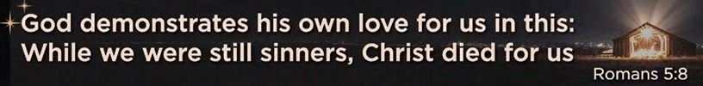
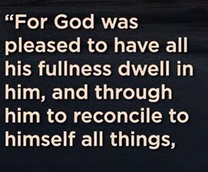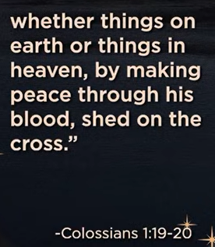

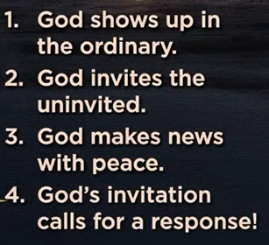
1. God shows up in the ordinary.
2. God inveites the uninvited.
3. God makes news with peace.
4. God’s invitation calls for a response!

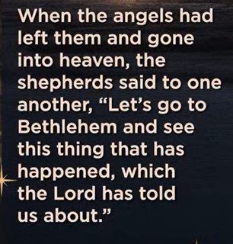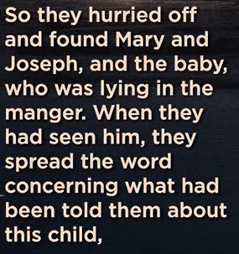

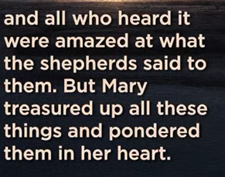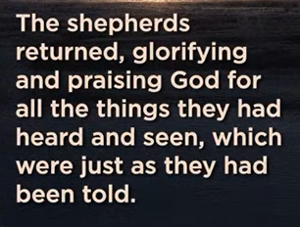

12/27/2025, Legacy (last week)
https://www.youtube.com/live/9fu_vdVRpMM?si=U8usNoNdp-G7olN9
“Come All Ye Lonely | Come All Ye Faithless,” Phil EuBank, Lead Pastor

“Ye” = “y’all.” The phrase
1. " Come All Ye Lonely " means “Come here. All of you who are Lonely".
2. "Come All Ye Faithless" means “Come here. All of you who are without faith".

Summary:

