06/20/2026, Menlo Church Worship (Summary of last week, 05/14/2026)
https://www.youtube.com/watch?v=Yj3rzuRKpXk
Going Offline | Glitch | Menlo Church Phil EuBank

5:23/1:16:05

Allison Joy Li

Introduction:
15:00/1:16:05

Mark Swarner, Campus Pastor

20:30/1:16:05
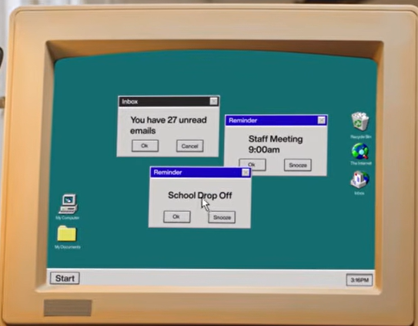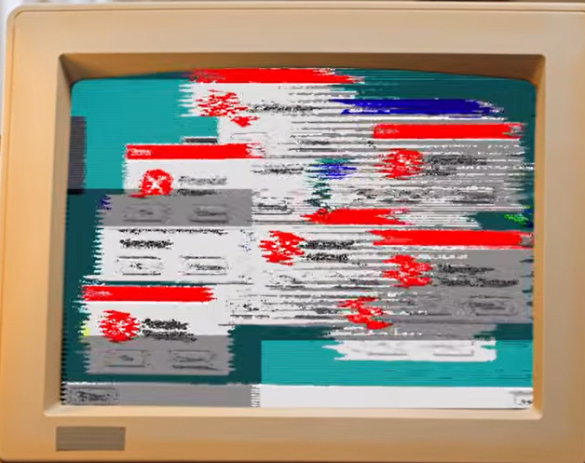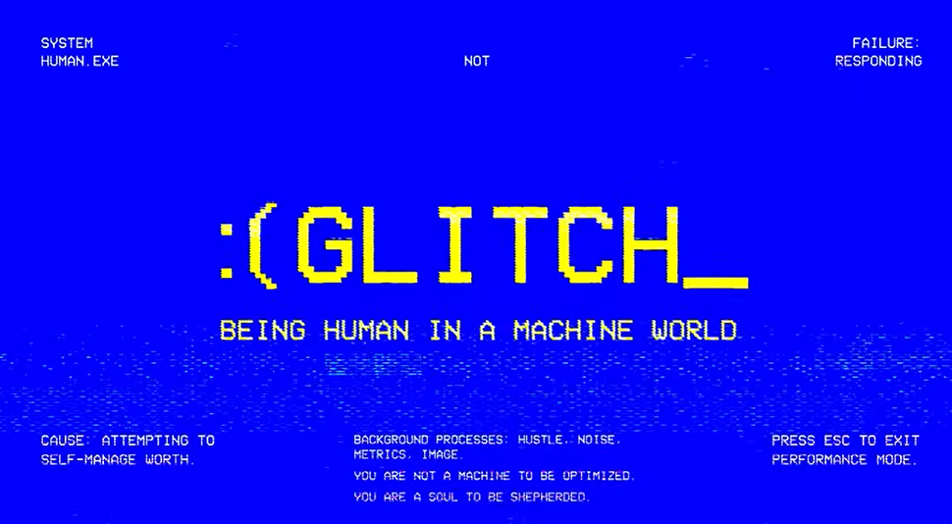

21:30/1:16:05
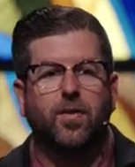
Phil EuBank, Lead Pastor

26:30/1:16:05
We are in the four-week series called “Glitch”. We have been navigated the 1. Fatal Error, 2. Infinity Loop, 3. Hardware Failure. What human should be in a machine world? Now, we talk the “Going Offline”.

======
06/20/2026, Menlo Church Worship (Summary of last week, 05/14/2026)
https://www.youtube.com/watch?v=Yj3rzuRKpXk
Going Offline | Glitch | Menlo Church Phil EuBank

