04/18/2026, Menlo Church Worship (Summary of last week, 04/12/2028)
https://www.youtube.com/live/JUlc3qrWy7o?si=BDG3Bgxu8Lmm-ADu
“If You’re Real, Show Me |God, If You’re Real,” Phil EuBank, Lead Pastor

0:39/1:15:00

9:50/1:15:00
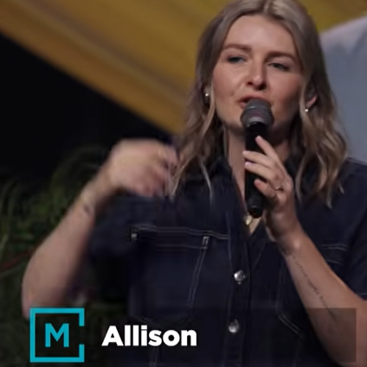

Introduction:
24:00/1:15:00


29:10/1:15:00
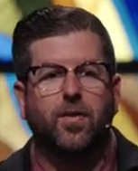
Phil EuBank, Lead Pastor

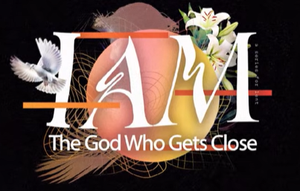

======
04/18/2026, Menlo Church Worship (Summary of last week, 04/12/2028)
https://www.youtube.com/live/JUlc3qrWy7o?si=BDG3Bgxu8Lmm-ADu
“If You’re Real, Show Me |God, If You’re Real,” Phil EuBank, Lead Pastor

Summary:

