10/17/2026, Menlo Church Worship (Summary of last week, 10/11/2026)
https://youtu.be/z2DxywzITAc?si=v2pbRoNGe3Wb61CS
https://github.com/peterhchen/1000_Family/tree/main/Church/2026
Without Pretense | Repentance For the Rest Of Us| Menlo Church, Phil EuBank, Lead Pastor

0:00/34:47
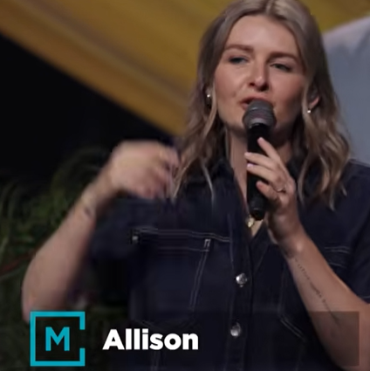
Allison Joy Li

Introduction:
0:00/34:47
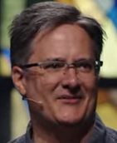
Mark Swarner, Campus Pastor

0:00/34:47
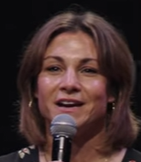

1:06/34:47
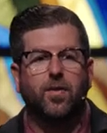
Phil EuBank, Lead Pastor

1:20/34:47
Last weeks, we have collected $5.3M, 167 volunteers in two year.
We paused the series of “Repentance for the Rest of Us” and highlight and celebrate what God has been up to around here at all of our campuses through the Bay Area. This week, we are jumping back to finish our series “Repentance for the Rest of Us.” We got the concept of reclaiming the repentance.”

2:59/34:47
Pray: We have love from God. There is nothing can separate from God and us.

4:56/34:47

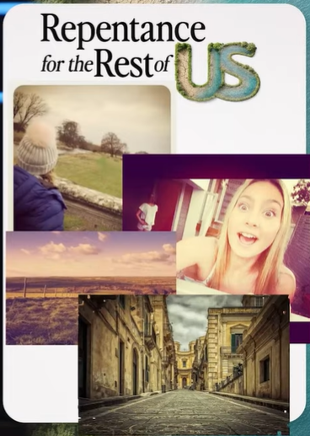
We have so many photos. We always use filter to get the one we want. Life is same. We give other people the filtered one. Pretense = 偽裝、假裝。"Without Pretense" means remove the filter, i.e., face the reality. (就是「毫不偽裝」——拿掉面具，真實面對。)

這個比喻很妙——我們給照片加濾鏡，篩掉幾百張只留最好的一張發出去；人生也一樣，給別人看的永遠是濾鏡版。這篇 "Without Pretense" 就是要人把濾鏡拿掉。你剛傳的那張拼貼主視覺，用的正是這種未經修飾的日常照片，正好就是「拿掉濾鏡」的樣子。

************
************
10/17/2026, Menlo Church Worship (Summary of last week, 10/11/2026)
https://youtu.be/z2DxywzITAc?si=v2pbRoNGe3Wb61CS
https://github.com/peterhchen/1000_Family/tree/main/Church/2026
Without Pretense | Repentance For the Rest Of Us| Menlo Church, Phil EuBank, Lead Pastor

