09/12/2026, Menlo Church Worship (Summary of last week, 09/06/2026)
https://youtu.be/d9_kJxWp-18?si=iPLy4AkzVvfvIqF5
https://github.com/peterhchen/1000_Family/tree/main/Church/2026
Small Fire, Big Forest (Thoughtful Witness, 深思的見證者) | What Is a Follower Of the Way? | Menlo Church
Matt Summers, Pastor of Spiritual Formation
Phil EuBank, Lead Pastor

0:00/35:07
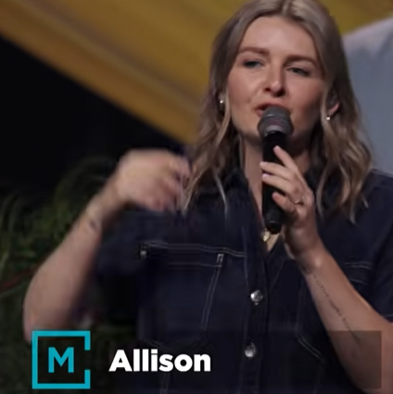
Allison Joy Li

Introduction:
0:00/35:07
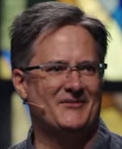
Mark Swarner, Campus Pastor

0:00/35:07
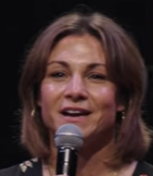

0:58/35:07
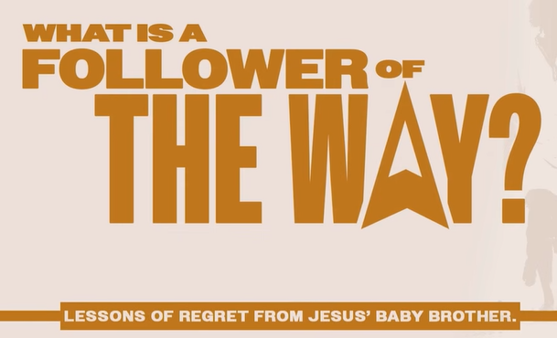

Thoughtful Witness (深思的見證者)

0:00/35:07
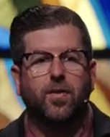
Phil EuBank, Lead Pastor

************
************
09/12/2026, Menlo Church Worship (Summary of last week, 09/06/2026)
https://youtu.be/d9_kJxWp-18?si=iPLy4AkzVvfvIqF5
https://github.com/peterhchen/1000_Family/tree/main/Church/2026
Small Fire, Big Forest (Thoughtful Witness, 深思的見證者) | What Is a Follower Of the Way? | Menlo Church
Matt Summers, Pastor of Spiritual Formation
Phil EuBank, Lead Pastor

