11/29/2025, Legacy (last week)
https://www.youtube.com/live/Idm_ZntO2q0?si=sn5DDgHKKwcUReMe
“They’re Still Worth It | Hope for Everyone,” Phil EuBank, Lead Pastor


Introduction:
10:00/1:15:01











23:53/1:15:01

Phil EuBank, Lead Pastor

"They're Still Worth It | Hope for Everyone" encouraging faith and continued investment in the future despite challenges. It argues that people should have faith in a better future and continue to take steps forward, just as previous generations did, to build a legacy for future generations to be grateful for, and that even in the face of difficulty, there is hope in continuing to act and to believe in a better tomorrow.
- Call to action: The message calls for people to step out in faith and make investments, both big and small, to support future endeavors.
- Legacy building: It emphasizes the importance of building upon the legacy left by previous generations and creating a positive future for the generations to come.
- Inspiration: The core message is one of inspiration, reminding listeners that there is hope for everyone and that their actions today can help build a brighter future tomorrow.

Below, we show the Menlo Church currently doing.


Class for kids of next generation.


New Menlo Church

Father who keeps the house ready. This is the hope for everyone.

The older son is lost outside the house, the younger son is lost inside the house.
Father gives the hope for the house.

When hope is for everyone, the lost come home and the found come alive.

The phrase is a poetic interpretation of biblical themes found in Luke 15 and other passages, particularly the parables of the lost sheep, lost coin, and lost son, which describe God's joy in finding the lost. The saying reflects the belief that when hope is extended to everyone, those who have strayed return "home," and those who felt worthless or forgotten find a new sense of "life" or purpose.
- The lost come home: This part of the saying is powerfully illustrated in the Parable of the Prodigal Son in Luke 15:11-32, where a father joyfully welcomes his son back after he had squandered his inheritance and returned in poverty.
- The found come alive: The joy of being found is shown in the parable of the lost sheep (Luke 15:4-7), where the shepherd rejoices over the one sheep he has found, and in the celebration when the prodigal son returns. The phrase suggests that being found by God brings a new sense of life and purpose.

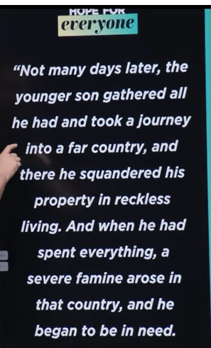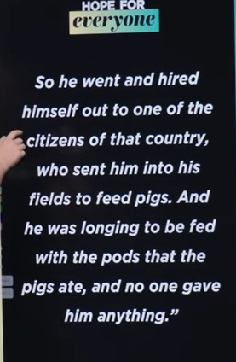
Luke 15:13-16
English Standard Version
¹³ Not many days later, the younger son gathered all he had and took a journey into a far country, and there he squandered his property in reckless living. ¹⁴ And when he had spent everything, a severe famine arose in that country, and he began to be in need. ¹⁵ So he went and hired himself out to^{[a]} one of the citizens of that country, who sent him into his fields to feed pigs. ¹⁶ And he was longing to be fed with the pods that the pigs ate, and no one gave him anything.

The main point of Luke 15:13-16 is to illustrate how sin leads to a miserable and isolated life, contrasting with God's loving and welcoming nature. The passage describes the younger son's wasteful lifestyle, his resulting desperation, and how he ended up in a state of complete ruin, feeding pigs and wanting their food. This section highlights the downward spiral of a life lived far from God and sets the stage for the parable's conclusion about repentance and forgiveness.
- Sin leads to separation: The son's decision to leave his father and venture to a "distant country" represents a physical and spiritual separation from God and family.
- Sin results in ruin: He squanders his inheritance on "wild living," eventually finding himself utterly destitute and forced into a humiliating and degrading job feeding pigs.
- A life without God is a miserable existence: His "wanting state" is described as a time of great need, lacking not only material goods but also spiritual nourishment and true companionship.
- This is the reality of sin: The shocking detail of him wanting to eat the pigs' slop emphasizes the depths of his degradation, a condition that reflects a life without God's presence.

Luke 15:11-32, ESV
The Parable of the Prodigal Son
¹¹ And he said, “There was a man who had two sons. ¹² And the younger of them said to his father, ‘Father, give me the share of property that is coming to me.’ And he divided his property between them. ¹³ Not many days later, the younger son gathered all he had and took a journey into a far country, and there he squandered his property in reckless living. ¹⁴ And when he had spent everything, a severe famine arose in that country, and he began to be in need. ¹⁵ So he went and hired himself out to^{[a]} one of the citizens of that country, who sent him into his fields to feed pigs. ¹⁶ And he was longing to be fed with the pods that the pigs ate, and no one gave him anything.
¹⁷ “But when he came to himself, he said, ‘How many of my father's hired servants have more than enough bread, but I perish here with hunger! ¹⁸ I will arise and go to my father, and I will say to him, “Father, I have sinned against heaven and before you. ¹⁹ I am no longer worthy to be called your son. Treat me as one of your hired servants.”’ ²⁰ And he arose and came to his father. But while he was still a long way off, his father saw him and felt compassion, and ran and embraced him and kissed him. ²¹ And the son said to him, ‘Father, I have sinned against heaven and before you. I am no longer worthy to be called your son.’^{[b]} ²² But the father said to his servants,^{[c]} ‘Bring quickly the best robe, and put it on him, and put a ring on his hand, and shoes on his feet. ²³ And bring the fattened calf and kill it, and let us eat and celebrate. ²⁴ For this my son was dead, and is alive again; he was lost, and is found.’ And they began to celebrate.
²⁵ “Now his older son was in the field, and as he came and drew near to the house, he heard music and dancing. ²⁶ And he called one of the servants and asked what these things meant. ²⁷ And he said to him, ‘Your brother has come, and your father has killed the fattened calf, because he has received him back safe and sound.’ ²⁸ But he was angry and refused to go in. His father came out and entreated him, ²⁹ but he answered his father, ‘Look, these many years I have served you, and I never disobeyed your command, yet you never gave me a young goat, that I might celebrate with my friends. ³⁰ But when this son of yours came, who has devoured your property with prostitutes, you killed the fattened calf for him!’ ³¹ And he said to him, ‘Son, you are always with me, and all that is mine is yours. ³² It was fitting to celebrate and be glad, for this your brother was dead, and is alive; he was lost, and is found.’”

Luke 15:11-32, known as the parable of the Prodigal Son, tells of a father with two sons: the younger wastes his inheritance in reckless living, repents, and is welcomed back joyfully by his father, while the older son resents the celebration. The parable illustrates God's unconditional love, forgiveness, and joy for those who have strayed but return to Him, while also addressing the self-righteousness of those who have never strayed.
- The younger son:
He asks for his inheritance early, leaves home, squanders it, and ends up broke and working with pigs. When he returns, he is prepared to beg to be a hired servant.
- The father:
The father sees him from a distance, runs to him, and embraces him, honoring him with a robe, a ring, and sandals. He then throws a feast to celebrate his son's return, saying, "for this my son was dead, and is alive again; he was lost, and is found".
- The older son:
He is angry and resentful that his father celebrates the younger son's return. His father reminds him that it was right to celebrate because the younger son had been lost and is now found.
- The meaning:
The parable is a powerful illustration of God's character, demonstrating His compassion and grace towards those who are "lost" (the younger son) and His desire to include and celebrate the return of sinners. It also challenges those who are self-righteous (the older son) to rejoice in the forgiveness and restoration of others.

The father kept looking down the road
The father has not forgotten to give children. Father keeps the eye down the road.




Luke 15:11-32: The father kept the light on.
The lost kid can find the way to go home. Jesus keeps the light on.

The phrase "the father kept the light on" is a modern inspirational interpretation or application of the Parable of the Prodigal Son found in the Bible in Luke 15:11-32.
This specific phrasing does not appear directly in the biblical text itself, but it is a popular way to illustrate the father's constant hope and readiness for his son's return.
Meaning in the Parable
The concept derived from the parable is that:
- The father never gave up hope that his rebellious son would come home.
- He was always watching and waiting; the text says he saw his son "a long way off," suggesting he may have been looking down the road regularly.
- The "light on" symbolizes an enduring welcome, unconditional love, and the persistent prayer of a parent for a lost loved one to return.
The actual story describes the father immediately running to his son, embracing him, and throwing a celebration, demonstrating God's welcoming grace and forgiveness for those who repent and "come home" to Him.


15:20-24: The father kept the calf ready
Luke 15:20-24
English Standard Version
²⁰ And he arose and came to his father. But while he was still a long way off, his father saw him and felt compassion, and ran and embraced him and kissed him. ²¹ And the son said to him, ‘Father, I have sinned against heaven and before you. I am no longer worthy to be called your son.’^{[a]} ²² But the father said to his servants,^{[b]} ‘Bring quickly the best robe, and put it on him, and put a ring on his hand, and shoes on his feet. ²³ And bring the fattened calf and kill it, and let us eat and celebrate. ²⁴ For this my son was dead, and is alive again; he was lost, and is found.’ And they began to celebrate.

The phrase from the Gospel of Luke, "the father kept the calf ready," refers to the parable of the Prodigal Son, where the father prepares a feast with a fattened calf to celebrate the son's return. This calf was kept for special, significant occasions, and its preparation symbolized immense joy, a complete restoration, and a welcoming, celebratory atmosphere for the returning son who was considered lost and is now found.
- Symbol of celebration: In ancient cultures, meat was not eaten regularly, and a fattened calf was a symbol of abundance and a major celebration, indicating that the occasion was of utmost importance.
- Symbol of restoration: The act of killing the fattened calf was a sign of the father's complete forgiveness and joy at his son's return, representing a joyful reunion and restoration of the family's honor.
- Symbol of God's grace: The parable uses this image to teach about God's love and the joy in heaven over a repentant sinner who returns to God, showing that God's grace is abundant and freely offered.
- Sign of a feast: The father's command to "bring the fattened calf and kill it" was an immediate action to prepare for a great feast, symbolizing a communal celebration that would include the son, the father, and the servants.

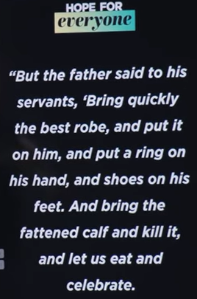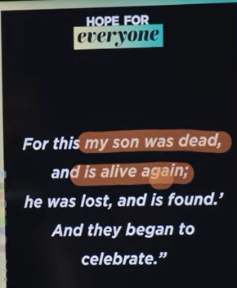
Luke 15:22-24 ESV
But the father said to his servants, ‘Bring quickly the best robe, and put on him, and put a ring on his hand, and shoes on his feet. And being the flattened calf and kill it, and let us eat and celebrate. For this my son was dead and is alive again; he was lost, and is found.” And they began to celebrate.

Luke 15:22-24
English Standard Version
²² But the father said to his servants,^{[a]} ‘Bring quickly the best robe, and put it on him, and put a ring on his hand, and shoes on his feet. ²³ And bring the fattened calf and kill it, and let us eat and celebrate. ²⁴ For this my son was dead, and is alive again; he was lost, and is found.’ And they began to celebrate.

The main point of Luke 15:22-24 is that God's love is eager, forgiving, and restorative, not hesitant or stingy. When a person repents and returns to God, He eagerly welcomes them, restores their dignity with lavish gifts, and celebrates their return as if they were lost and are now found.
- Eager forgiveness: The father doesn't wait for the son to clean himself up but runs to meet him, symbolizing God's immediate and compassionate response to a returning sinner.
- Restoration of dignity: The father provides the best robe, a ring, and sandals. These aren't just gifts, but symbols of full restoration to his place as a son, not a servant. The robe covers the rags of his sin, the ring represents authority, and the sandals signify he is a free son, not a slave.
- Prodigal grace: God's grace is described as "prodigal" or wasteful in its generosity, far exceeding what a person could earn or deserve. The celebration with a feast highlights that God prioritizes this restoration and rejoices over the one who returns.
- A new beginning: The parable emphasizes that repentance leads to a fresh start. God doesn't just pardon past mistakes but provides a new, honorable beginning for the repentant person.

Father is amazing and waiting for son to come back.


The father kept loving both sons.
Luke 15:11-32
English Standard Version
The Parable of the Prodigal Son
¹¹ And he said, “There was a man who had two sons. ¹² And the younger of them said to his father, ‘Father, give me the share of property that is coming to me.’ And he divided his property between them. ¹³ Not many days later, the younger son gathered all he had and took a journey into a far country, and there he squandered his property in reckless living. ¹⁴ And when he had spent everything, a severe famine arose in that country, and he began to be in need. ¹⁵ So he went and hired himself out to^{[a]} one of the citizens of that country, who sent him into his fields to feed pigs. ¹⁶ And he was longing to be fed with the pods that the pigs ate, and no one gave him anything.
¹⁷ “But when he came to himself, he said, ‘How many of my father's hired servants have more than enough bread, but I perish here with hunger! ¹⁸ I will arise and go to my father, and I will say to him, “Father, I have sinned against heaven and before you. ¹⁹ I am no longer worthy to be called your son. Treat me as one of your hired servants.”’ ²⁰ And he arose and came to his father. But while he was still a long way off, his father saw him and felt compassion, and ran and embraced him and kissed him. ²¹ And the son said to him, ‘Father, I have sinned against heaven and before you. I am no longer worthy to be called your son.’^{[b]} ²² But the father said to his servants,^{[c]} ‘Bring quickly the best robe, and put it on him, and put a ring on his hand, and shoes on his feet. ²³ And bring the fattened calf and kill it, and let us eat and celebrate. ²⁴ For this my son was dead, and is alive again; he was lost, and is found.’ And they began to celebrate.
²⁵ “Now his older son was in the field, and as he came and drew near to the house, he heard music and dancing. ²⁶ And he called one of the servants and asked what these things meant. ²⁷ And he said to him, ‘Your brother has come, and your father has killed the fattened calf, because he has received him back safe and sound.’ ²⁸ But he was angry and refused to go in. His father came out and entreated him, ²⁹ but he answered his father, ‘Look, these many years I have served you, and I never disobeyed your command, yet you never gave me a young goat, that I might celebrate with my friends. ³⁰ But when this son of yours came, who has devoured your property with prostitutes, you killed the fattened calf for him!’ ³¹ And he said to him, ‘Son, you are always with me, and all that is mine is yours. ³² It was fitting to celebrate and be glad, for this your brother was dead, and is alive; he was lost, and is found.’”

Luke 15:11-32, known as the parable of the Prodigal Son, tells of a father with two sons: the younger wastes his inheritance in reckless living, repents, and is welcomed back joyfully by his father, while the older son resents the celebration. The parable illustrates God's unconditional love, forgiveness, and joy for those who have strayed but return to Him, while also addressing the self-righteousness of those who have never strayed.
- The younger son:
He asks for his inheritance early, leaves home, squanders it, and ends up broke and working with pigs. When he returns, he is prepared to beg to be a hired servant.
- The father:
The father sees him from a distance, runs to him, and embraces him, honoring him with a robe, a ring, and sandals. He then throws a feast to celebrate his son's return, saying, "for this my son was dead, and is alive again; he was lost, and is found".
- The older son:
He is angry and resentful that his father celebrates the younger son's return. His father reminds him that it was right to celebrate because the younger son had been lost and is now found.
- The meaning:
The parable is a powerful illustration of God's character, demonstrating His compassion and grace towards those who are "lost" (the younger son) and His desire to include and celebrate the return of sinners. It also challenges those who are self-righteous (the older son) to rejoice in the forgiveness and restoration of others

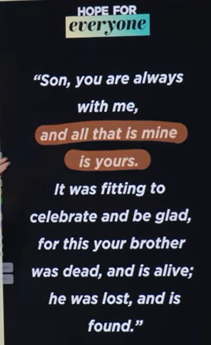
Son, you are always with me, and all that is mine is yours, It was fitting to celebrate and be glad, for this your brother was dead, and it alive; he was lost, and is found.
Luke 15:31-32
English Standard Version
³¹ And he said to him, ‘Son, you are always with me, and all that is mine is yours. ³² It was fitting to celebrate and be glad, for this your brother was dead, and is alive; he was lost, and is found.’”

The main point of Luke 15:31-32 is that God's love is extravagant and joyous, and He welcomes repentant sinners with open arms, just as the father in the parable does for his lost son. The passage, spoken by the father to his elder son, emphasizes that all of God's blessings are for those who have faith, and the focus is on the joy of restoring a lost person to fellowship rather than punishing past mistakes.
- God's extravagant love: The father's words highlight that his love is lavish and unconditional, and the celebration is meant to show his joy over his son's return, not to punish the elder son.
- The father's generosity: The father assures the elder son, "all that is mine is yours," and points to the celebration as a way of expressing a desire to share God's love and joy with those who repent.
- A message to the self-righteous: This part of the parable serves as a message to religious leaders who were critical of Jesus's association with sinners. The father's response is a lesson in compassion, humility, and the importance of celebrating God's mercy with the repentant, rather than being resentful or judgmental.
- The joy of restoration: The ultimate message is about the joy of finding the lost and restoring them to fellowship with God. The father's celebration of his son's return represents God's rejoicing when a sinner repents and comes to Him.



We modify into below.

Menlo Church is the home of everyone and welcome children to come home.
We are not building yet but we are preparing for kids to come back.


First session: new member and second session: older member
You are still worth the hope of continuous of mission ..

11/29/2025, Legacy (last week)
https://www.youtube.com/live/Idm_ZntO2q0?si=sn5DDgHKKwcUReMe
“They’re Still Worth It | Hope for Everyone,” Phil EuBank, Lead Pastor

Summary:
Previous generation build current home (Menlo church). We plan to extend home for kids’ education and re-build church for future generations.
Today discussion is Luke 15 (A father welcomes his younger son (lost son) to return home)
1. When hope is for everyone, the lost come home and the found come alive: A Father hopes to everyone who return home, no matter a loser (young sone who lost all money) or winner (the one who found way to come back).
2. Luke 15:11-13: The younger son lost all his money and come home. Father welcomes the younger son return The younger son lost all money when he comes home.
3. Luke 15:14-15: God's love is unconditional. The younger son lost all his money and father welcomed him back. The older son hates the celebration of his father.
4. Luke 15:16-20: The father kept the light on. The lost kid can always find the way to go home. 5. Luke 15:20-24: Father prepares a feast with calf (beef) to welcome the younger son return.
6. Luke 15:25-30: The father kept loving both sons.
7. Luke 15:31-32: God welcomes repentant sinners with open arms, just as the father in the parable does for his lost son.

